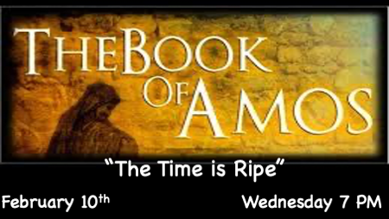

How important is the Word of God in your life?

- If you hide it in your heart it will protect you from sin. Psalm 119:11
- It is a light to guide you. Psalm 119:105
- “Does not my word burn like fire? says the Lord. Is it not like a mighty hammer that smashes a rock to pieces?” Jeremiah 23:29
- A cleansing agent to wash our hearts and minds. Ephesians 5:23
- He who heeds the Word wisely will find good. Proverbs 16:20

*Amos 8:1Thus hath the Lord GOD shewed unto me: and behold a basket of summer fruit.
Amos 8:2 And he said, Amos, what seest thou? And I said, A basket of summer fruit. Then said the LORD unto me, The end has come upon my people of Israel; I will not again pass by them anymore. (KJV)

“Summer is Near”
Author T.W. Tramm

- Israel is ripe for judgement for the reasons that are listed in Amos 1 – 8:8
- There are parallels of Israel’s judgement and world’s (especially the U.S.A.)
- Spring/Summer is key to end-time thinking. A time for weddings Ruth 4, A significant time of births, Enoch, Jacob, David, the Nation Israel, and the Christian Church Acts 2. Plus, the resurrection & ascension all occurred in spring or summer. Matthew 27:51-53
- ﻿According to Scripture, there is an appointed season for everything (Ecc. 3:1). Summer is God’s appointed season for judgment, weddings, harvest, birth, new beginnings, redemption, and transformation. What do these themes have in common? They each describe the awesome event we call the Rapture:
Tramm, T.W. . Summer Is Near: Why 2021 Could Be a Pivotal Year In Bible Prophecy (p. 13). Kindle Edition.

*Amos8:9 "In that day," declares the Sovereign LORD, "I will make the sun go down at noon and darken the earth in broad daylight. 10 I will turn your religious festivals into mourning and all your singing into weeping. I will make all of you wear sackcloth and shave your heads. I will make that time like mourning for an only son and the end of it like a bitter day.

In That Day

- This term always points to Jesus second advent/coming. It is a day of reckoning. Signs are given through-out the Bible about this day. Joel 2:31 calls it the terrible day of the Lord. (Amos 8:10 a bitter day)
- Over Eighty references to the Day of the Lord. Here’s a shortlist, Job, Joel, Jeremiah, Daniel, Ezekiel, Zachariah, Zephaniah, Isaiah, Micah Malachi, Matthew, Mark, Luke John, 2 Timothy, Philippians, 2 Peter, and Revelation.
- The 21st Century has had 7 major signs fulfilled. Blood-moons, the Solar Eclipse on Aug. 21, 2017, fell on the Jewish day of Elul 1 the same day Jonah started his 40-day message to Nineveh.

*Amos 8:11 "The days are coming," declares the Sovereign LORD, "when I will send a famine through the land—not a famine of food or a thirst for water, but a famine of hearing the words of the LORD.
12 People will stagger from sea to sea and wander from north to east, searching for the word of the LORD, but they will not find it.
13 "In that day "the lovely young women and strong young men will faint because of thirst.
14 Those who swear by the sin of Samaria—who say, 'As surely as your god lives, Dan,' or, 'As surely as the god of Beersheba lives'—they will fall, never to rise again."

Hearing the Words of the Lord

- Faith is diminished, because faith comes from hearing the Word of God.
- Defeated attitudes, because only those who hear His Word and obey it will develop the skill of being an overcomer.
- James 1:6 the double-minded person who hasn’t heard the Word will be tossed back and forth.

