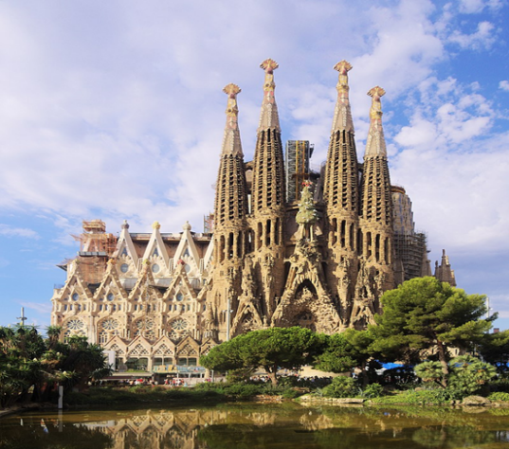
“The Troubling Trifecta”
(Zechariah 10)

Now therefore, if you will indeed obey My voice and keep My covenant, then you shall be a special treasure to Me above all people; for all the earth is Mine. And you shall be to Me a kingdom of priests and a holy nation.’ (Exodus 19:5-6; NKJV)

This people I have formed for Myself; they shall declare My praise. (Isaiah 43:21; NKJV)

But you are a chosen generation, a royal priesthood, a holy nation, His own special people, that you may proclaim the praises of Him who called you out of darkness into His marvelous light; (I Peter 2:9; NKJV) “…having a form of godliness but denying its power,… (I Timothy 3:5a; NKJV)

Verse 1 – “Ask the Lord for rain in the time of the latter rain. The Lord will make flashing clouds; He will give them showers of rain, grass in the field for everyone.”

Verse 2-3 (our key verses) –”For the idols speak delusion; the diviners envision lies, and tell false dreams; they comfort in vain. Therefore the people went their way like sheep; they are in trouble because there is no shepherd. My anger is kindled against the shepherds, and I will punish the goatherd. For the Lord of hosts will visit His flock, the house of Judah, and will make them as His royal horse in the battle.

- ABBERANT SPIRITS
- ARROGANT SEERS
- ABSENT SHEPHERDS

- ABBERANT SPIRITS - “The idols speak dilusion”

‘awen (Heb.) = Iniquity, vanity, - their assurances and comfort were empty and useless.

For I will pour water on him who is thirsty, and floods on the dry ground; I will pour My Spirit on your descendants, and My blessing on your offspring; they will spring up among the grass like willows by the watercourses.’ (Isaiah 44:3-4; NKJV)

- ARROGANT SEERS – “The diviners envision lies and tell false dreams, they comfort in vain”

The diviners (those priests, pagan religious practitioners and leaders to whom an appeal was made concerning the future) were always met with disappointment because…

But our God is in heaven; He does whatever He pleases. Their idols are silver and gold, the work of men’s hands. They have mouths, but they do not speak; eyes they have, but they do not see; they have ears, but they do not hear; noses they have, but they do not smell; they have hands, but they do not handle; feet they have, but they do not walk; nor do they mutter through their throat. Those who make them are like them; so is everyone who trusts in them. (Psalm 115:3-8; NKJV)

The idols of the nations are silver and gold, the work of men’s hands. They have mouths, but they do not speak; eyes they have, but they do not see; they have ears, but they do not hear; nor is there any breath in their mouths. Those who make them are like them; So is everyone who trusts in them. (Psalm 135:15-18; NKJV) …Basically, you are what you worship!!!

“…in flaming fire taking vengeance on those who do not know God, and on those who do not obey the gospel of our Lord Jesus Christ. These shall be punished with everlasting destruction from the presence of the Lord and from the glory of His power, when He comes, in that Day, to be glorified in His saints and to be admired among all those who believe, because our testimony among you was believed. Therefore, we also pray always for you that our God would count you worthy of this calling and fulfill all the good pleasure of His goodness and the work of faith with power, that the name of our Lord Jesus Christ may be glorified in you, and you in Him, according to the grace of our God and the Lord Jesus Christ.” (II Thessalonians 1:8-12; NKJV)

- ABSENT SHEPHERDS – “They are in trouble because there are no shepherds”.

All the previous calamities stemmed from the fact that there was no shepherd – no true messenger of God who would proclaim to them the truth of Jehovah. The nation rejected the ministries of the pre-exilic prophets and turned instead to idols and diviners who deceived them. What Zechariah’s message her emphasizes is that Israel would realize these 6 blessings as being God’s oracle and representation in the world…

The six blessings that Zechariah speaks about for Israel’s ultimate fulfillment of their destiny!!!!!
- 1st Blessing – to be blessed of Jehovah (ch. 8)
- 2nd Blessing – to be a blessing to all those around God’s People
- 3rd Blessing – Complete deliverance from idolatrous practices
- 4th Blessing – (vss. 4-7) – Deliverance by the Deliverer: Messiah’s prominence and stability
- 5th Blessing - (vss. 8-11) - Restoration
- 6th Blessing – (vs. 12) - National Redemption

We end with the scripture that we looked at earlier this evening…

But you are a chosen generation, a royal priesthood, a holy nation, His own special people, that you may proclaim the praises of Him who called you out of darkness into His marvelous light; (I Peter 2:9; NKJV)

This is how God plans to effect His Program in this world to reveal His Person, Presence, and Purpose!!!

