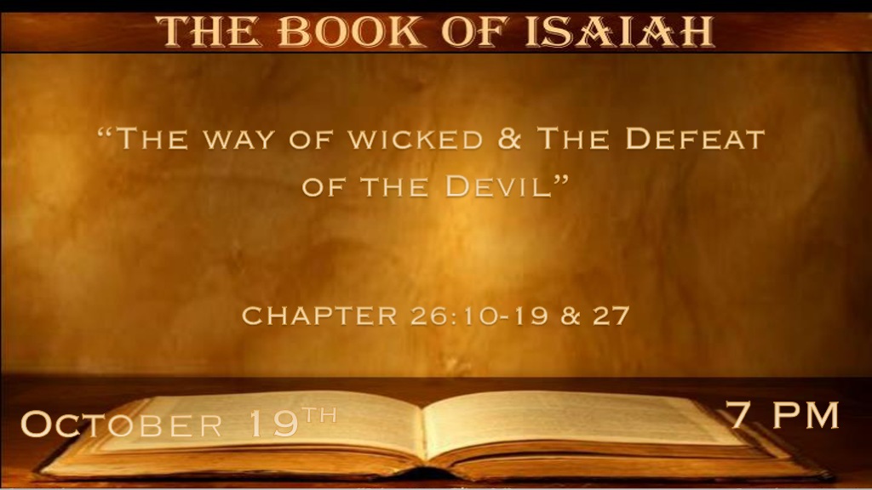

*Grace to the wicked and promises to a humble heart.

*Isaiah 26:10 Let grace be shown to the wicked, yet he will not learn righteousness; In the land of uprightness he will deal unjustly, and will not behold the majesty of the LORD. 11 LORD, when Your hand is lifted up, they will not see. But they will see and be ashamed for their envy of people; Yes, the fire of Your enemies shall devour them. 12 LORD, You will establish peace for us, for you have also done all our works in us. 13 O LORD our God, masters besides you have had dominion over us; But by You only we make mention of Your name. 14 They are dead, they will not live; They are deceased, they will not rise. Therefore You have punished and destroyed them and made all their memory to perish. 15 You have increased the nation, O LORD, you have increased the nation; You are glorified; You have expanded all the borders of the land. 16 LORD, in trouble they have visited You, they poured out a prayer when Your chastening was upon them. 17 As a woman with child is in pain and cries out in her pangs, when she draws near the time of her delivery, so have we been in Your sight, O LORD. 18 We have been with child, we have been in pain; We have, as it were, brought forth wind; We have not accomplished any deliverance in the earth, nor have the inhabitants of the world fallen.

- V:10-11 Wickedness rejects righteousness. God’s hand is invisible to them.
Wicked people are unjust/biased the evil in their life controls them.
On judgment day they are reserved for the fire.

- V:12-14 God does all the work in us. The masters besides God are the false gods of this world who have dominion over us until God delivers us from them.
This is a foreshadowed of the work of Grace.
If you don’t allow God’s work in your life. There is no promise of the resurrection from the dead for you. Only punishment and destruction wait for those who reject God.

- V:15-18 The Promise to Israel.
- The increase of the Nation is taking back to the Abraham covenant that will be fulfilled in the millennial reign of Jesus.
- Israel’s struggles and as they come to the last days it is described as a woman in childbirth.

* The Rapture in the Old Testament.

*Isaiah 26:19 Your dead shall live; Together with my dead body they shall arise. Awake and sing, you who dwell in dust;
For your dew is like the dew of herbs, And the earth shall cast out the dead. 20 Come, my people, enter your chambers,
And shut your doors behind you; Hide yourself, as it were, for a little moment, until the indignation is past. 21 For behold, the LORD comes out of His place to punish the inhabitants of the earth for their iniquity; The earth will also disclose her blood,
and will no more cover her slain.

- V:19 Those who dwell in the dust are resurrected.
1st Thessalonians 4:16 The dead in Christ rise first.
1st Corinthians 15:52 The dead are raised as imperishable and we that alive are changed in the twinkle of an eye.

- V:20-21 We enter our rooms as we hear the word “Come”. John 14:1-6
Until the wrath has passed.
This is the prophecy of Jesus' promise to his disciples.
Confirms we are not here for the wrath.

*The Defeat of the Beast and the Devil as God establishes His Kingdom.

*Isaiah 27:1 In that day the LORD with His severe sword, great and strong, will punish Leviathan (beast) the fleeing serpent,
Leviathan that twisted serpent; And He will slay the reptile that is in the sea. 2 In that day sing to her, “A vineyard of red wine!
3 I, the LORD, keep it, I water it every moment; Lest any hurt it, I keep it night and day. 4 Fury is not in Me. Who would set briers and thorns against Me in battle? I would go through them, I would burn them together. 5 Or let him take hold of My strength, that he may make peace with Me; And he shall make peace with Me.” 6 Those who come He shall cause to take root in Jacob; Israel shall blossom and bud, and fill the face of the world with fruit. 7 Has He struck Israel as He struck those who struck him? Or has He been slain according to the slaughter of those who were slain by Him? 8 In measure, by sending it away, you contended with it. He removes it by His rough wind in the day of the east wind. 9 Therefore by this the iniquity of Jacob will be covered; And this is all the fruit of taking away his sin: When he makes all the stones of the altar like chalkstones that are beaten to dust, wooden images and incense altars shall not stand. 10 Yet the fortified city will be desolate, the habitation forsaken and left like a wilderness; There the calf will feed, and there it will lie down and consume its branches. 11 When its boughs are withered, they will be broken off; The women come and set them on fire. For it is a people of no understanding;
Therefore He who made them will not have mercy on them, and He who formed them will show them no favor. 12 And it shall come to pass in that day that the LORD will thresh, from the channel of the River to the Brook of Egypt; And you will be gathered one by one, O you children of Israel. 13 So it shall be in that day: The great trumpet will be blown; They will come, who are about to perish in the land of Assyria, and they who are outcasts in the land of Egypt and shall worship the LORD in the holy mount at Jerusalem.

- V:1 The Sword of God. The Lord’s sword is a common theme in Isaiah 34:5-6 & 66:16
*Psalm 17:13 Arise, O LORD, Confront him, cast him down; Deliver my life from the wicked with Your sword.
Genesis 3:24 is the 1st time a flaming sword is mentioned.
It is also found in Deuteronomy. Numbers, Joshua, and Judges.
In the New Testament, we learn the sword is the Word of God; Isaiah says, it is hard/severe, great, and strong.
God will punish the devil.

- V:2-6 The vine that God kept and prophecy.
God kept it, watered it, and watched over Israel day and night.
God will blossom Israel once again was the promise and it is fulfilled. Filling the face of the world with fruit. The fruit of the knowledge of God and Israel literally became an exporter of the fruit.
God again declares it is by fire He will purge those that came against Him and Israel.

- V:7-9 The Kingdom brings judgment and mercy.
God disciplines Israel and yet gives it mercy for it could have surely been destroyed.

- V:10-11 The judgment against the World’s system.
The system is Anti-Christ and the Anti-Christ power is destroyed.

- V:12-13 The regathering of all and worship in Jerusalem.
We see the sequence once again the world and Israel are gathering in the millennial reign in Jerusalem.

