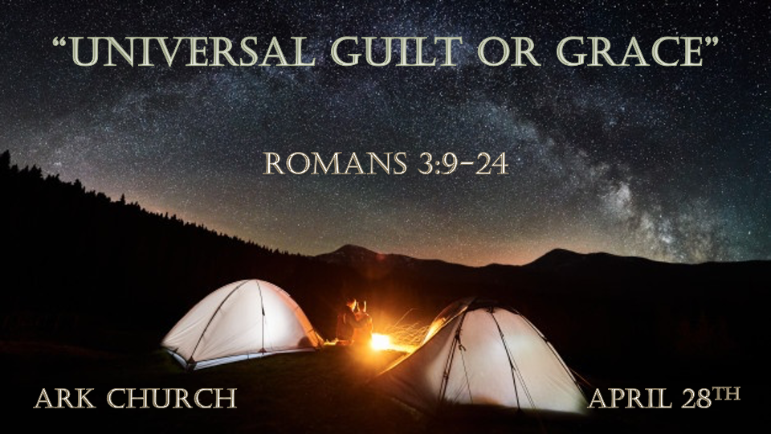

*Romans is a Book about Two Camps. 1^{st Camp} is a complete diagnosis of sin, and the 2^{nd Camp} is the solution through salvation.

- Chapters 1-3 The predicament of educated pagans, moral, and religious people.
Without God, humanity has no hope.

- The Age of Darkness is in a battle with the Age of Light.

The darkness is apparent to those who have the light of Christ.

*All are Guilty and are Under Sin's Power.

*Romans 3:9 What then? Are we better than they? Not at all. For we have previously charged both Jews and Greeks that they are all under sin.
10 As it is written: "There is none righteous, no, not one; 11 There is none who understands; There is none who seeks after God.
12 They have all turned aside; They have together become unprofitable; There is none who does good, no, not one."
13 "Their throat is an open tomb; With their tongues they have practiced deceit";
"The poison of asps is under their lips"; 14 "Whose mouth is full of cursing and bitterness."
15 "Their feet are swift to shed blood; 16 Destruction and misery are in their ways; 17 And the way of peace they have not known."
18 "There is no fear of God before their eyes."
19 Now we know that whatever the law says, it says to those who are under the law, that every mouth may be stopped, and all the world may become guilty before God. 20 Therefore by the deeds of the law no flesh will be justified in His sight, for by the law is the knowledge of sin.

- V:9-11 There are no exemptions or self-righteous people. (A greater awareness of our sinfulness is needed. This awareness allows us to see our need for The Savior Jesus Christ.)
Chapter One: the person's education level apart from God will only dam them in their foolishness.
Chapter Two is about the moral person who understands the law and is not free from sin. H
Chapter Three The religious person who benefits from knowing about God is much like the educated pagan. They are not safe in their knowledge. The devil has vast knowledge of God but doesn't obey Him.

*V:10 There is none righteous, no, not one; There is none who understands; There is none who seeks after God.

- V:12-17 Rotten fruit will never bring a profit. We are all unprofitable in our untransformed life to the Kingdom of God.
What does it profit a person if they gain the whole world yet lose their soul?
The word unprofitable means rotten fruit.
Their throat is an open tomb: The references are from the Psalms, and Paul calls every part of the human body into guilt. We are filled with sin and rebellion against God.

- V:18-20 There is no fear of God in their eyes.
The fear of the Lord is the beginning of Wisdom.

Fearing God, you will boast about the things of God, not the things of this world. Let them that boast that know and understand God who exercises Loving, Kindness. 2 Cor. 10:17 & Jeremiah 9:23-24 "Let not the wise man glory in his wisdom,
Let not the mighty man glory in his might,
Nor let the rich man glory in his riches;
24 But let him who glories glory in this,
That he understands and knows Me,
That I am the LORD, exercising lovingkindness, judgment, and righteousness in the earth.
For in these I delight," says the LORD.

*The Revelation of the Almighty God.
*Romans 3:21 But now the righteousness of God apart from the law is revealed, being witnessed by the Law and the Prophets, 22 even the righteousness of God, through faith in Jesus Christ, to all and on all who believe. For there is no difference; 23 for all have sinned and fall short of the glory of God, 24 being justified freely by His grace through the redemption that is in Christ Jesus, 25 whom God set forth as a propitiation by His blood, through faith, to demonstrate His righteousness, because in His forbearance God had passed over the sins that were previously committed, 26 to demonstrate at the present time His righteousness, that He might be just and the justifier of the one who has faith in Jesus.
27 Where is boasting then? It is excluded. By what law? Of works? No, but by the law of faith. 28 Therefore we conclude that a man is justified by faith apart from the deeds of the law. 29 Or is He the God of the Jews only? Is He not also the God of the Gentiles? Yes, of the Gentiles also, 30 since there is one God who will justify the circumcised by faith and the uncircumcised through faith. 31 Do we then make void the law through faith? Certainly not! On the contrary, we establish the law.

- V:21-26 The revelation of our need and it being fully met.
*Justified: This is the image of the legal system requirement being met. The court says it's paid in full.

*Redemption: This is the image from the slave market. Our freedom was bought to be free indeed.

*Propitiation: It is the image of satisfying a just Creator with the proper sacrifice. The religious person could never sacrifice to the level of complete satisfaction of God.
The Substitute Sacrifice Our God wasn't seeking satisfaction, but He initiated it! The Creator set for the redemption of the creation.

- V:27-28 The Law of Faith

Faith is not trusting in God to do something. It's the faith in what has already been done.

- V:29-32 Faith understands the need for the law and will establish it.

The law knew justification was coming.

By faith, we understand the law's purpose and place in society.

Beware, there is a spirit in the land! It's the spirit of lawlessness.

