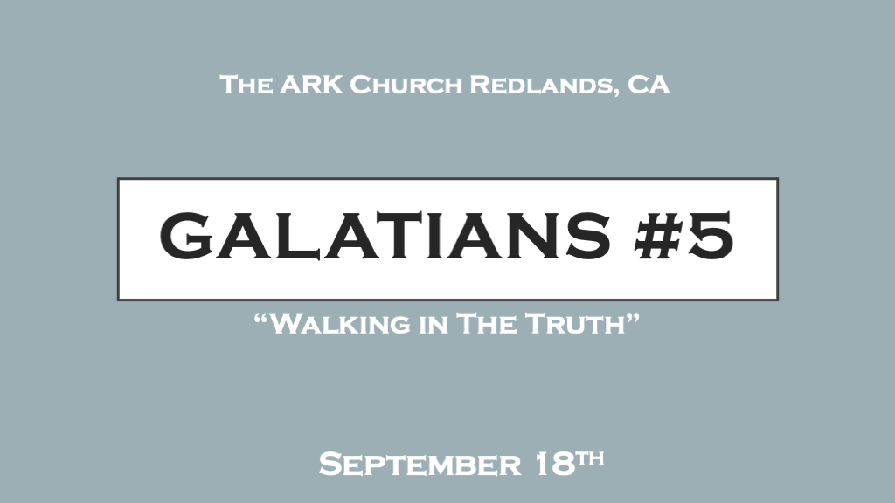

There are many different styles in a person’s walk there’s only one style of truth.

*Don’t live separated from the truth.
*Galatians 5:1 Stand fast therefore in the liberty by which Christ has made us free, and do not be entangled again with a yoke of bondage. 2 Indeed I, Paul, say to you that if you become circumcised, Christ will profit you nothing. 3 And I testify again to every man who becomes circumcised that he is a debtor to keep the whole law. 4 You have become estranged from Christ, you who attempt to be justified by law; you have fallen from grace. 5 For we through the Spirit eagerly wait for the hope of righteousness by faith. 6 For in Christ Jesus neither circumcision nor uncircumcision avails anything, but faith working through love.

- V:1 A shaky truth is how we all start.
Once you start walking in the truth your confidence and stability should never be reversed.
There are seasons when we can become bedridden, but never decide to stay in bed on purpose.

- V:2-4 Absolute Truth is never based on religion, person, or institution. (Judaism)
When the truth is based on religion, those over the religion can move the goalpost.

Falling from Grace can be simply you are stumbling or it could mean you are rejecting grace.
Values are altered and realities are changed all because there is absolute truth and grace.

- V:5-6 Waiting is a part of the development of the Spirit-filled life.
*Waiting is essential to our maturation process. A good sauce often has to simmer to bring the flavor to its fullest.

V:6 Give the reason for the delay its faith working through love. It’s the development of the relationship.
This is the law vs love.
The difference between the people who love their country and a law-abiding citizens. Maid vs wife, protector vs husband, or the day of the Lord is the sabbath and every day is the Lord’s day.

*Moral and Spiritual Relativity are Destroying Society.

*Galatians 5:7 You ran well. Who hindered you from obeying the truth? 8 This persuasion does not come from Him who calls you. 9 A little leaven leavens the whole lump. 10 I have confidence in you, in the Lord, that you will have no other mind; but he who troubles you shall bear his judgment, whoever he is.
11 And I, brethren, if I still preach circumcision, why do I still suffer persecution? Then the offense of the cross has ceased. 12 I could wish that those who trouble you would even cut themselves off!
13 For you, brethren, have been called to liberty; only do not use liberty as an opportunity for the flesh, but through love serve one another. 14 For all the law is fulfilled in one word, even in this: “You shall love your neighbor as yourself.” 15 But if you bite and devour one another, beware lest you be consumed by one another!

- V:7-11 Hindrances to truth are everywhere.
*Truth is now what is true for the individual. And if one’s personal truth contradicted reality, then it was the reality that would have to be bent into conformity. ~Cahn, Jonathan. The Return of the Gods (pp. 48-49).

Those that lead a society to the destruction of absolute truth are on their way to eternal judgment.

- V:12-13 Liberty is not a license to sin.
The mature understand the power of the flesh. They respect it, they don’t make statements like; “I will never do that!” We know but for the grace of God and the discernment of the Holy Spirit, we are capable of anything.

- V:14-15 What you should be willing to be consumed by is God’s love.
This is not romantic love it will bite one another regularly.
This is not brotherly love
This is not parental love

*Walking in the Spirit is more advanced than walking in the truth.
*Galatians 5:16 I say then: Walk in the Spirit, and you shall not fulfill the lust of the flesh. 17 For the flesh lusts against the Spirit, and the Spirit against the flesh; and these are contrary to one another, so that you do not do the things that you wish. 18 But if you are led by the Spirit, you are not under the law.
19 Now the works of the flesh are evident, which are: adultery, fornication, uncleanness, lewdness, 20 idolatry, sorcery, hatred, contentions, jealousies, outbursts of wrath, selfish ambitions, dissensions, heresies, 21 envy, murders, drunkenness, revelries (orgies), and the like; of which I tell you beforehand, just as I also told you in time past, that those who practice such things will not inherit the kingdom of God.

- V:16-17 The war of two different walks. Walk in the Spirit and you will not fulfill the flesh!
Whenever we give excuses for our flesh, natural, or human response we are justifying something that is against the spirit.

- V:18 The leading of the Holy Spirit.
- *Counterfeit leadings always center on a human agenda instead of God’s kingdom.
- * Genuine leadings are often humbling, overtly other-centered, and holy.

- V:19-21 Walking in the flesh could cost you more in this world and the next than you want to pay.

*Uncleanness and Lewdness are sensual sins. Involving what you are watching and listening to.

*Hatred, contentions (Discord), and jealousy are sins against people and against the command to love one another.

*Outburst of wrath, selfish ambitions, dissensions (Rebellion), and envy are sins against people and the root is in the sin of pride.

*Heresies are sins against the truth of God, His Word, history, and humanity.

*The list is not exhaustive but there is a complete remedy for all of this Jesus.

Communion is the sacrament that says remember this is all covered!

