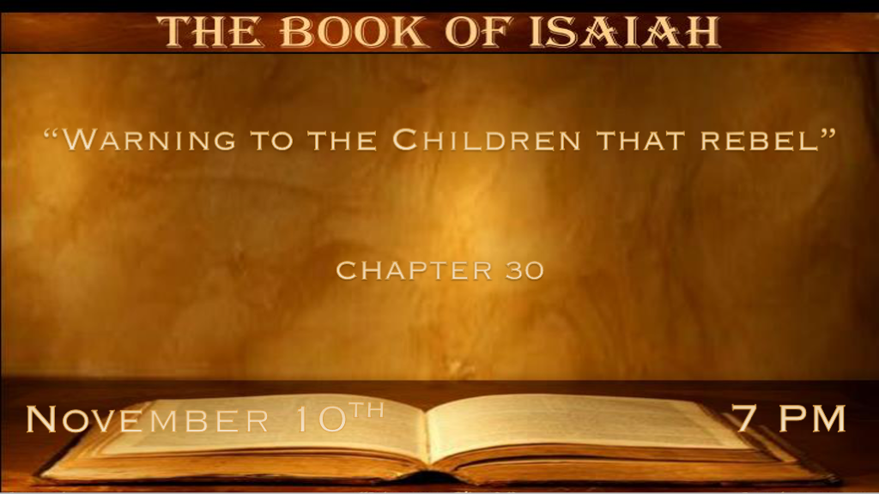

*The depravity of a rebellious generation is revealed by who they turn to.

*Isaiah 30:1 “Woe to the rebellious children,” says the LORD, “Who take counsel, but not of Me, and who devise plans, but not of My Spirit, that they may add sin to sin; 2 Who walk to go down to Egypt, and have not asked My advice, to strengthen themselves in the strength of Pharaoh, and to trust in the shadow of Egypt! 3 Therefore the strength of Pharaoh shall be your shame, and trust in the shadow of Egypt shall be your humiliation. 4 For his princes were at Zoan, and his ambassadors came to Hanes. 5 They were all ashamed of a people who could not benefit them, or be help or benefit, but a shame and also a reproach.” 6 The burden against the beasts of the South. Through a land of trouble and anguish, from which came the lioness and lion, the viper and fiery flying serpent,
they will carry their riches on the backs of young donkeys, and their treasures on the humps of camels, to a people who shall not profit;
7 For the Egyptians shall help in vain and to no purpose. Therefore I have called her Rahab-Hem-Shebeth.

- V:1-3 Warning to the rebellious Children. Historically this is God speaking to Israel when they turned to Egypt for help during the time of the Assyrian Empire.
- *Taking counsel from those that would hold you captive. Egypt represents to us those that rejected the ways of God and devise their plans on the counsel of the ungodly.

- *Sin adds to sin: This two-fold process they’ve turned away from God and at a time of trouble they seek wisdom from those who can do nothing to them but shame & reproach.

- *The result: Those that you turned to instead of God, for their perceived strength shall lead you to your shame.

- V:4-7 A land that is troubled and anguished and they call on the do-nothing people to help.

*A generation that doesn’t want to see & begs us not to declare what’s right!

*Isaiah 30:8 Now go, write it before them on a tablet, and note it on a scroll, that it may be for time to come, forever and ever: 9 That this is a rebellious people, lying children, children who will not hear the law of the LORD; 10 Who say to the seers, “Do not see,” and to the prophets, “Do not prophesy to us right things; Speak to us smooth things, prophesy deceits. 11 Get out of the way, turn aside from the path, cause the Holy One of Israel to cease from before us.” 12 Therefore thus says the Holy One of Israel: “Because you despise this word, and trust in oppression and perversity, and rely on them, 13 Therefore this iniquity shall be to you like a breach ready to fall, a bulge in a high wall, whose breaking comes suddenly, in an instant. 14 And He shall break it like the breaking of the potter’s vessel, which is broken in pieces; He shall not spare. So there shall not be found among its fragments a shard to take fire from the hearth, or to take water from the cistern.” 15 For thus says the Lord GOD, the Holy One of Israel: “In returning and rest you shall be saved; In quietness and confidence shall be your strength.” But you would not, 16 And you said, “No, for we will flee on horses”—Therefore you shall flee! And, “We will ride on swift horses”—Therefore those who pursue you shall be swift! 17 One thousand shall flee at the threat of one, at the threat of five you shall flee, till you are left as a pole on top of a mountain and as a banner on a hill.

- V:8-13 The absolutes in this judgment are staggering.
*Write on a tablet: Nail it down we must be a people who have the answers that are absolutes.

That generation parallels this one. Rebellious people, lying children that will not hear the law of God. They despised the prophetic word and wanted to be spoken to them the things that only soothe them.

Therefore God declares that their iniquity is filled with oppression and perversity. Their judgment will come suddenly or in an instant.

- V:14-17 God reveals He is the Potter that the clay rejected.
*As God destroys their falsehood there will be no fragment of the lie that will hold water.

V:15 Revealed the path that all needed then and that we all need now. In returning and rest you shall be saved! There is a confidence that God holds open the path of salvation but it is a narrow way!

*Sadly, many will continue to run from God and be destroyed as they were in the time period we see in Isaiah.

*The Call is to Trust in God’s Timing!

*Isaiah 30:18 Therefore the LORD will wait, that He may be gracious to you; And therefore He will be exalted, that He may have mercy on you. For the LORD is a God of justice; Blessed are all those who wait for Him. 19 For the people shall dwell in Zion at Jerusalem; You shall weep no more. He will be very gracious to you at the sound of your cry; When He hears it, He will answer you. 20 And though the Lord gives you the bread of adversity and the water of affliction, yet your teachers will not be moved into a corner anymore, but your eyes shall see your teachers. 21 Your ears shall hear a word behind you, saying, “This is the way, walk in it,” whenever you turn to the right hand or whenever you turn to the left. 22 You will also defile the covering of your images of silver, and the ornament of your molded images of gold. You will throw them away as an unclean thing; You will say to them, “Get away!” 23 Then He will give the rain for your seed with which you sow the ground, and bread of the increase of the earth; It will be fat and plentiful. In that day your cattle will feed in large pastures. 24 Likewise the oxen and the young donkeys that work the ground will eat cured fodder, which has been winnowed with the shovel and fan. 25 There will be on every high mountain and on every high hill rivers and streams of waters, In the day of the great slaughter, when the towers fall. 26 Moreover the light of the moon will be as the light of the sun, and the light of the sun will be sevenfold, as the light of seven days,
In the day that the LORD binds up the bruise of His people and heals the stroke of their wound.

- V:18-22 Blessed are those who wait for Him.
The promises are V:18 Grace and Mercy, V:19 No more weeping & Dwelling in Jerusalem, V:20 We won’t always be off in the corner, V:21 We will hear “This is the way, walk in it.” And V:22 We will cast off everything that hinders us even money!

- V:23-26 In that day we see a glimpse of the future.

*The Lord’s return and we shall hear His voice.

*Isaiah 30:27 Behold, the name of the LORD comes from afar, burning with His anger, and His burden is heavy; His lips are full of indignation, and His tongue like a devouring fire. 28 His breath is like an overflowing stream, which reaches up to the neck, to sift the nations with the sieve of futility; and there shall be a bridle in the jaws of the people, causing them to err. 29 You shall have a song as in the night when a holy festival is kept, and gladness of heart as when one goes with a flute, to come into the mountain of the LORD, to the Mighty One of Israel. 30 The LORD will cause His glorious voice to be heard, and show the descent of His arm, with the indignation of His anger and the flame of a devouring fire, with scattering, tempest, and hailstones. 31 For through the voice of the LORD Assyria will be beaten down, as He strikes with the rod. 32 And in every place where the staff of punishment passes, which the LORD lays on him, it will be with tambourines and harps; And in battles of brandishing He will fight with it. 33 For Tophet was established of old, yes, for the king it is prepared. He has made it deep and large; Its pyre is fire with much wood; The breath of the LORD, like a stream of brimstone, kindles it.

- V:27-28 The second coming of Jesus and His deliverance.
*Jesus' second coming is dynamic and powerful over all that is evil.

- V:29-33 The mixture of the Lord’s voice and His might.
*After a time period where there are so many voices a clarity of the Lord’s glorious voice is heard.

The Tophet (the garbage dump where the fire never goes out) is on the outskirts of Jerusalem. This is the image of hell and judgment for the wicked. Jesus' breath gives life to all who accept Him and death to all who reject Him.

