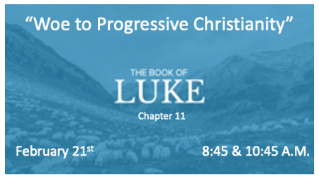

Do you believe God’s Kingdom is Coming?

*Luke 11:1-2 One day Jesus was praying in a certain place. When he finished, one of his disciples said to him, "Lord, teach us to pray, just as John taught his disciples."

2 He said to them, "When you pray, say:" 'Father, hallowed be your name, your kingdom come. 2 (KJV) And he said unto them, When ye pray, say, Our Father which art in heaven, Hallowed be thy name. Thy kingdom come. Thy will be done, as in heaven, so in earth.

*Luke 11:9 (KJV) And I say unto you, Ask, and it shall be given you; seek, and ye shall find; knock, and it shall be opened unto you.

*Luke 11:13 If you then, though you are evil, know how to give good gifts to your children, how much more will your Father in heaven give the Holy Spirit to those who ask him!"

Praying Kingdom Prayers

- V:2 God’s kingdom, and will, are always be done in heaven. We are to declare it done here on earth. (Christians are not being taught how to pray, but why?)
- V:1 We learn something about John the Baptist that only Luke tells us.
- V:5-10 Kingdom prayers have three elements: Jesus says it is seeking, asking, and knocking. He gives a promise: Seek and you fill find. Ask and you will receive. Knock and the door will be open.
- V:11-13 Earthly fathers give properly to their children earthly things. Our heavenly Father will give those things too, along with His Spirit and His Kingdom.

*Luke 11:14 Jesus was driving out a demon that was mute. When the demon left, the man who had been mute spoke, and the crowd was amazed.
*Luke 11:17 Jesus knew their thoughts and said to them: "Any kingdom divided against itself will be ruined, and a house divided against itself will fall.

*Luke 11:26 Then it goes and takes seven other spirits more wicked than itself, and they go in and live there. And the final condition of that person is worse than the first."

Divided Kingdoms Lack Power

- V:14-26 Kingdom power is available for all who seek or ask for it. Leaving your religious thinking and accepting kingdom principles as the way to kingdom power.
- Progressive Christians don’t believe in miracles or the supernatural power of God in today’s world. (Like the Pharisees in Luke who couldn’t figure out how Jesus healed a young man with a demonic spirit that kept him mute).
- V:17 The Church is a divided kingdom in the 21st century.
- V:26 Progressive Christians, they seek cleansing (forgiveness) but avoid the Holy Spirit. They are being filled with other spirits that inhabit their empty lives. The spirit of academia, homosexuality, cultural deception, church tradition, unspiritual reasoning, unsanctified science, and the spirit of social equality.

Foolishness and Six Woes to Progressive Christianity
(Luke 11:37-54)

Key verse: Luke 11:35 See to it, then, that the light within you is not darkness.

- V:42 Woe to the Progressive Christian who teaches cultural, social, and racial justice, but neglects God’s justice.
- V:43 Woe to the Progressive Christian. You desire a respectful seat in the marketplace, but you have traded your seat within the kingdom of God for it.
- V:44 Woe to you Progressive Christian. You are an unmarked grave that many are stumbling over because of your teachings.
- V:46 Woe to you Progressive Christian. You burden this generation with so much confusion and you will not lift a finger to help them.
- V:47-51 Woe to you Progressive Christian. You exalt your New Testament Church leaders & Saints, yet you kill their witness and discredit their names with your apostate teachings.
- V: 52 "Woe to you experts (Progressives) in the law, because you have taken away the key to knowledge. You yourselves have not entered, and you have hindered those who were entering."

