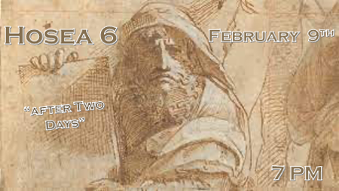

*Hosea chapter 6 parallels the issues we as believers face in our world today.

*Hosea 5:15 (KJV) I will go and return to my place, till they acknowledge their offence, and seek my face: in their affliction they will seek me early. (Earnestly)

- Israel must earnestly seek Jesus as a prerequisite before His second coming.
- The Devil is trying to destroy the people before they can repent.

*Hosea 6:1 "Come, let us return to the LORD. He has torn us to pieces but he will heal us; he has injured us but he will bind up our wounds.

2 After two days he will revive us; on the third day he will restore us, that we may live in his presence.

3 Let us acknowledge the LORD; let us press on to acknowledge him. As surely as the sun rises, he will appear; he will come to us like the winter rains, like the spring rains that water the earth."

4 "What can I do with you, Ephraim? What can I do with you, Judah? Your love is like the morning mist, like the early dew that disappears.

5 Therefore I cut you in pieces with my prophets, I killed you with the words of my mouth—then my judgments go forth like the sun.
6 For I desire mercy, not sacrifice, and acknowledgment of God rather than burnt offerings.

*The resurrection of the people of God.

- V:1 God judges his people/church before he judges the world. Better to be judged here on earth than at the great white throne.

- V:2 A single day in the Bible often represents a single year of our time and also a thousand years.
  - *Psalm 90:4 & 2 Peter 3:8 A thousand years in your sight are like a day that has just gone by.
  - *Daniel 9:27 He will make a firm covenant with the many for one week.
  - *Romans 11:25-32 Until the fullness of the Gentiles has come in and in this way, all of Israel will be saved.

- V:2 This verse could have a double meaning within it. One for Israel and one for the Church. You decide.

- V:3 Gives a certainty of the main event in verse 2; as certain as the sun rises in the morning this is going to happen.
  - Two periods are referenced, the winter, and the spring rains.
  - Are these two events attached in some way?

- V:4-5 What should God do with Israel/Church? Your loyalty is fleeting; therefore I will sift you with my Word (His mouth). The judgments of God are tools to prepare us for his return.

- V:6 Jesus quotes this verse in Matthew 12:7 and questions the religious leaders about their confidence in knowing the heart of God.

*Hosea 6:7 As at Adam, they have broken the covenant; they were unfaithful to me there.

8 Gilead is a city of evildoers, stained with footprints of blood.

9 As marauders lie in ambush for a victim, so do bands of priests; they murder on the road to Shechem, carrying out their wicked schemes.

10 I have seen a horrible thing in Israel: There Ephraim is given to prostitution, Israel is defiled.

11 "Also for you, Judah, a harvest is appointed. "Whenever I would restore the fortunes of my people.

*A harvest is appointed for who?

- V:7 There is no harvest for the unfaithful. The phrase at Adam is a Holy Spirit wordplay for the fallen humanity, it is also a reference to the lack of faith at the place where Joshua crossed the Jordan and those that stayed behind.

- V:8 There is no harvest for those who centered their lives on wicked deeds. Gilead was such a city.

- V:9-10 No harvest for those who took consent (Shechem) to do works of evil and lewdness.

- V:11 The Harvest is for those who have received a new bloodline through Salvation in Christ Jesus.

