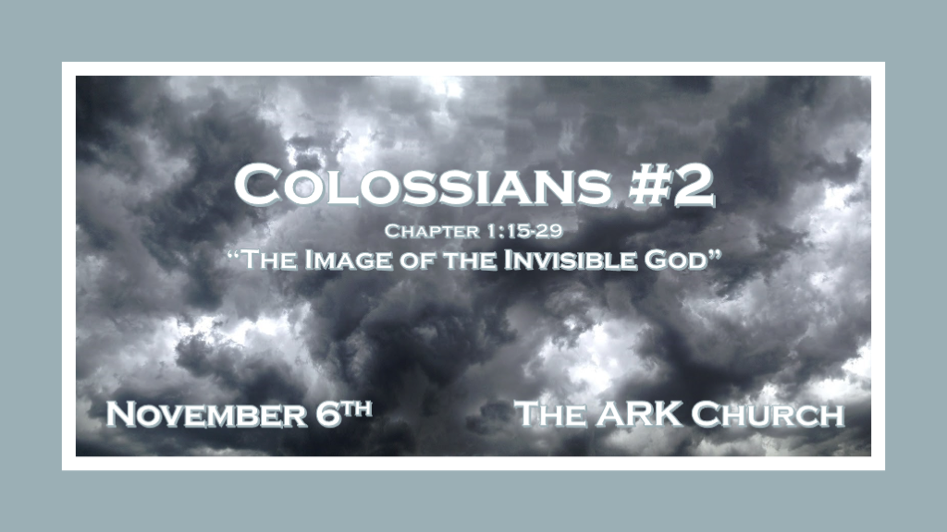

Review: Humans, religions, and earthly knowledge have always attacked the deity of Jesus Christ. This is what is happening in the Church of Colosse and is happening today in the modern Church world with the Laodicea spirit.

*Human intelligence and the invisible world.

*Colossians1:15 He is the image of the invisible God, the firstborn over all creation. 16 For by Him all things were created that are in heaven and that are on earth, visible and invisible, whether thrones or dominions or principalities or powers. All things were created through Him and for Him. 17 And He is before all things, and in Him all things consist. 18 And He is the head of the body, the church, who is the beginning, the firstborn from the dead, that in all things He may have the preeminence.

- Humanity is fascinated with the invisible world; Much more so than they are with God.

*Isaiah 29:15-16 Woe to those who seek deep to hide their counsel far from the LORD, and their works are in the dark; They say, “Who sees us?” and, “Who knows us?” 16 Surely you have things turned around! Shall the potter be esteemed as the clay; For shall the thing made say of him who made it, “He did not make me”? Or shall the thing formed say of him who formed it, “He has no understanding”?

We cannot see most of the universe with the naked eye. Yet, we believe in the universal world because of microscopes and telescopes. Like Isaiah’s words, wrongly the creation wants to be esteemed by the Creator.

*There are no instruments to see God. We can only know or experience God through the Son & The Holy Spirit.

- *V:15 Jesus has no human or non-human equal! He is the image of the invisible God because Jesus is God in the flesh.
No other person comes close to who Jesus is and what the Son of God did for humanity.

Image: Expressed two ideas. 1st Likeness, as in the image on a coin or the reflection in a mirror.
2nd Manifestation, with the sense that God is fully revealed in Jesus.

- *The attack is always against Jesus and the work of salvation that is completed. Done!

- *V:16-17 Jesus is the creator of a visible and invisible reality. Jesus has no beginning and no end. Nothing can exist without Him.

- *V:18 Only Jesus (God) is completely sufficient. Yet, the devil and false religions attack Jesus by insisting he is only human.
There’s no true church without Jesus being the head of it. There’s no life or universe without Jesus who holds everything together literally.

*To the agnostic Jesus is the proof so that you can know there is a God.

*Fullness of life and reconciliation comes only through Jesus.

*Colossians 1:19 For it pleased the Father that in Him all the fullness should dwell, 20 and by Him to reconcile all things to Himself, by Him, whether things on earth or things in heaven, having made peace through the blood of His cross.
21 And you, who once were alienated and enemies in your mind by wicked works, yet now He has reconciled 22 in the body of His flesh through death, to present you holy, and blameless, and above reproach in His sight— 23 if indeed you continue in the faith, grounded and steadfast, and are not moved away from the hope of the gospel which you heard, which was preached to every creature under heaven, of which I, Paul, became a minister.

- V:19 Fullness of life isn’t the result of a career, relationships, or money.
The fullness of life is only achieved in this world through Jesus Christ.

- V:20 Reconciliation or peace with God is only made through Jesus Christ.
Reconciliation can also be known as a settlement but is better described as a covenant. Covenant is the initiator that brings the peace offering.

- V:21-23 The transformation is described: We were once alienated and enemies of God and are now adopted by Him.
Jesus presents us to the Father. As holy, blameless, and above reproach.

*Warning don’t replace Jesus with anything or anybody.

*Colossians 1:24 I now rejoice in my sufferings for you and fill up in my flesh what is lacking in the afflictions of Christ, for the sake of His body, which is the church, 25 of which I became a minister according to the stewardship from God which was given to me for you, to fulfill the word of God, 26 the mystery which has been hidden from ages and from generations, but now has been revealed to His saints. 27 To them God willed to make known what are the riches of the glory of this mystery among the Gentiles: which is Christ in you, the hope of glory. 28 Him we preach, warning every man and teaching every man in all wisdom, that we may present every man perfect in Christ Jesus. 29 To this end I also labor, striving according to His working which works in me mightily.

- V:24-26 Every believer is part of a mystery.
A mystery is not a riddle. It is a truth that cannot be known until revelation knowledge from heaven is given. Hidden for ages and from generations but now made known through Jesus' life to the saints.

This is why the Word of God is so powerful you hold revelation knowledge in your hand.

- V:27-28 We warn through preaching and teaching everyone from Biblical wisdom how to receive this hope.
The Church age is a marvelous period of history. It’s soon coming to an end. Don’t labor in this life in vain.

