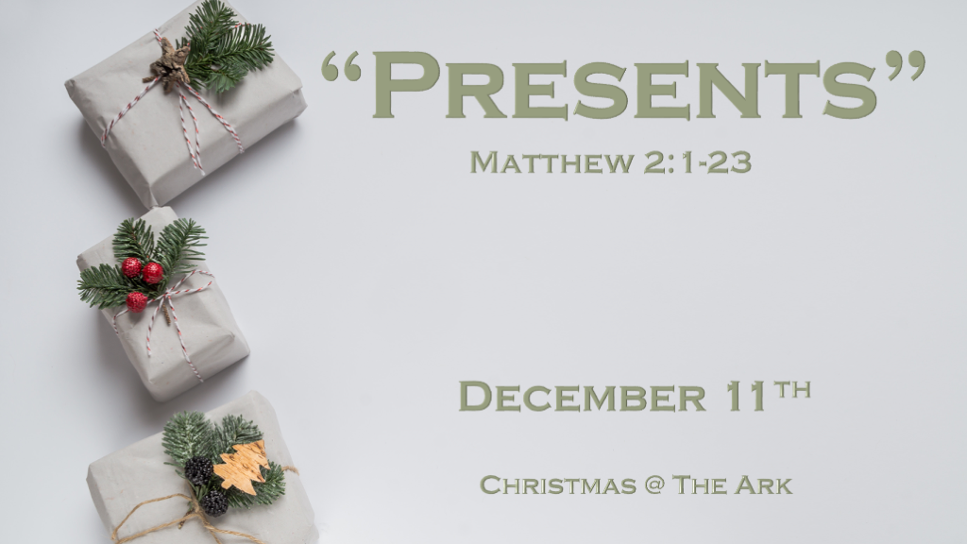

*A Present that was being prepared generations before its time.

*Matthew 2:1 Now after Jesus was born in Bethlehem of Judea in the days of Herod the king, behold, wise men from the East came to Jerusalem, 2 saying, “Where is He who has been born King of the Jews? For we have seen His star in the East and have come to worship Him.” 3 When Herod the king heard this, he was troubled, and all Jerusalem with him. 4 And when he had gathered all the chief priests and scribes of the people together, he inquired of them where the Christ was to be born.
5 So they said to him, “In Bethlehem of Judea, for thus it is written by the prophet:
6 ‘But you, Bethlehem, in the land of Judah,
Are not the least among the rulers of Judah;
For out of you shall come a Ruler
Who will shepherd My people Israel.’ ”

- V:1-2 A gift that took over 500 years for a single generation to be ready to deliver.
It was ordered by God on His Prime delivery service that is always on time. (Daniel Chapter 2)

- V:3 A troubled spirit is hitting again those who have known about Jesus their whole life.
Christians are troubled as they learn the truth about December 25th.
God tucked away redemption in this day and date long before it became a celebration for the pagans.

- V:4-6 God followers who had all the information needed.
Yet, they didn’t go to see the gift to all of humanity. The teachers of the law and Pharisees.
Many Bible teachers are not looking for the gift of His return for His bride.

*Most presents have good intentions while others can have divine ones.

*Matthew 2:7 Then Herod, when he had secretly called the wise men, determined from them what time the star appeared. 8 And he sent them to Bethlehem and said, “Go and search carefully for the young Child, and when you have found Him, bring back word to me, that I may come and worship Him also.”
9 When they heard the king, they departed; and behold, the star which they had seen in the East went before them, till it came and stood over where the young Child was. 10 When they saw the star, they rejoiced with exceedingly great joy. 11 And when they had come into the house, they saw the young Child with Mary His mother, and fell down and worshiped Him. And when they had opened their treasures, they presented gifts to Him: gold, frankincense, and myrrh.

- V:7-8 Some only pretend to have godly intentions.
Herod was a pretender saying he wanted to worship the newborn king.
Herod was a destroyer of the life of children before Jesus was born.

- V:9-10 Divine directions are here again. How many are exceedingly joyful over the signs in the skies?

Just as the Wisemen followed divine signs. We must be followers of signs that are being fulfilled in our lifetime.

- V:11 The gifts that told a story, and gave provision for Joseph and Mary’s future.

The proper gift for a King is gold, for a high priest is Frankincense, and Myrrh is the proper gift given to one who is prepared to die.

*The 1st Christmas was filled with “Divine Warnings” and so is this one.

*Matthew 2:12 Then, being divinely warned in a dream that they should not return to Herod, they departed for their own country another way.
13 Now when they had departed, behold, an angel of the Lord appeared to Joseph in a dream, saying, “Arise, take the young Child and His mother, flee to Egypt, and stay there until I bring you word; for Herod will seek the young Child to destroy Him.”
14 When he arose, he took the young Child and His mother by night and departed for Egypt, 15 and was there until the death of Herod, that it might be fulfilled which was spoken by the Lord through the prophet, saying, “Out of Egypt I called My Son.”
16 Then Herod, when he saw that he was deceived by the wise men, was exceedingly angry; and he sent forth and put to death all the male children who were in Bethlehem and in all its districts, from two years old and under, according to the time which he had determined from the wise men. 17 Then was fulfilled what was spoken by Jeremiah the prophet, saying:
18 “A voice was heard in Ramah,
Lamentation, weeping, and great mourning,
Rachel weeping for her children,
Refusing to be comforted,
Because they are no more.”

- V:12 The Messiah’s 1st & 2nd advents are filled with divine warnings.
Is it a present (gift) from God to be warned?
Our divine warnings came from Jesus himself.
As it was in the days of Noah so shall it be with the coming of the Son of Man.
As it was in the days of Sodom so shall it be with

- V:13-15 Warning about the spirit of death/destruction and the fulfillment of prophecy.

Joseph heeds the warning and takes Jesus and Mary to Egypt. Hosea 11:1
This is the fulfillment of another prophecy about the Messiah.

- V:16-18 A deliverer coming into the world has been a key for evildoers to bring death.

Moses' generation saw the killing of male children by a leader's decree. Evil wants to stop righteousness before it changes the world.

At Jesus' birth, the killing of male children by a leader's decree came again.

Rachel is the mother of Israel's three tribes (Joseph) Ephraim, Manasseh, and Benjamin. Jeremiah 31:15

