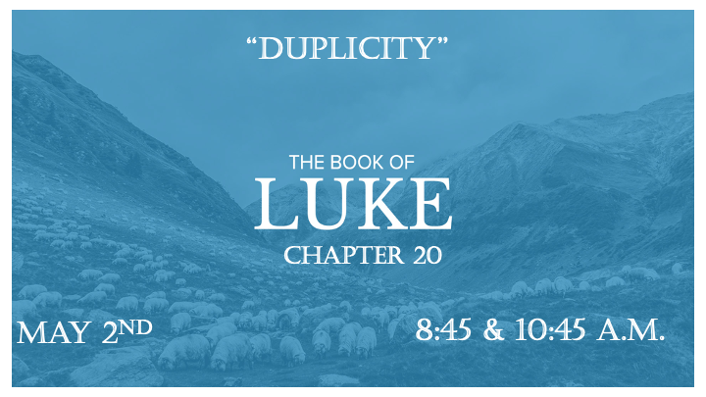

*Does duplicity make a person unstable?

*James 1:8 Such a person is double-minded and unstable in all they do.

*Luke 20:1 One day as Jesus was teaching the people in the temple courts and proclaiming the good news, the chief priests and the teachers of the law, together with the elders, came up to him. 2 "Tell us by what authority you are doing these things," they said. "Who gave you this authority?"
3 He replied, "I will also ask you a question. Tell me: 4 John's baptism—was it from heaven, or of human origin?"
5 They discussed it among themselves and said, "If we say, 'From heaven,' he will ask, 'Why didn't you believe him?' 6 But if we say, 'Of human origin,' all the people will stone us because they are persuaded that John was a prophet."
7 So they answered, "We don't know where it was from."
8 Jesus said, "Neither will I tell you by what authority I am doing these things."

God’s Word, can we choose what sections we believe in it?

- V:1-4 God is not obligated to giving us an answer. Jesus uses a technique of answering a question with a question.

- V:4-8 There are four people groups in this story. The people, the chief priest, teachers of the law, and the elders. Each had a different source for authority.

- Duplicity: a double standard that affects the core of a person. Deceitfulness.

*Luke 20:9 He went on to tell the people this parable: "A man planted a vineyard, rented it to some farmers and went away for a long time. 10 At harvest time he sent a servant to the tenants so they would give him some of the fruit of the vineyard. But the tenants beat him and sent him away empty-handed. 11 He sent another servant, but that one also they beat and treated shamefully and sent away empty-handed. 12 He sent still a third, and they wounded him and threw him out.
13 "Then the owner of the vineyard said, 'What shall I do? I will send my son, whom I love; perhaps they will respect him.'
14 "But when the tenants saw him, they talked the matter over. 'This is the heir,' they said. 'Let's kill him, and the inheritance will be ours.' 15 So they threw him out of the vineyard and killed him. "What then will the owner of the vineyard do to them? 16 He will come and kill those tenants and give the vineyard to others." When the people heard this, they said, "God forbid!" (Isaiah 5:1-7)
17 Jesus looked directly at them and asked, "Then what is the meaning of that which is written:" 'The stone the builders rejected has become the cornerstone'?
18 Everyone who falls on that stone will be broken to pieces; anyone on whom it falls will be crushed." (Psalm 118:26)
19 The teachers of the law and the chief priests looked for a way to arrest him immediately, because they knew he had spoken this parable against them. But they were afraid of the people.

*The Serious Sins

- V:9-12 The parable was for the people so they could understand what you have comes from God and He is the owner.

- V:13-15 Two sins we must see as dangerous sins. The rejection of God’s message and the abuse of God’s messengers by false teachers.

- V:16-18 False teacher limit who Jesus is and they intimidate people with their questions.

*Luke 20:23 He saw through their duplicity and said to them, 24 "Show me a denarius. Whose image and inscription are on it?"
"Caesar's," they replied.
25 He said to them, "Then give back to Caesar what is Caesar's, and to God what is God's."
26 They were unable to trap him in what he had said there in public. And astonished by his answer, they became silent.

*What image are you trying to live up to?

*Luke 20:45 While all the people were listening, Jesus said to his disciples, 46 "Beware of the teachers of the law. They like to walk around in flowing robes and love to be greeted with respect in the marketplaces and have the most important seats in the synagogues and the places of honor at banquets. 47 They devour widows' houses and for a show make lengthy prayers. These men will be punished most severely."

*Duplicity will be punished severely.

- V:45-46 Beware of the teachers. Was this a statement or a prophecy?

- V:46-47 They devour the widows' houses. They attack the homes that have no leadership authority. Publicly they are seen as religious.

- What’s a severe punishment?

