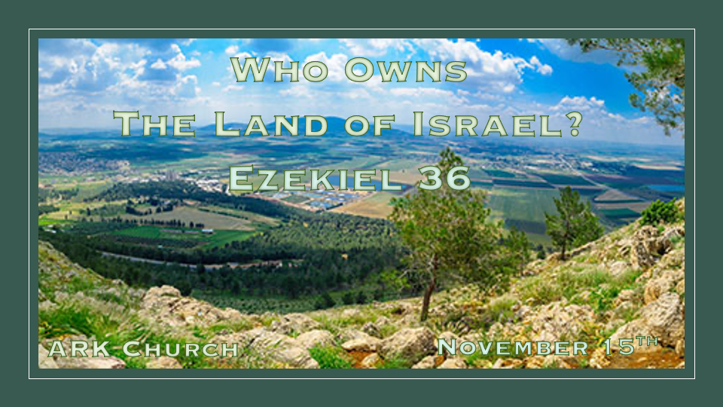

*Why is there such a dispute about the land of Israel?
*Ezekiel 36:1:1 “And you, son of man, prophesy to the mountains of Israel, and say, ‘O mountains of Israel, hear the word of the LORD! 2 Thus says the Lord GOD: “Because the enemy has said of you, ‘Aha! The ancient heights have become our possession,’ ” ’ 3 therefore prophesy, and say, ‘Thus says the Lord GOD: “Because they made you desolate and swallowed you up on every side, so that you became the possession of the rest of the nations, and you are taken up by the lips of talkers and slandered by the people”— 4 therefore, O mountains of Israel, hear the word of the Lord GOD! Thus says the Lord GOD to the mountains, the hills, the rivers, the valleys, the desolate wastes, and the cities that have been forsaken, which became plunder and mockery to the rest of the nations all around— 5 therefore thus says the Lord GOD: “Surely I have spoken in My burning jealousy against the rest of the nations and against all Edom, who gave My land to themselves as a possession, with wholehearted joy and spiteful minds, in order to plunder its open country.” ’

Insights V:1-5 The enemy intends to swallow up the promises of God.

V:1-3 The devil will use people, governments, and even ignorant believers to stop God’s plan and swallow up the land and the people of Israel.

V:3-4 They slander Israel, and they make a mockery of facts.

V:5 God declares it’s His land, and the enemies of Israel gave God’s land to themselves.

*The Prophecies of Shame.
*Ezekiel 36:6 “Therefore prophesy concerning the land of Israel, and say to the mountains, the hills, the rivers, and the valleys, ‘Thus says the Lord GOD: “Behold, I have spoken in My jealousy and My fury, because you have borne the shame of the nations.” 7 Therefore thus says the Lord GOD: “I have raised My hand in an oath that surely the nations that are around you shall bear their own shame. 8 But you, O mountains of Israel, you shall shoot forth your branches and yield your fruit to My people Israel, for they are about to come. 9 For indeed I am for you, and I will turn to you, and you shall be tilled and sown. 10 I will multiply men upon you, all the house of Israel, all of it; and the cities shall be inhabited and the ruins rebuilt. 11 I will multiply upon you man and beast; and they shall increase and bear young; I will make you inhabited as in former times, and do better for you than at your beginnings. Then you shall know that I am the LORD. 12 Yes, I will cause men to walk on you, My people Israel; they shall take possession of you, and you shall be their inheritance; no more shall you bereave them of children.

Insights V:6-12 Israel has borne the shame of Nations how many times?

Only the modern world could know the shame as it’s happening, once through the holocaust 1938-1945 and now 2023 as the world judges them for dismantling Gaza.

V:5 & 6 Burning with Jealousy against the Nations and Edom (The Muslims) Song of Song 8:6 Jealousy as cruel as the grave; its flames are flames of fire. V:7 Many waters cannot quench God’s love.

What shame will God make the nations bear? The shame of rejecting Christ unless they repent.

V:8-12 Israel will shoot forth and did on May 14, 1948, but as the prophecy said, Men will continue to walk on them.

*Ezekiel 36:13 ‘Thus says the Lord GOD: “Because they say to you, You devour men and bereave your nation of children,’ 14 therefore you shall devour men no more, nor bereave your nation anymore,” says the Lord GOD. 15 “Nor will I let you hear the taunts of the nations anymore, nor bear the reproach of the peoples anymore, nor shall you cause your nation to stumble anymore,” says the Lord GOD.’ ”

Insights for V:13-15 A futuristic prophecy of the removal of reproach and the taunting of nations.
You devour men; interestingly, the unfaithful ten spies said about the land in their testimony. (Numbers 13:32)
The prophecy can only be fulfilled in the millennial when Christ is ruling from Jerusalem.

*God Created Israel so the world could see His redemption and faithfulness.
*Ezekiel 36:16 Moreover the word of the LORD came to me, saying: 17 “Son of man, when the house of Israel dwelt in their own land, they defiled it by their own ways and deeds; to Me their way was like the uncleanness of a woman in her customary impurity. 18 Therefore I poured out My fury on them for the blood they had shed on the land, and for their idols with which they had defiled it. 19 So I scattered them among the nations, and they were dispersed throughout the countries; I judged them according to their ways and their deeds. 20 When they came to the nations, wherever they went, they profaned My holy name—when they said of them, ‘These are the people of the LORD, and yet they have gone out of His land.’ 21 But I had concern for My holy name, which the house of Israel had profaned among the nations wherever they went. 22 “Therefore say to the house of Israel, ‘Thus says the Lord GOD: “I do not do this for your sake, O house of Israel, but for My holy name’s sake, which you have profaned among the nations wherever you went. 23 And I will sanctify My great name, which has been profaned among the nations, which you have profaned in their midst; and the nations shall know that I am the LORD,” says the Lord GOD, “when I am hallowed in you before their eyes.

Insights for V:16-23 Israel’s past sins brought about the dispersion. One day, God’s name will be great in Israel for the whole world to see. (V:16-18 Israel defiled their own land and God)

V:19-20 God judged them according to their ways and deeds. Israel’s lack of trust in God brought a spirit of blaspheming to the name of God around the world.

V:21-23 All has come to pass to, with, for, or against Israel is a validation of God’s Holy name and power.

*The Greatest Comeback Story in History!
*Ezekiel 36:24 For I will take you from among the nations, gather you out of all countries, and bring you into your own land. 25 Then I will sprinkle clean water on you, and you shall be clean; I will cleanse you from all your filthiness and from all your idols. 26 I will give you a new heart and put a new spirit within you; I will take the heart of stone out of your flesh and give you a heart of flesh. 27 I will put My Spirit within you and cause you to walk in My statutes, and you will keep My judgments and do them. 28 Then you shall dwell in the land that I gave to your fathers; you shall be My people, and I will be your God. 29 I will deliver you from all your uncleanness. I will call for the grain and multiply it, and bring no famine upon you. 30 And I will multiply the fruit of your trees and the increase of your fields, so that you need never again bear the reproach of famine among the nations. 31 Then you will remember your evil ways and your deeds that were not good; and you will loathe yourselves in your own sight, for your iniquities and your abominations. 32 Not for your sake do I do this,” says the Lord GOD, “let it be known to you. Be ashamed and confounded for your own ways, O house of Israel!”

Insights for V:22-32 A Four-part restoration plan.
Part 1: The Gathering of Israel from all the nations.
Part 2: The Cleansing of Israel's heart and His Spirit will dwell in the people of Israel.
Part 3: The Covenant to Israel God and people will be one.
Part 4: The reversal of Israel’s consequences and the outpouring of God's blessing.

Ezekiel 36:33 ‘Thus says the Lord GOD: “On the day that I cleanse you from all your iniquities, I will also enable you to dwell in the cities, and the ruins shall be rebuilt. 34 The desolate land shall be tilled instead of lying desolate in the sight of all who pass by. 35 So they will say, ‘This land that was desolate has become like the garden of Eden; and the wasted, desolate, and ruined cities are now fortified and inhabited.’ 36 Then the nations which are left all around you shall know that I, the LORD, have rebuilt the ruined places and planted what was desolate. I, the LORD, have spoken it, and I will do it.”

Insights for V:33-36 The day of cleansing has come for the world, while another day is reserved for Israel.
V:36 Prophetic verse says that the nations left shall know what the Lord has done.

The repetitive theme is what God says He will do gets done!

*Ezekiel 36:37 ‘Thus says the Lord GOD: “I will also let the house of Israel inquire of Me to do this for them: I will increase their men like a flock. 38 Like a flock offered as holy sacrifices, like the flock at Jerusalem on its feast days, so shall the ruined cities be filled with flocks of men. Then they shall know that I am the LORD.” ’ ”

Insights for V:37-38 The final promise is will the fulfillment.
The Abraham covenant is the promise to increase the people of Israel.
V:38 Says again that the purpose behind this fulfillment is that the world knows that God keeps His promises.

