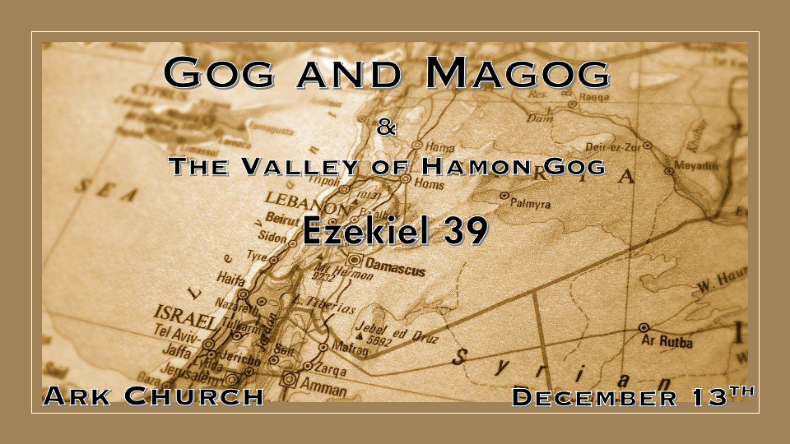
Chapter 38 Review.
Gog is the king of the demonic locust. He is the demonic evil spirit of war.
The nations that are coming against Israel are the descendants of Ham and Japheth.

Evil has a progressive plan. It looks for those without boundaries. Just speaking against it will not stop it.

When evil gets aggressive in this war, God will match that aggression with His wrath.

*The Defeat of Gog, Magog, and the Cleansing of Israel

*Insights for Ezekiel 39:1 “And you, son of man, prophesy against Gog, and say, ‘Thus says the Lord GOD: “Behold, I am against you, O Gog, the prince of Rosh, Meshech, and Tubal; 2 and I will turn you around and lead you on, bringing you up from the far north, and bring you against the mountains of Israel. 3 Then I will knock the bow out of your left hand, and cause the arrows to fall out of your right hand. 4 You shall fall upon the mountains of Israel, you and all your troops and the peoples who are with you; I will give you to birds of prey of every sort and to the beasts of the field to be devoured. 5 You shall fall on the open field; for I have spoken,” says the Lord GOD. 6 “And I will send fire on Magog and on those who live in security in the coastlands. Then they shall know that I am the LORD. 7 So I will make My holy name known in the midst of My people Israel, and I will not let them profane My holy name anymore. Then the nations shall know that I am the LORD, the Holy One in Israel. 8 Surely it is coming, and it shall be done,” says the Lord GOD. “This is the day of which I have spoken.
9 “Then those who dwell in the cities of Israel will go out and set on fire and burn the weapons, both the shields and bucklers, the bows and arrows, the javelins and spears; and they will make fires with them for seven years. 10 They will not take wood from the field nor cut down any from the forests, because they will make fires with the weapons; and they will plunder those who plundered them, and pillage those who pillaged them,” says the Lord GOD.

- Another rarity in Ezekiel is to talk for a whole Chapter to explain the aftermath of war.

*V:3 The bow is another word for a launcher.
That’s precisely how a bow works; it launches the arrow.

*V:3 The arrow is another word for Missiles in Hebrew, and one of Israel’s modern missiles is called the arrow. (Show a picture of the arrow missile and Chariot the Tank)

V:6 A Fire warning to those who live in security, but the KJV says those who dwell carelessly in the isles and on Magog (Russia).

The Coastlands are a third party that gets included in the devastation of this war.

V:7 God draws the line of no more. King James Version: I will not let them pollute my holy name anymore.

V:8-10 A fire or energy supply that lasts for seven years!

*The Cleansing of the land.
*Ezekiel 39:11 “It will come to pass in that day that I will give Gog a burial place there in Israel, the valley of those who pass by east of the sea; and it will obstruct travelers, because there they will bury Gog and all his multitude. Therefore they will call it the Valley of Hamon Gog. 12 For seven months the house of Israel will be burying them, in order to cleanse the land. 13 Indeed all the people of the land will be burying, and they will gain renown for it on the day that I am glorified,” says the Lord GOD. 14 “They will set apart men regularly employed, with the help of a search party, to pass through the land and bury those bodies remaining on the ground, in order to cleanse it. At the end of seven months they will make a search. 15 The search party will pass through the land; and when anyone sees a man’s bone, he shall set up a marker by it, till the buriers have buried it in the Valley of Hamon Gog. 16 The name of the city will also be Hamonah. Thus they shall cleanse the land.” ’

Why does this Chapter get the consideration of a nuclear scenario?
- V:10 The energy ability or fire for seven years.

- V:14 Professionals are hired to deal with the contamination of the situation.

- V:11-13 They wait seven months and bury the dead for seven months.

- V:15 If they find a dead person's bones, they mark it and call a professional

- V:16 They cleanse the land in this valley south of the Dead Sea or downwind—Hamon of Gog, the valley of the multitude/horde of soldiers.

*A Poem about a grotesque feasting that may mark the great tribulation.
*Ezekiel 39:17 “And as for you, son of man, thus says the Lord GOD, Speak to every sort of bird and to every beast of the field:
“Assemble yourselves and come; Gather together from all sides to My sacrificial meal which I am sacrificing for you, a great sacrificial meal on the mountains of Israel, that you may eat flesh and drink blood.18 You shall eat the flesh of the mighty, drink the blood of the princes of the earth, of rams and lambs, of goats and bulls, all of them fatlings of Bashan. 19 You shall eat fat till you are full, and drink blood till you are drunk, at My sacrificial meal which I am sacrificing for you. 20 You shall be filled at My table with horses and riders, with mighty men and with all the men of war,” says the Lord GOD.

There are similarities between the end of the Gog and Magog war and Armageddon.
Revelation 19:17-18 Then I saw an angel standing in the sun, and with a loud voice he called to all the birds that fly directly overhead, “Come, gather for the great supper of God, 18 to eat the flesh of kings, the flesh of captains, the flesh of mighty men, the flesh of horses and their riders, and the flesh of all men, both free and slave, both small and great.” 19 And I saw the beast and the kings of the earth with their armies gathered to make war against him who was sitting on the horse and against his army.

Some scholars do not connect the two wars together.
Some believe there could have been a rest period between the Gog and Magog War and the tribulation period.

*The ultimate repentance of Israel and the removal of their shame. When?

*Ezekiel 39:21 “I will set My glory among the nations; all the nations shall see My judgment which I have executed, and My hand which I have laid on them. 22 So the house of Israel shall know that I am the LORD their God from that day forward. 23 The Gentiles shall know that the house of Israel went into captivity for their iniquity; because they were unfaithful to Me, therefore I hid My face from them. I gave them into the hand of their enemies, and they all fell by the sword. 24 According to their uncleanness and according to their transgressions I have dealt with them, and hidden My face from them.” ’
25 “Therefore thus says the Lord GOD: Now I will bring back the captives of Jacob, and have mercy on the whole house of Israel; and I will be jealous for My holy name— 26 after they have borne their shame, and all their unfaithfulness in which they were unfaithful to Me, when they dwelt safely in their own land and no one made them afraid. 27 When I have brought them back from the peoples and gathered them out of their enemies’ lands, and I am hallowed in them in the sight of many nations, 28 then they shall know that I am the LORD their God, who sent them into captivity among the nations, but also brought them back to their land, and left none of them captive any longer. 29 And I will not hide My face from them anymore; for I shall have poured out My Spirit on the house of Israel,’ says the Lord GOD.”

- *God’s glory among the nations. When? The Millennial Reign of Christ.

- *The house of Israel will know that the LORD (Jesus) is their God. When? Halfway through the tribulation, Israel will come to Jesus.

- *When does God not hide his face? When Jesus returns to reign on earth for one thousand years.

