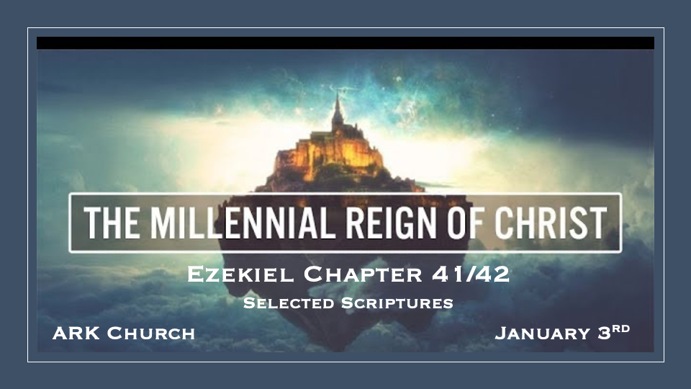
What temple was Ezekiel describing?

Why does the millennial reign point to blood sacrifices?

Is Ezekiel's temple one of the future or the past?

Does The Levitical sacrifice differ from the Millennial sacrifice?

2 Timothy 3:16-17 is our guidelines.

*Millennial Temple and Animal Sacrifices Continue?

*Insights for Ezekiel 40:38 There was a chamber and its entrance by the gateposts of the gateway, where they washed the burnt offering. 39 In the vestibule of the gateway were two tables on this side and two tables on that side, on which to slay the burnt offering, the sin offering, and the trespass offering.

Why are animal sacrifices mentioned in the Millennial reign of Christ?

*Hebrew 10:1 For the law, having a shadow of the good things to come, and not the very image of the things, can never with these same sacrifices, which they offer continually year by year, make those who approach perfect. 2 For then would they not have ceased to be offered? For the worshipers, once purified, would have had no more consciousness of sins. 3 But in those sacrifices there is a reminder of sins every year. 4 For it is not possible that the blood of bulls and goats could take away sins.

*Hebrew 10:10 By that will we have been sanctified through the offering of the body of Jesus Christ once for all.
11 And every priest stands ministering daily and offering repeatedly the same sacrifices, which can never take away sins.

Hebrews 10 insights

*The Building that faced the Separating Courtyard
*Ezekiel 41:12 The building that faced the separating courtyard at its western end was seventy cubits wide; the wall of the building was five cubits thick all around, and its length ninety cubits.
13 So he measured the temple, one hundred cubits long; and the separating courtyard with the building and its walls was one hundred cubits long; 14 also the width of the eastern face of the temple, including the separating courtyard, was one hundred cubits. 15 He measured the length of the building behind it, facing the separating courtyard, with its galleries on the one side and on the other side, one hundred cubits, as well as the inner temple and the porches of the court, 16 their doorposts and the beveled window frames. And the galleries all around their three stories opposite the threshold were paneled with wood from the ground to the windows—the windows were covered— 17 from the space above the door, even to the inner room, as well as outside, and on every wall all around, inside and outside, by measure.

Nobody knows why a separate building with no name is behind the temple.

*The Chambers of the Priest Who Serve Jesus and the Temple Sacrifices.

*Ezekiel 42:13 Then he said to me, “The north chambers and the south chambers, which are opposite the separating courtyard, are the holy chambers where the priests who approach the LORD shall eat the most holy offerings. There they shall lay the most holy offerings—the grain offering, the sin offering, and the trespass offering—for the place is holy. 14 When the priests enter them, they shall not go out of the holy chamber into the outer court; but there they shall leave their garments in which they minister, for they are holy. They shall put on other garments; then they may approach that which is for the people.”

20 He measured it on the four sides; it had a wall all around, five hundred cubits long and five hundred wide, to separate the holy areas from the common.

The Millennial Sacrifices Told in Other O.T. Books

*Isaiah 56:7 Even them I will bring to My holy mountain, and make them joyful in My house of prayer. Their burnt offerings and their sacrifices will be accepted on My altar; For My house shall be called a house of prayer for all nations.”
8 The Lord GOD, who gathers the outcasts of Israel, says, “Yet I will gather to him others besides those who are gathered to him.”

*Zechariah 14:16 And it shall come to pass that everyone who is left of all the nations which came against Jerusalem shall go up from year to year to worship the King, the LORD of hosts, and to keep the Feast of Tabernacles. 17 And it shall be that whichever of the families of the earth do not come up to Jerusalem to worship the King, the LORD of hosts, on them there will be no rain. 18 If the family of Egypt will not come up and enter in, they shall have no rain; they shall receive the plague with which the LORD strikes the nations who do not come up to keep the Feast of Tabernacles. 19 This shall be the punishment of Egypt and the punishment of all the nations that do not come up to keep the Feast of Tabernacles.
20 In that day “HOLINESS TO THE LORD” shall be engraved on the bells of the horses. The pots in the LORD’s house shall be like the bowls before the altar. 21 Yes, every pot in Jerusalem and Judah shall be holiness to the LORD of hosts. Everyone who sacrifices shall come and take them and cook in them. In that day there shall no longer be a Canaanite in the house of the LORD of hosts.

*Malachi 3:3 He will sit as a refiner and a purifier of silver; He will purify the sons of Levi, and purge them as gold and silver, that they may offer to the LORD an offering in righteousness.
4 “Then the offering of Judah and Jerusalem will be pleasant to the LORD, as in the days of old, as in former years.

