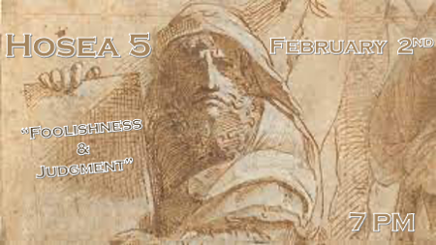

“Foolishness and Judgment”

*Israel was foolish with the blessings of God and came under judgement. Why would this not be true for the Church also?

*Hosea 5:1 1 "Hear this, you priests! Pay attention, you Israelites! Listen, royal house! This judgment is against you: You have been a snare at Mizpah, a net spread out on Tabor.
2 The rebels are knee-deep in slaughter. I will discipline all of them.
3 I know all about Ephraim; Israel is not hidden from me. Ephraim, you have now turned to prostitution; Israel is corrupt.
4 "Their deeds do not permit them to return to their God. A spirit of prostitution is in their heart; they do not acknowledge the LORD.
5 Israel's arrogance testifies against them; the Israelites, even Ephraim, stumble in their sin; Judah also stumbles with them.
6 When they go with their flocks and herds to seek the LORD, they will not find him; he has withdrawn himself from them.
7 They are unfaithful to the LORD; they give birth to illegitimate children. When they celebrate their New Moon feasts, he will devour their fields.
8 "Sound the trumpet in Gibeah, the horn in Ramah. Raise the battle cry in Beth Aven; lead on, Benjamin.
9 Ephraim will be laid waste on the day of reckoning. Among the tribes of Israel I proclaim what is certain.

*When leaders are unfaithful… the rebuke is stinging because “…For everyone to whom much is given, from him much will be required; and to whom much has been committed, of him they will ask the more.” (Luke 12:48b – NKJV))

“I hate, I despise your feast days, and I do not savor your sacred assemblies.
Though you offer Me burnt offerings and your grain offerings, I will not accept them,
Nor will I regard your fattened peace offerings. Take away from Me the noise of your songs, for I will not hear the melody of your stringed instruments. But let justice run down like water, and righteousness like a mighty stream.” (Amos 5:21-24; NKJV)

Israel’s religious sacrifices and monthly festivals no longer brought divine favor, only judgment. God “has withdrawn Himself from them”.

*Hosea 5:10-15
V10 - Judah's leaders are like those who move boundary stones. I will pour out my wrath on them like a flood of water.
V11 Ephraim is oppressed, trampled in judgment, intent on pursuing idols.
V12 I am like a moth to Ephraim, like rot to the people of Judah.
V13 "When Ephraim saw his sickness, and Judah his sores, then Ephraim turned to Assyria, and sent to the great king for help. But he is not able to cure you, not able to heal your sores.
V14 For I will be like a lion to Ephraim, like a great lion to Judah. I will tear them to pieces and go away; I will carry them off, with no one to rescue them.
V15 Then I will return to my lair until they have borne their guilt and seek my face—in their misery they will earnestly seek me."

*Misery or pain can be a path back to God… (Psalm 119)

Vs. 67 - ”Before I was afflicted I went astray, but now I keep Your Word”

Vs. 71 – “It is good for me that I have been afflicted, that I may learn Your statutes.”

Vs. 75 – “I know, O Lord, that Your judgments are right, and that in faithfulness, You have afflicted me.”

“You shall not remove your neighbor’s landmark, which the men of old have set, in your inheritance which you will inherit in the land that the Lord your God is giving you to possess.” (Deuteronomy 19:14)

Foreign assistance would have been of no value, sine the Lord was orchestrating lion-like punishment at the hands of the Assyrians for Israel and the Babylonians for Judah. He would remove Himself “till they acknowledge their offense” and “seek my face”.

“Afterward the children of Israel shall return and seek the Lord their God and David their king. They shall fear the Lord and His goodness in the latter days.” (Hosea 3:5 – NKJV)

