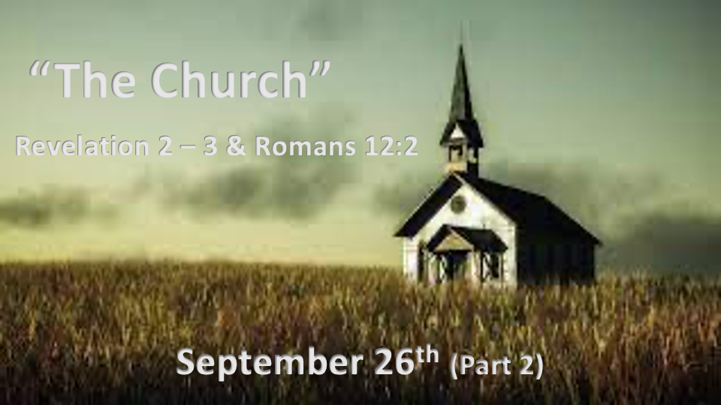

*Jesus never leaves His will or blessings as a mystery to his Church families.

*Romans 12:2 Do not conform to the pattern of this world, but be transformed by the renewing of your mind. Then you will be able to test and approve what God's will is—his good, pleasing and perfect will.

*God’s family must understand His will and their step of faith.

- *Revelation 2:5 The Ephesus family, God’s will for them is to remember and return.
Jonathan Cahn teachings about the last days say; “Everything will be returning to how it was in the first century. Israel returns to land. Jews return to Jerusalem; the world returns to their pagan ways of 1st century Rome. The Christian will return to the power of the Book of Acts. Jesus who ascended to heaven will return.”

- Revelation 2:9 The Smyrna family, do not be afraid of what you are about to suffer. (Hebrew 11:6 level of God’s will)

- *Revelation 2:15-16 The Pergamum family, God’s will for them is to repent stop teaching false truths or I will come and fight against you.

- *Revelation 2:22-23 The Thyatira family, God’s will for them is to repent stop the immorality or God will strike your children dead.

- *Revelation 3:2-3 The Sardis family, God’s will for them is to wake up, and remember or you will miss the rapture.

- *Revelation 3:10-11 The Philadelphia family, God’s will for them is holding on to what they have and they won’t face the hour of trial.

- *Revelation 3:19 The Laodicea family, God’s will for them is to receive His rebuke and be earnest and repent.

*God gives each family promises of hope & blessings.

- Rev. 2:7 Those who are victorious will eat from the tree of life. (Ephesus family)

- Rev. 2:10-11 Those who are victorious over fear will not fear the second death (Smyrna family)

- Rev. 2:17 Those who are victorious will receive hidden mana & a new name. (Pergamum family)

- Rev. 2:26-28 Those who are victorious and do my will Jesus will give them power over the nations and the morning star. (Thyatira family)

- Rev. 3:4-5 Those who are victorious will be dressed in white and acknowledge before the Father and his angels. (Sardis family)

- Rev. 3:12 Those who are victorious, I will make a pillar in the temple of my God. Never again will they leave it. I will write on them the name of my God and the name of the city of my God, the new Jerusalem, which is coming down out of heaven from my God; and I will also write on them my new name. (Philadelphia family)

- Rev. 3:21 Those who are victorious is given the right to sit down with Jesus on His throne, just as he sat down with His Father. (Laodicea family)

*Most children never receive a blessing from their father.

- *Numbers 6:24-26 " ' "The LORD bless you and keep you;
25 the LORD make his face shine on you and be gracious to you;
26 the LORD turn his face toward you and give you peace. " '

- *Philippians 4:7 And may the blessing of the peace of God, which transcends all understanding, guard your hearts and your minds in Christ Jesus.

