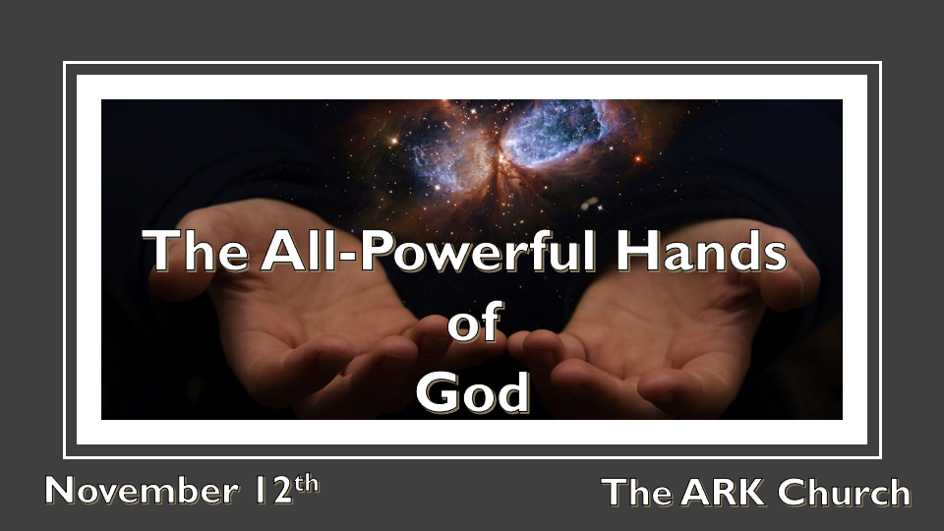
*A Eternal Mindset Must Include the Power of God.

*I Peter 1:4 to an inheritance incorruptible and undefiled and that does not fade away, reserved in heaven for you, 5 who are kept by the power of God through faith for salvation ready to be revealed in the last time.

*The Privileges and Power of Heavenly Citizenship.

Insights I Peter 1:5 *You are kept/sustained by the Omnipotent God.

Things to know about our heavenly citizenship:
Privileges

- *Colossians 1:12 Giving thanks to the Father who has qualified us to be partakers of the inheritance of the saints in the light. 13 He has delivered us from the power of darkness and conveyed us into the kingdom of the Son of His love,
You are kept informed as a citizen. The world keeps people in the darkness, but those who receive light are a part of the heavenly inheritance and citizenship.

- *Ephesians 2:19 Now, therefore, you are no longer strangers and foreigners, but fellow citizens with the saints and members of the household of God,
The Privilege of Citizenship includes household rights. We are family in heaven, brothers and sisters.

- *Isaiah 54:17 No weapon formed against you shall prosper, and every tongue which rises against you in judgment you shall condemn. This is the heritage of the servants of the LORD, and their righteousness is from Me,” Says the LORD.
The Number 1 role of the Authority over their citizens is protection. The privilege of protection is a promise.

*Joel 2:11 11 The LORD gives voice before His army, for His camp is very great; For strong is the One who executes His word. For the day of the LORD is great and very terrible; Who can endure it?

(2 Chronicles 20:1-25 The Battle Belongs to the Lord)

2 Thess. 3:3 But the Lord is faithful, who will establish you and guard you from the evil one.
Psalm 34:7 The angel of the LORD encamps all around those who fear Him and delivers them.

*Psalm 46:1 God is our refuge and strength, a very present help in trouble. 2 Therefore we will not fear,
even though the earth be removed, and though the mountains be carried into the midst of the sea;
3 Though its waters roar and be troubled, though the mountains shake with its swelling.
4 There is a river whose streams shall make glad the city of God, the holy place of the tabernacle of the Most High. 5 God is in the midst of her; she shall not be moved; God shall help her, just at the break of dawn.

Power
*1st Peter 1:5 who are kept by the power of God through faith for salvation ready to be revealed in the last time.

Those Who Experienced the Power of God’s Hand

The Babylonian Emperor Nebuchadnezzar
Daniel 4:34 And at the end of the time I, Nebuchadnezzar, lifted my eyes to heaven, and my understanding returned to me; and I blessed the Most High and praised and honored Him who lives forever:
For His dominion is an everlasting dominion, and His kingdom is from generation to generation.
*Daniel 4:35 All the inhabitants of the earth are reputed as nothing; He does according to His will in the army of heaven and among the inhabitants of the earth. No one can restrain His hand or say to Him, “What have You done?”

- A Gentile ruler with firsthand experience gives this kind of testimony because of a Jewish Prophet who became a vessel for the Hand of God.
- The acknowledgment: No one can restrain God’s hand in heaven or on earth.
- There are two types of people on the planet: Jews and Gentiles.

Why does the Power of God and Israel have such a connection?

Isaiah 43:13 Indeed before the day was, I am He; and there is no one who can deliver out of My hand; I work, and who will reverse it?”
14 Thus says the LORD, your Redeemer, The Holy One of Israel: “For your sake I will send to Babylon, and bring them all down as fugitives—The Chaldeans, who rejoice in their ships. 15 I am the LORD, your Holy One, The Creator of Israel, your King.”
16 Thus says the LORD, who makes a way in the sea and a path through the mighty waters, 17 Who brings forth the chariot and horse,
the army and the power (They shall lie down together, they shall not rise; They are extinguished, they are quenched like a wick): 18 “Do not remember the former things, nor consider the things of old.
19 Behold, I will do a new thing, now it shall spring forth; Shall you not know it? I will even make a road in the wilderness and rivers in the desert. 20 The beast of the field will honor Me, the jackals and the ostriches, because I give waters in the wilderness and rivers in the desert, to give drink to My people, My chosen. 21 This people I have formed for Myself; They shall declare My praise.

Insights for V:13-15 Out of God’s hand He works, and no one can reverse it.

- Some may perverse His work in the short term, but His hand is still accomplishing His will.
- God uses all the resources of humanity and creation to accomplish His will.
- He is the Creator of all the universes and the Nation of Israel.

For V:16-18, God is never tied to previous methods to accomplish His will.

Those who try to hold God to what He has done in the past are trapped by the human finite thinking and understanding.

Insights for V:19-21 God’s mode of operation is the new and why because he is the Creator.

The Bible is so important. Israel has a guaranteed future! Christians under the new covenant have the same assurance.

Do you need a new path or your dessert to be transformed? The incorruptible, the undefiled God is offering His hand. His might will keep your faith intact by the promise of the inheritance and His power.

