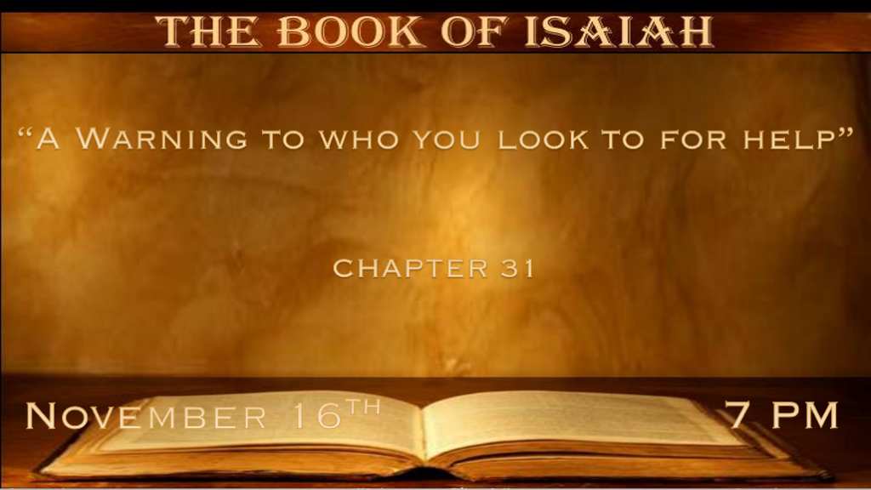

A Short Review of Isaiah:
- Chapters 24-27 A mini apocalypse
- Chapter 28 Warning #1 To those who made their lies a refuge.
- Chapter 29 Warning #2 Against spiritual illiteracy.
- Chapter 30 Warning #3 To the children that rebel.

*Warnings when you can find reasons to trust in others and not God.

*Isaiah 31:1 Woe to those who go down to Egypt for help, and rely on horses, who trust in chariots because they are many, and in horsemen because they are very strong, but who do not look to the Holy One of Israel, Nor seek the LORD! 2 Yet He also is wise and will bring disaster, and will not call back His words, but will arise against the house of evildoers, and against the help of those who work iniquity.
3 Now the Egyptians are men, and not God; And their horses are flesh, and not spirit. When the LORD stretches out His hand, both he who helps will fall, and he who is helped will fall down; They all will perish together.

- V:1 Don’t depend on this world. Living in it but not of it takes spiritual insight. (Warning #2)
- Israel was called out of Egypt therefore Egypt is often an idiom for this world.
Be sensitive that Pharaoh is often considered the idiom for Satan. Looking at the world you could be drawn into the evil one’s system.

- Learn where to draw the line as to how much help you seek from this world.
- In spiritual insight don’t cross the line to false beliefs.

- In medical insight pray how much is too much dependence on this world.

- In protection, we need to use wisdom and answer the question what/who is your true source?

- V:2 God is wise and will rise up against evil. (Warning #3)

God rises against the house of evil & against those who work iniquity.

This is speaking to the stronghold of evil. Remembering the work of iniquity is generational.

- V:3 We can substitute almost any word for the Egyptians. They are only human and the promise is those that who set themselves up against God will fall together.

The proud, the wicked, and those who oppose God have things in common. They underestimate God while they overestimate their abilities against Him.
All the Lord had to do is to stretch out His hand against them.

*The stage is set for blood. Will you choose the blood that redeems or avenges?

*Isaiah 31:4 For thus the LORD has spoken to me: “As a lion roars, and a young lion over his prey (When a multitude of shepherds is summoned against him, He will not be afraid of their voice nor be disturbed by their noise), so the LORD of hosts will come down to fight for Mount Zion and for its hill. 5 Like birds flying about, so will the LORD of hosts defend Jerusalem. Defending, He will also deliver it; Passing over, He will preserve it.” 6 Return to Him against whom the children of Israel have deeply revolted. 7 For in that day every man shall throw away his idols of silver and his idols of gold—sin, which your own hands have made for yourselves.
8 “Then Assyria shall fall by a sword not of man, and a sword not of mankind shall devour him. But he shall flee from the sword, and his young men shall become forced labor. 9 He shall cross over to his stronghold for fear, and his princes shall be afraid of the banner,” Says the LORD, whose fire is in Zion and whose furnace is in Jerusalem.

- V:4-5 Two pictures of God.
- The picture of a lion: We should respect the fierceness and might of our God.
- The picture of birds: This speaks to the swiftness of God.
- Together there is a promise for Jerusalem; Defending, delivering, and preserving it.

- V:6-7 The message to return and repent. How?
Look to Him first! Then tear down the idols that are in your life.

- V:8-9 The Prophecy.

(*2 Kings 19:33-34) 33 By the way that he came, by the same shall he return; And he shall not come into this city, ’Says the LORD.
34 ‘For I will defend this city, to save it for My own sake and for My servant David’s sake.’ ”

- The Assyrian army will go back the same way they came. Remember Israel was looking to Egypt for help with their enemy.

- The reason: It was for David’s sake and God’s name, meaning His covenant is good.

(*2 Kings 19:35-36) And it came to pass on a certain night that the angel of the LORD went out, and killed in the camp of the Assyrians one hundred and eighty-five thousand; and when people arose early in the morning, there were the corpses—all dead. 36 So Sennacherib king of Assyria departed and went away, returned home, and remained at Nineveh.

- The fulfillment of verse 8. This is a picture of the mini-apocalypse.

- The banner of God. His presence is of a fiery God as a picture of the future. His zeal to purge a world of sin and Jerusalem.

