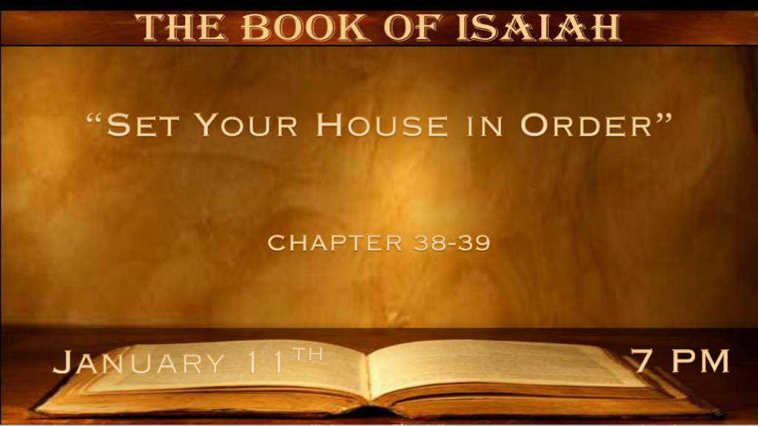

*Warnings Show The Kindness of God ( 2 Kings 20:1-11 )

*Isaiah 38:1 In those days Hezekiah was sick and near death. And Isaiah the prophet, the son of Amoz, went to him and said to him, “Thus says the LORD: Set your house in order, for you shall die and not live.’ ”
2 Then Hezekiah turned his face toward the wall, and prayed to the LORD, 3 and said, “Remember now, O LORD, I pray, how I have walked before You in truth and with a loyal heart, and have done what is good in Your sight.” And Hezekiah wept bitterly.
4 And the word of the LORD came to Isaiah, saying, 5 “Go and tell Hezekiah, ‘Thus says the LORD, the God of David your father: “I have heard your prayer, I have seen your tears; surely I will add to your days fifteen years. 6 I will deliver you and this city from the hand of the king of Assyria, and I will defend this city.” ’ 7 And this is the sign to you from the LORD, that the LORD will do this thing which He has spoken: 8 Behold, I will bring the shadow on the sundial, which has gone down with the sun on the sundial of Ahaz, ten degrees backward.” So the sun returned ten degrees on the dial by which it had gone down.

- V:1 Set your house in order. There is no kinder warning from the hand of God than that time is running out.

- V:2-3 Pray and tears are powerful if… they are genuine and not just trying to escape the consequences of our choices.
Psalm 56:8 God collects our tears.
*Philippians 3:18 For many walk, of whom I have told you often, and now tell you even weeping, that they are the enemies of the cross of Christ:
Rev. 7:17 & 21:4 He will wipe away our tears.
*Joel 2:12 “Now, therefore,” says the LORD, “Turn to Me with all your heart, With fasting, with weeping, and with mourning.” 13 So rend your heart, and not your garments; Return to the LORD your God, For He is gracious and merciful, Slow to anger, and of great kindness; And He relents from doing harm.

- V:4-6 The Word of the Lord must be revered for deliverance to come to our lives.
Many who know the Word of God have seen deliverance.

- V:7-8 The God of the Universe. Is the true God that opens doors no one can shut and shuts doors no one can open. (Rev. 3:7-8)
You’ve kept my Word and have not denied my name.

Confession, Repentance, and Turning to God is the Right Path.

*Isaiah 38:9 This is the writing of Hezekiah king of Judah, when he had been sick and had recovered from his sickness:
10 I said, “In the prime of my life I shall go to the gates of Sheol; I am deprived of the remainder of my years.”
11 I said, “I shall not see YAH, The LORD in the land of the living; I shall observe man no more among the inhabitants of the world.
12 My life span is gone, taken from me like a shepherd’s tent; I have cut off my life like a weaver. He cuts me off from the loom; From day until night You make an end of me.
13 I have considered until morning—Like a lion, so He breaks all my bones; From day until night You make an end of me.
14 Like a crane or a swallow, so I chattered; I mourned like a dove; My eyes fail from looking upward. O LORD, I am oppressed; Undertake for me!
15 “What shall I say? He has both spoken to me, And He Himself has done it. I shall walk carefully all my years in the bitterness of my soul.

- The Old Testament did not have the gift of salvation.
It had the voice of mighty men and women that God spoke through. They are called the Prophets.

- The Path to God was still very clear.
Honor God’s Word and fear disobeying him.

- What if we don’t walk carefully before the Lord?
We will reap what we have sowed. Harvesting evil will be the destruction of people’s souls.

*Learn to honor God beyond the words of your mouth.

*Isaiah 38:16 O Lord, by these things men live; And in all these things is the life of my spirit; So You will restore me and make me live.
17 Indeed it was for my own peace that I had great bitterness; But You have lovingly delivered my soul from the pit of corruption, for You have cast all my sins behind Your back.
18 For Sheol cannot thank You, Death cannot praise You; Those who go down to the pit cannot hope for Your truth.
19 The living, the living man, he shall praise You, as I do this day; The father shall make known Your truth to the children.
20 “The LORD was ready to save me; Therefore we will sing my songs with stringed instruments
All the days of our life, in the house of the LORD.”
21 Now Isaiah had said, “Let them take a lump of figs, and apply it as a poultice on the boil, and he shall recover.”
22 And Hezekiah had said, “What is the sign that I shall go up to the house of the LORD?”

- V:16-18 The soul deliverance is the deliverance from our sins.

- V:19 Fathers are to make known the truth of God to their children.

- V:20-22 A great truth is the Lord is ready to save.

Your Choices Today Will Change Tomorrow

*Isaiah 39:1 At that time Merodach-Baladan the son of Baladan, king of Babylon, sent letters and a present to Hezekiah, for he heard that he had been sick and had recovered. 2 And Hezekiah was pleased with them, and showed them the house of his treasures—the silver and gold, the spices and precious ointment, and all his armory—all that was found among his treasures. There was nothing in his house or in all his dominion that Hezekiah did not show them.
3 Then Isaiah the prophet went to King Hezekiah, and said to him, “What did these men say, and from where did they come to you?” So Hezekiah said, “They came to me from a far country, from Babylon.”
4 And he said, “What have they seen in your house?” So Hezekiah answered, “They have seen all that is in my house; there is nothing among my treasures that I have not shown them.”
5 Then Isaiah said to Hezekiah, “Hear the word of the LORD of hosts: 6 ‘Behold, the days are coming when all that is in your house, and what your fathers have accumulated until this day, shall be carried to Babylon; nothing shall be left,’ says the LORD. 7 ‘And they shall take away some of your sons who will descend from you, whom you will beget; and they shall be eunuchs in the palace of the king of Babylon.’ ”
8 So Hezekiah said to Isaiah, “The word of the LORD which you have spoken is good!” For he said, “At least there will be peace and truth in my days.”

- Isaiah 39:1-7 Pride came before the fall of Israel to Babylon.

- V:8 We must see beyond our day. Setting your house in order is a command from God to point us to tomorrow.

