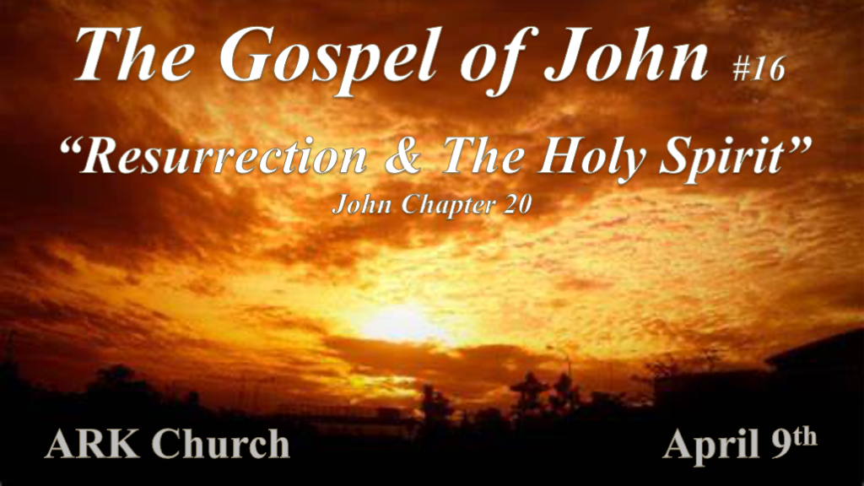
Chapter 19/20 Gives us a unique view of resurrection and the role of the unified message system of the Holy Spirit in scripture.

*Jesus is buried by believers.
*John 19:38 After this, Joseph of Arimathea, being a disciple of Jesus, but secretly, for fear of the Jews, asked Pilate that he might take away the body of Jesus; and Pilate gave him permission. So he came and took the body of Jesus. 39 And Nicodemus, who at first came to Jesus by night, also came, bringing a mixture of myrrh and aloes, about a hundred pounds. 40 Then they took the body of Jesus, and bound it in strips of linen with the spices, as the custom of the Jews is to bury. 41 Now in the place where He was crucified there was a garden and in the garden a new tomb in which no one had yet been laid. 42 So there they laid Jesus, because of the Jews’ Preparation Day, for the tomb was nearby.

Two key men and a spice Joseph of Arimathea Mark 15:43. He was waiting for the kingdom of God a member of the Sanhedrin along with Nicodemus and the myrrh one of the gifts that the wise men gave Jesus.
Myrrh is the gift given to one who is about to die. The king was born to die for humanity. Matthew 2:11

*Do you know the Scripture and that Jesus must have risen from the dead?
*John 20:1 Now the first day of the week Mary Magdalene went to the tomb early, while it was still dark, and saw that the stone had been taken away from the tomb. 2 Then she ran and came to Simon Peter, and to the other disciple, whom Jesus loved, and said to them, “They have taken away the Lord out of the tomb, and we do not know where they have laid Him.”
3 Peter therefore went out, and the other disciple, and were going to the tomb. 4 So they both ran together, and the other disciple outran Peter and came to the tomb first. 5 And he, stooping down and looking in, saw the linen cloths lying there; yet he did not go in. 6 Then Simon Peter came, following him, and went into the tomb; and he saw the linen cloths lying there, 7 and the handkerchief that had been around His head, not lying with the linen cloths, but folded together in a place by itself. 8 Then the other disciple, who came to the tomb first, went in also; and he saw and believed. 9 For as yet they did not know the Scripture, that He must rise again from the dead. 10 Then the disciples went away again to their own homes.

- V:1-2 Jesus rose while it was still dark. If He doesn’t rise all the rest that Jesus did doesn’t matter.
The light of our Savior’s resurrection happened in the early hours of the third day while it was still dark.
They believed someone took Jesus' body and they didn’t know where they had laid Him.

- V:3-9 The danger of not knowing the scripture. (V:9)
When you don’t know the scriptures it’s easy to follow the influential voices in your life and many may not be godly.
The Easter message is the victory over death & knowing the Word of God that connects everything.
*Genesis 8:4 The ark rested on the seventh month on the seventeenth day of that month.

*Exodus 12:2 “This month shall be your beginning of months; it shall be the first month of the year to you. 3 Speak to all the congregation of Israel, saying: ‘On the tenth of this month every man shall take for himself a lamb, according to the house of his father, a lamb for a household. 4 And if the household is too small for the lamb, let him and his neighbor next to his house take it according to the number of the persons; according to each man’s need you shall make your count for the lamb. 5 Your lamb shall be without blemish, a male of the first year. You may take it from the sheep or from the goats. 6 Now you shall keep it until the fourteenth day of the same month. Then the whole assembly of the congregation of Israel shall kill it at twilight.

*That same day was filled with every emotion.
*John 20:11 But Mary stood outside by the tomb weeping, and as she wept she stooped down and looked into the tomb. 12 And she saw two angels in white sitting, one at the head and the other at the feet, where the body of Jesus had lain. 13 Then they said to her, “Woman, why are you weeping?”
She said to them, “Because they have taken away my Lord, and I do not know where they have laid Him.”
14 Now when she had said this, she turned around and saw Jesus standing there, and did not know that it was Jesus. 15 Jesus said to her, “Woman, why are you weeping? Whom are you seeking?” She, supposing Him to be the gardener, said to Him, “Sir, if You have carried Him away, tell me where You have laid Him, and I will take Him away.” 16 Jesus said to her, “Mary!” She turned and said to Him, “Rabboni!” (which is to say, Teacher).
17 Jesus said to her, “Do not cling to Me, for I have not yet ascended to My Father; but go to My brethren and say to them, I am ascending to My Father and your Father, and to My God and your God.’ ” 18 Mary Magdalene came and told the disciples that she had seen the Lord and that He had spoken these things to her. 19 Then, the same day at evening, being the first day of the week, when the doors were shut where the disciples were assembled, for fear of the Jews, Jesus came and stood in the midst, and said to them, “Peace be with you.”

- V:11-19 The human reaction to that day. Every emotion you can think of was experienced on resurrection day.
Confusion, upset, grief, surprise, joy, and fear are the obvious ones.

- V:11-19 The spiritual dimension of that day.
There are angels or men in white that are not from this world. There is a faith realm developing in some and doubt in others. A tug-of-war is happening in the spiritual realm.

*On the 1st day of resurrection who received the breath of life and why?

*John 20:19 Then, the same day at evening, being the first day of the week, when the doors were shut where the disciples were assembled, for fear of the Jews, Jesus came and stood in the midst, and said to them, “Peace be with you.” 20 When He had said this, He showed them His hands and His side. Then the disciples were glad when they saw the Lord.
21 So Jesus said to them again, “Peace to you! As the Father has sent Me, I also send you.” 22 And when He had said this, He breathed on them, and said to them, “Receive the Holy Spirit. 23 If you forgive the sins of any, they are forgiven them; if you retain the sins of any, they are retained.”

- V:19-20 The Declaration of Peace twice is on purpose!
According to linguists, abracadabra is the most universally used word that doesn’t need a translation.[1] It’s a word employed by magicians, but the etymology is more spiritual than magical.

*The ancient words A’bra K’dabra mean “As I speak, I shall create.”[2] In other words, words create worlds! “Words,” said the Jewish theologian Abraham Heschel, “are themselves sacred, God’s tool for creating the universe, and our tools for bringing holiness—or evil—into the world.”
[3] Batterson, Mark. Please, Sorry, Thanks. The Crown Publishing Group. Kindle Edition.

Picture of Mark Batterson’s book “The Three Words that Change Everything.”

- V:21-23 Jesus breathed on them and said; “Receive the Holy Spirit.”
What’s the first fruit of the Spirit? Peace is what Jesus declared twice before He breathed on them and says receive the Holy Spirit.
I believe the body of Jesus Christ is born here. The tangible community is Jesus, but it won’t receive the power of the Holy Spirit until Pentecost. Did Jesus breathe life into the Church the body of Christ? You decide.

*The signs are written that you may believe Jesus is the Christ, the Son of God.

*John 20:24 Now Thomas, called the Twin, one of the twelve, was not with them when Jesus came. 25 The other disciples therefore said to him, “We have seen the Lord.” So he said to them, “Unless I see in His hands the print of the nails, and put my finger into the print of the nails, and put my hand into His side, I will not believe.” 26 And after eight days His disciples were again inside, and Thomas with them. Jesus came, the doors being shut, and stood in the midst, and said, “Peace to you!” 27 Then He said to Thomas, “Reach your finger here, and look at My hands; and reach your hand here, and put it into My side. Do not be unbelieving, but believing.” 28 And Thomas answered and said to Him, “My Lord and my God!” 29 Jesus said to him, “Thomas, because you have seen Me, you have believed. Blessed are those who have not seen and yet have believed.” 30 And truly Jesus did many other signs in the presence of His disciples, which are not written in this book; 31 but these are written that you may believe that Jesus is the Christ, the Son of God, and that believing you may have life in His name.

- V:24-25 Doubt from the beginning is associated with the resurrection. Thomas is that symbol.
What’s making you hold out on believing in Jesus as the Resurrected Son of God?

- V:26-28 After eight days. Eight is an octave the eighth day is a new beginning.
It’s a new beginning! Sin is defeated, and death has been overcome.

- V:29-31 All signs are not written in the Bible. The ones recorded in the Gospel of John were so that you would believe in the deity of Jesus and have life in His name.
Are you ready to join the “I AM” it takes an act revealing your belief?

