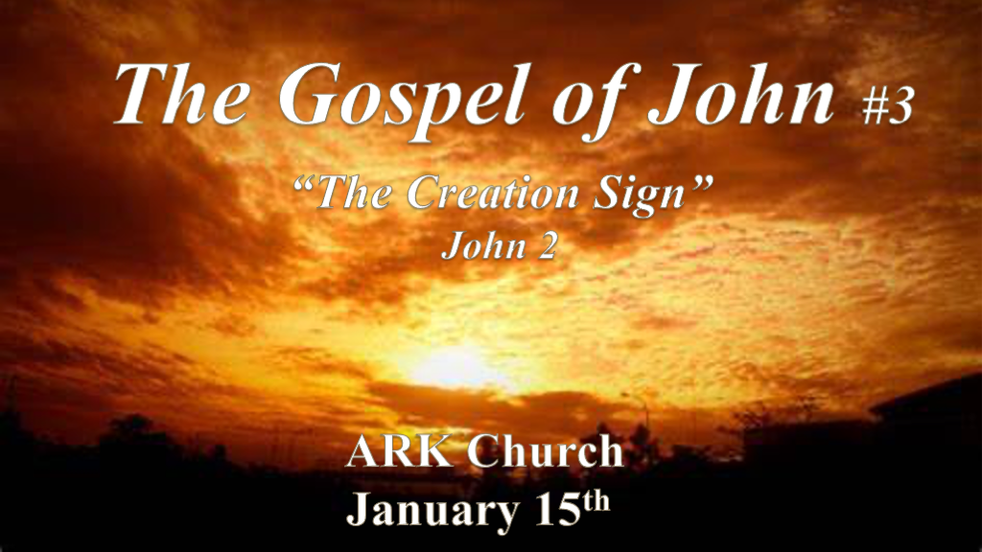

*The Beginning of Signs Happens at a Wedding.

*John 2:1 On the third day there was a wedding in Cana of Galilee, and the mother of Jesus was there. 2 Now both Jesus and His disciples were invited to the wedding.
Hebrew # 3 Three brings harmony and unity to opposites like the number two. Three creates a solid foundation and makes the first geometric shape (triangle). The sequence of three makes a chain of continuity. Three major feasts,
Israel is the center of the Biblical World. Three continents Europe, Asia, and Africa. The Triune God is 3 in 1, The interwind message is everywhere. A cord of three is not easily broken. Jesus will rise on the third day. Creation's third day is the vine.

*John 2:3 And when they ran out of wine, the mother of Jesus said to Him, “They have no wine.” 4 Jesus said to her, “Woman, what does your concern have to do with Me? My hour has not yet come.” 5 His mother said to the servants, “Whatever He says to you, do it.” 6 Now there were set there six waterpots of stone, according to the manner of purification of the Jews, containing twenty or thirty gallons apiece. 7 Jesus said to them, “Fill the waterpots with water.” And they filled them up to the brim. 8 And He said to them, “Draw some out now, and take it to the master of the feast.” And they took it. 9 When the master of the feast had tasted the water that was made wine, and did not know where it came from (but the servants who had drawn the water knew), the master of the feast called the bridegroom. 10 And he said to him, “Every man at the beginning sets out the good wine, and when the guests have well drunk, then the inferior. You have kept the good wine until now! 11 This beginning of signs Jesus did in Cana of Galilee, and manifested His glory; and His disciples believed in Him. 12 After this He went down to Capernaum, He, His mother, His brothers, and His disciples; and they did not stay there many days.

- V:3-5 Whatever Jesus says to you, do it. Make sure it’s Him speaking!
The words of Jesus’ mother in the scripture are few and most are around the angel talking to her about the gospel of Luke.
These words have an application beyond the immediate situation and therefore have a calling forth or forward aspect to them.

- V:6-8 Following instruction is a step of obedience to God and faith.
The servants at the wedding were in a unique situation to be part of this miracle that would become famous.
This too has the aspect of bringing it forward to those who serve Jesus and play a unique part in seeing the impossible.
Their action took faith they knew the jars had been filled with water.

- V:9-10 This miracle was a sign of Jesus’ divinity. This is the purpose of John’s Gospel.
Water changed to wine is directly related to the act of Creation. God makes something significant out of the ordinary.
The abundance of wine was a gift to the newlyweds’ that turned their shame of not having enough wine to sell after the wedding banquet.

- V:11-12 The beginning of signs is often the most significant.
If you don’t find the beginning of God’s work significant (His Creation) you most like won’t be ready for God’s finishing act or signs. Another Wedding will be the next noteworthy sign to the Church.

*Religious People always Desire a Sign. God’s Desire is Holiness.

*John 2:13 Now the Passover of the Jews was at hand, and Jesus went up to Jerusalem. 14 And He found in the temple those who sold oxen and sheep and doves, and the money changers doing business. 15 When He had made a whip of cords, He drove them all out of the temple, with the sheep and the oxen, and poured out the changers’ money and overturned the tables. 16 And He said to those who sold doves, “Take these things away! Do not make My Father’s house a house of merchandise!” 17 Then His disciples remembered that it was written, “Zeal for Your house has eaten Me up.”
18 So the Jews answered and said to Him, “What sign do You show to us, since You do these things?”
19 Jesus answered and said to them, “Destroy this temple, and in three days I will raise it up.”
20 Then the Jews said, “It has taken forty-six years to build this temple, and will You raise it up in three days?”
21 But He was speaking of the temple of His body. 22 Therefore, when He had risen from the dead, His disciples remembered that He had said this to them; and they believed the Scripture and the word which Jesus had said.

- V:13-17 The 1st interaction with one of the three major feasts.
- Passover is inseparable from purification.
Passover is a sign of remembrance that the death angel passed over their homes.

- Jesus purifies the temple at His first public appearance at Passover.
His last appearance was before Passover and it will pay the price of humanity's purification.

- V:18-20 Jesus prophesied for future generations the most significant sign of His divinity.
Jesus' resurrection is the major sign that He is God.

*Recognizing Biblical Signs doesn’t mean you have a discerning heart.

*John 2:23 Now when He was in Jerusalem at the Passover, during the feast, many believed in His name when they saw the signs which He did. 24 But Jesus did not commit Himself to them, because He knew all men, 25 and had no need that anyone should testify of man, for He knew what was in man.

- V:23 Many have caught the three signs of John’s Gospel in Chapter two.
Question? What advantage does this give them if they don’t have a heart led by the Holy Spirit?

- V:24-25 Jesus will only commit to those who surrender to Him as Lord and the Son of God.
Anything less is you’ve only acknowledged historical truths but your heart was unchanged.

