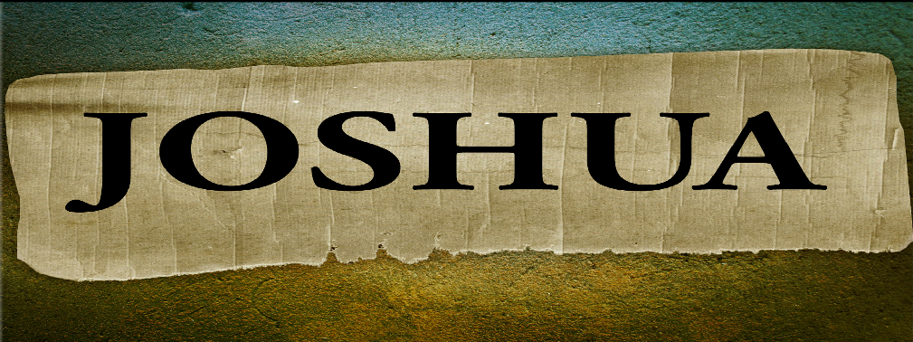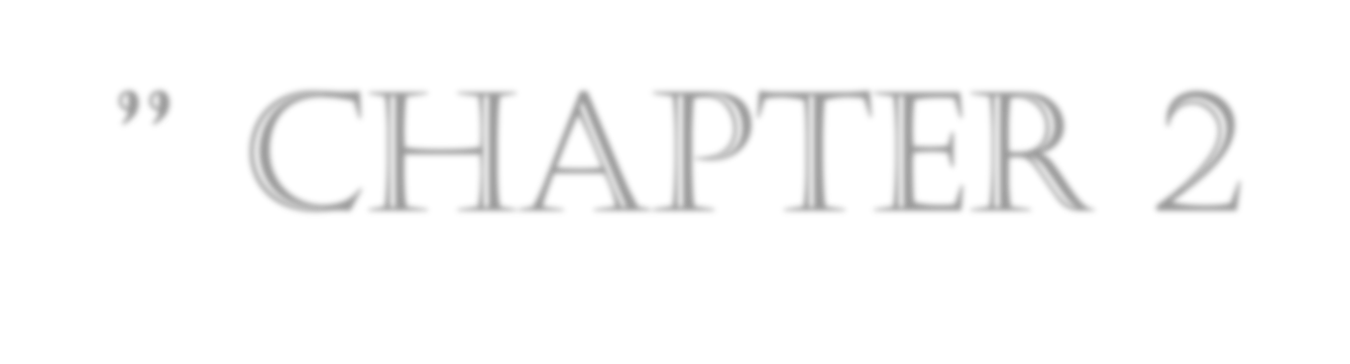
”MELTING IN FEAR” CHAPTER 2
OCTOBER 14TH
7 P.M.

Fear & It’s Messages
- Psalm 118:6 The LORD is with me; I will not be afraid. What can mere mortals do to me?
- Isaiah 41:10 So do not fear, for I am with you; do not be dismayed, for I am your God. I will strengthen you and help you; I will uphold you with my righteous right hand.
- I Chronicles 28:20 David also said to Solomon his son, “Be strong and courageous, and do the work. Do not be afraid or discouraged, for the LORD God, my God, is with you.
- John 14:27 Peace I leave with you; my peace I give you. I do not give to you as the world gives. Do not let your hearts be troubled and do not be afraid.
- Genesis 15:16 In the fourth generation your descendants will come back here, for the sin of the Amorites has not yet reached its full measure.”
*Joshua hears the stories of their enemy’s fear and realized this Prophecy fulfilled!

Joshua 2:1-6

The Story Within the Story

- Rahab: One of the main characters that makes an impact. Hebrews 11:31, James 2:25 consider righteous, Matthew 1:5 & Ruth 4. She became the mother of the kinsman redeemer. (Boaz)
- The Enemy: V:2-3 The king Jericho (Amorite) Deuteronomy 2:24-25
- Salvation: Rahab the prostitute, lies to the King and sends his men on fake trail. She was saved by her faith and not her conduct.
- The Two Spies: Why only 2 spies this time? They possibly were messengers/witnesses rather than spies. They do become witnesses to God’s plan.

Joshua 2:7-11

Witnesses of God’s Power
- V:9,11, & 24, 4 times they mentioned the fear of their enemies because of God’s power.
- V:10 God’s power had been revealed while they were still in the wilderness. The Kings of Sihon (Amorite) & Og Kings East of Jordan.
- Rahab was alone in her stance, but she had witnessed God’s power. (Hebrews 11)
- Rahab understood God was not just the God of Israel. V:11 Her statement The Lord your God is God in heaven above and on the earth below.
- They are witnesses to the fulfillment of Genesis 15:16. They are witnesses to the fear people have when the fullness of their sin controls everything. (Until the Amorites transgressions are complete.)

Joshua 2:12-19

Signs that Point To…

- Three days: The report of victory is hidden for three days.
- The Scarlet cord a sign of protection.
- Rahab’s family is only safe if they are in the house.
- A place of refuge before the judgment.

Joshua 2:20-24

Strange Truths

- V:24 This is the exact same report that Joshua brought back to Moses 38 years earlier. (The Lord has given us the whole land.)
- Time does not change God’s promises nor provision to His people.

