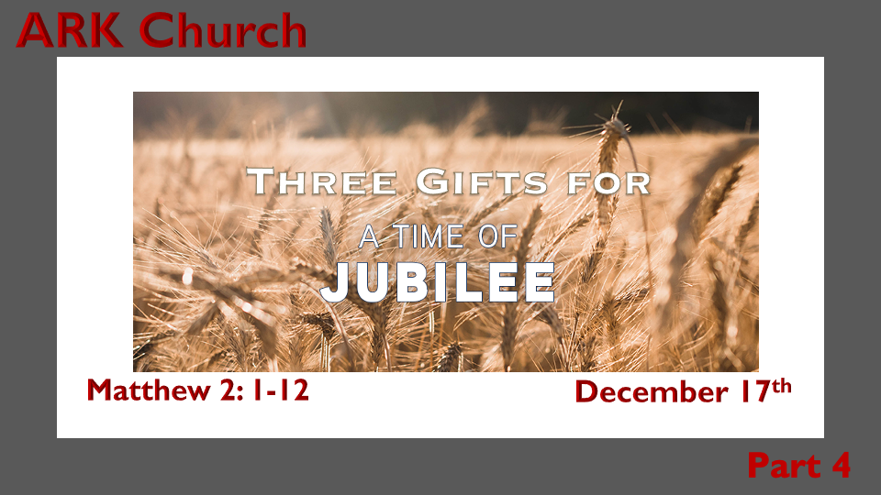

*Advent is the (simple) story of God's son coming from heaven. (The supernatural birth event)
*The Jubilee is the (complex) story about Jesus' life bringing restoration to all humanity.
*God's timing is a heavenly and earthly jubilee.

*Jubilee is God's long-term promise revealed through Jesus' birth. (Show timeline)

*Genesis 3:15 And I will put enmity between you and the woman, and between your seed and her Seed; He shall bruise your head, and you shall bruise His heel."

Advent is part of the long-term promise of the coming of the Messiah from Isaiah's prophecy.

*Isaiah 60:5b The wealth of the Gentiles shall come to you. 6 The multitude of camels shall cover your land, The dromedaries of Midian and Ephah; All those from Sheba shall come; They shall bring gold and incense, and they shall proclaim the praises of the LORD.

The promise of Gold and Frankincense from Gentiles. Why not myrrh?

Where do the Gentiles come from?
*Daniel 2:47 The king answered Daniel, and said, "Truly your God is the God of gods, the Lord of kings, and a revealer of secrets, since you could reveal this secret." 48 Then the king promoted Daniel and gave him many great gifts; and he made him ruler over the whole province of Babylon, and chief administrator over all the wise men of Babylon. 49 Also Daniel petitioned the king, and he set Shadrach, Meshach, and Abed-Nego over the affairs of the province of Babylon; but Daniel sat in the gate of the king.

*Daniel's Year of the Lord's Favor.
- When you receive favor from God, it can become multi-generational. This is over 500 years of favor.
- When you receive God's favor, pass it on to others. Daniel did this by changing the lives of Shadrach, Meshach, and Abed-Nego.
- The timing of this favor will come to fruition during the fulfillment of the 80th Jubilee found in Matt. 2.

*Matthew 2:1 Now after Jesus was born in Bethlehem of Judea in the days of Herod the king, behold, wise men from the East came to Jerusalem, 2 saying, "Where is He who has been born King of the Jews? For we have seen His star in the East and have come to worship Him."
3 When Herod the king heard this, he was troubled, and all Jerusalem with him. 4 And when he had gathered all the chief priests and scribes of the people together, he inquired of them where the Christ was to be born.
5 So they said to him, "In Bethlehem of Judea, for thus it is written by the prophet: 6 'But you, Bethlehem, in the land of Judah, are not the least among the rulers of Judah; For out of you shall come a Ruler Who will shepherd My people Israel.'"
7 Then Herod, when he had secretly called the wise men, determined from them what time the star appeared. 8 And he sent them to Bethlehem and said, "Go and search carefully for the young Child, and when you have found Him, bring back word to me, that I may come and worship Him also."
9 When they heard the king, they departed; and behold, the star which they had seen in the East went before them, till it came and stood over where the young Child was. 10 When they saw the star, they rejoiced with exceedingly great joy.

*The Gift of Gold and so much More.

*Matthew 2:11 And when they had come into the house, they saw the young Child with Mary His mother, and fell down and worshiped Him. And when they had opened their treasures, they presented gifts to Him: gold, frankincense, and myrrh.
12 Then, being divinely warned in a dream that they should not return to Herod, they departed for their own country another way.

Gold is the gift given to a King. Gold also represents purity.

- Jesus was born king. Please, Lord, may there be a Ruler over my World that is as pure as gold.
- Jesus is God who came as the King to purify sin.
- The gift of God's restoration is given to humanity. Please accept this gift.

Mark Batterson's new book "Please, Sorry, Thanks" is about three words that bring gifts of restorations to relationships.

Please is often a word that is used for manipulation. Could using the word "Please" be a new kind of gift we give at Christmas?

*The Gift of Frankincense and Sorry.

- Frankincense was the appropriate gift for a High Priest. Jesus is our high priest.

- The High Priest meets with God to bring an offering for the sins of people before God and says, "Sorry."

- The most effective Sorry carries the gift of gratitude with it.

*The Gift of Myrrh and Thanks

- Myrrh is the appropriate gift to one who is about to die. Jesus' advent mission was to be the lamb of God that would take away the sins of the world.

- Jesus was born in Bethlehem. The same place where the shepherds for the temple would produce the lambs that would be born for sacrifice in Jerusalem.

- The shepherds would wrap the lambs in swaddling cloths to protect them from being marred and unworthy of being presented to God. So, our Savior came into the world in the town of David Bethlehem, born in the lineage of Royalty, but in this 1st advent, He did not come to conquer the world but to save it.

- The Great Shepherd of humanity became our sacrificial Jubilee. To restore everything stolen through sin, to bring liberty to those held in the prison for their sins. To declare liberty for all who would feel the oppression of the world that has chosen to reject this Jubilee.

