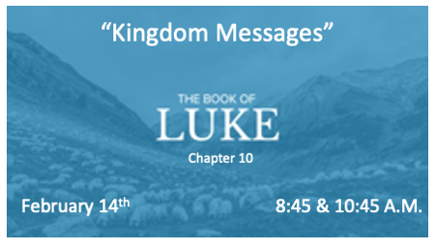

How much do you know and understand about the Kingdom?

*Luke 10:1 After this the Lord appointed seventy-two others and sent them two by two ahead of him to every town and place where he was about to go. 2 He told them, "The harvest is plentiful, but the workers are few. Ask the Lord of the harvest, therefore, to send out workers into his harvest field. 3 Go! I am sending you out like lambs among wolves.

Kingdom Principles

- Going out by two, activates a Kingdom principle. Matthew 18:20-22
- In the kingdom we do not recruit, we ask the Lord to draw more workers. The Church is a sending force.
- Do you know the difference between a lamb and a wolf?
- Christians, our assignment has always been a dangerous one.

*Luke 10:9 Heal the sick who are there and tell them, 'The kingdom of God has come near to you.' 10 But when you enter a town and are not welcomed, go into its streets and say, 11 'Even the dust of your town we wipe from our feet as a warning to you. Yet be sure of this: The kingdom of God has come near.' 12 I tell you, it will be more bearable on that day for Sodom than for that town.

*Luke 10:20 However, do not rejoice that the spirits submit to you, but rejoice that your names are written in heaven."
Kingdom Assignments

- Heal the sick! This includes the emotional and spiritual sickness, as well as physical illnesses.
- Instruct, explain, and reveal God’s Kingdom.
- The greatest sin is not immorality. It is rejection of the Kingdom.
- Our greatest joy is to have our names recorded in the Book of Life.

*Luke 10:23 Then he turned to his disciples and said privately, "Blessed are the eyes that see what you see. 24 For I tell you that many prophets and kings wanted to see what you see but did not see it, and to hear what you hear but did not hear it."

Statement: We are not just a Church studying prophetic scriptures. We are a people seeing and experiencing the very things the Apostles, Prophets, and the Saints before us, desired to see!

*Luke 10:27 He answered, " 'Love the Lord your God with all your heart and with all your soul and with all your strength and with all your mind'; and, 'Love your neighbor as yourself.’”

28 "You have answered correctly," Jesus replied. "Do this and you will live."

*Luke 10:41 "Martha, Martha, "the Lord answered, "you are worried and upset about many things, 42 but few things are needed—or indeed only one. Mary has chosen what is better, and it will not be taken away from her."

Do This and Live a Kingdom Life

- V:27-28 We cannot earn our way to heaven. We love God and others because of His love in our hearts. (Some use this story as a way of salvation.)
- The good Samaritan in the story was a person religious people would have dismissed. Kingdom people are people of mercy. Luke 10:37
- V:38-40 Martha was distracted by her service.
- V:41-42 Jesus says to Martha, “choose what is better.”
- What Martha was doing was needed, but she was worried and upset in her doing. Are you upset in your service to God? It’s a heart issue.
- Mary, did you know Jesus' presence was more important than the provisions you would be eating?
- Kingdom life comes about through transformation, not through our service. We serve because we are transformed/saved.

