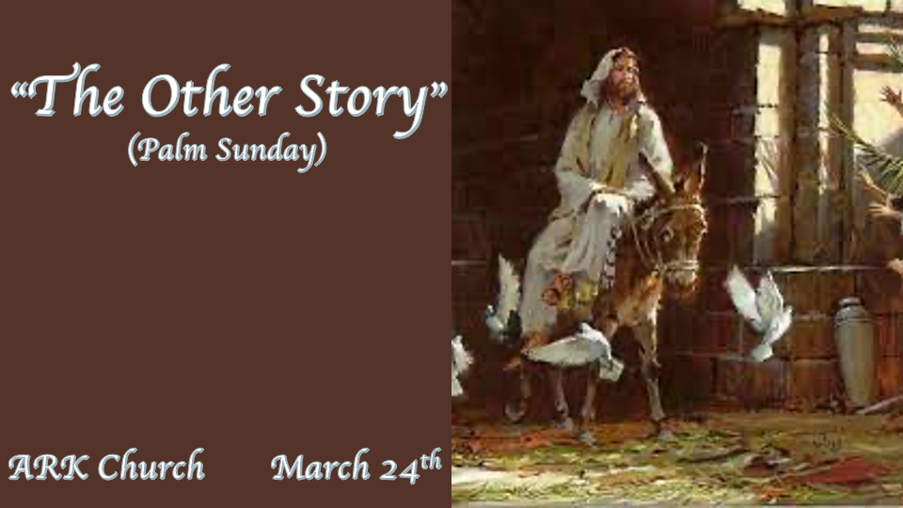

*All of this happened to fulfill what was spoken by the prophet.

*Matthew 21:1 Now when they drew near Jerusalem, and came to Bethphage, at the Mount of Olives, then Jesus sent two disciples, 2 saying to them, "Go into the village opposite you, and immediately you will find a donkey tied, and a colt with her. Loose them and bring them to Me. 3 And if anyone says anything to you, you shall say, 'The Lord has need of them,' and immediately he will send them."
4 All this was done that it might be fulfilled which was spoken by the prophet, saying:
5 "Tell the daughter of Zion,
'Behold, your King is coming to you,
Lowly, and sitting on a donkey,
A colt, the foal of a donkey.'"
6 So the disciples went and did as Jesus commanded them. 7 They brought the donkey and the colt, laid their clothes on them, and set Him on them.

- Palm Sunday is a prophetic day and more.
Daniel predicts the exact day the Messiah will enter Jerusalem, and the people declare Him King. (Dan.9:24-27)

David described Palm Sunday, though David is the King of Israel and not a prophet. (Psalm 118:24-26)

Zechariah 9:9 The King will come humbly on the foal of Donkey.

- Inspection day for the Passover.

Nisan 10 is the day on the Jewish calendar that Palm Sunday falls on.

Judgment day is for those who would not allow Jesus to take their place for all they did.

We knew He was the lamb of God from His birth. He was born at the same time as the lambs who are sacrificed for people's sins and wrapped in swaddling cloth like the lambs who are without blemish.

- The Controversy over two animals. The newest attack came in 2003 when the Gospel of Matthew (Jesus is King) was attacked over Jesus asking for the Donkey and her foal.
The harmony of the Gospels should never have the same exact details, and a legitimate story told by many will have different information.

*Who is this? The World has gone after Him.

*Matthew 21:8 And a very great multitude spread their clothes on the road; others cut down branches from the trees and spread them on the road. 9 Then the multitudes who went before and those who followed cried out, saying: "Hosanna to the Son of David! Blessed is He who comes in the name of the LORD!' Hosanna in the highest!"
10 And when He had come into Jerusalem, all the city was moved, saying, "Who is this?"
11 So the multitudes said, "This is Jesus, the prophet from Nazareth of Galilee."

*John 12:17 Therefore the people, who were with Him when He called Lazarus out of his tomb and raised him from the dead, bore witness. 18 For this reason the people also met Him, because they heard that He had done this sign. 19 The Pharisees therefore said among themselves, "You see that you are accomplishing nothing. Look, the world has gone after Him!"

1. The whole city was asking who this coming King was.

The whole world will again ask one day who this coming King is.

Only those born again who have received His blood as the gift of eternal life and know their Bibles will answer: He is Lord, the Son of David, the Most-High King.

2. John 12:17-19 The World is going after Him!
Are you following after Jesus?

Does your world know you are going after the way of Jesus and His life?

Perfected Praise Follows the Cleansing of God's House

*Matthew 21:12 Then Jesus went into the temple of God and drove out all those who bought and sold in the temple, and overturned the tables of the money changers and the seats of those who sold doves. 13 And He said to them, "It is written, My house shall be called a house of prayer,' but you have made it a den of thieves.'"
14 Then the blind and the lame came to Him in the temple, and He healed them. 15 But when the chief priests and scribes saw the wonderful things that He did, and the children crying out in the temple and saying, "Hosanna to the Son of David!" they were indignant 16 and said to Him, "Do You hear what these are saying?"
And Jesus said to them, "Yes. Have you never read,
Out of the mouth of babes and nursing infants
You have perfected praise'?"
17 Then He left them and went out of the city to Bethany, and He lodged there.

- V:12-13 The cleansing of God's House came before the gift of Salvation.
Three times, God drives people from His house. The 1st time is when the money changers are driven out.

The 2nd time is Hosea 9:15, When God drove the northern kingdom of Israel from His house before their destruction.

The 3rd time was in 2020, When God drove the whole world from His house during the Pandemic.

- V:14-15 The blind and lame were healed; the exception was that the religious blind and lame were not.
They were indignant.
Jesus was entirely in His Kingship mode. He sets His house in order, heals the sick, and teaches the Chief priest and scribes how spiritually blind they are.

The Jewish leaders took advantage of the people to make money for the upcoming Passover feast.
Jesus gave out freely to those who sought forgiveness and healing.

- V:16-17 The Religious leaders asked, "Do you hear what they are saying?"

*Psalm 8:1 O LORD, our Lord,
How excellent is Your name in all the earth,
Who have set Your glory above the heavens!
2 Out of the mouth of babes and nursing infants
You have ordained strength,
Because of Your enemies,
That You may silence the enemy and the avenger.

