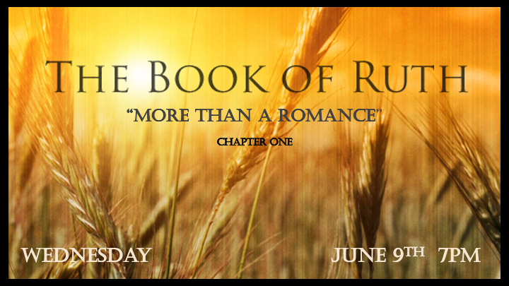

*Deeper levels of truth are needed for the shallow day we live in.

- In the book of Ruth, we see hints of God’s plan for humanity through a “Kinsman Redeemer.”
- The timeline is after Moses but before a king is over Israel. These were the days the Judges ruled Israel. Everyone did what was right in their own eyes was the outcome.
- Chuck Missler calls Ruth “The Romance of Redemption.” The Hebrew model of prophecy is key.
- A dramatic book of prophecy, giving us insights needed to fully understand Revelation Chapter 5.
- The book of Ruth will establish the distinction between Israel and the Church. The Gentile Church will remain a mystery in the O.T. tucked away nicely in the book of Ruth.

*Ruth 1:1 1 In the days when the judges ruled, there was a famine in the land. So, a man from Bethlehem in Judah, together with his wife and two sons, went to live for a while in the country of Moab. 2 And the name of the man was Elimelech, and the name of his wife Naomi, and the name of his two sons Mahlon and Chilion, Ephrathites of Bethlehem Judah. And they came into the country of Moab, and continued there.

Parallels to the 21st Century Judgments

- It’s a time of failures. Israel has at least 6 failures during this period. Hope during the time of “Judges” is found in the Book of Ruth.

- It was a time of famine. Often famine is associated with God’s judgement because they disobeyed the laws of God. (This was a local famine in Israel)

- V:2 The repetition of the phrase “the name of” points to the importance of the characters in this book.
- Elimelech: God is my King
- Naomi: Pleasant (The Land of Israel is known as the pleasant land)
- Mahlon: Sickly or unhealthy
- Chilion: Wasting or pinning (immobile)

*Ruth 1:3 And Elimelech Naomi's husband died; and she was left, and her two sons.
4 And they took them wives of the women of Moab; the name of the one was Orpah, and the name of the other Ruth: and they dwelled there about ten years.
5 And Mahlon and Chilion died also both of them; and the woman was left of her two sons and her husband.

Death, a Remnant, and Gentiles.

- The death of leadership: When the one who represents God is my King is gone and we are left with unhealthy/sickly (Mahlon) and wasting (Chilion) away leaders.

- The Remnant: Naomi represents the key person who knows what to do in the time of trouble.

- Gentiles: One abandon or goes their own way when leadership is lost and the other follows the one who knows what to do in a time of trouble. (Which one are you?)

*Ruth 1:6 When Naomi heard in Moab that the LORD had come to the aid of his people by providing food for them, she and her daughters-in-law prepared to return home from there. 6 (KJV) Then she arose with her daughters in law, that she might return from the country of Moab: for she had heard in the country of Moab how that the LORD had visited his people in giving them bread. 7 With her two daughters-in-law she left the place where she had been living and set out on the road that would take them back to the land of Judah.

8 Then Naomi said to her two daughters-in-law, "Go back, each of you, to your mother's home. May the LORD show you kindness, as you have shown kindness to your dead husbands and to me. 9 May the LORD grant that each of you will find rest in the home of another husband." Then she kissed them goodbye and they wept aloud 10 and said to her, "We will go back with you to your people."
11 But Naomi said, "Return home, my daughters. Why would you come with me? Am I going to have any more sons, who could become your husbands? 12 Return home, my daughters; I am too old to have another husband. Even if I thought there was still hope for me—even if I had a husband tonight and then gave birth to sons— 13 would you wait until they grew up? Would you remain unmarried for them? No, my daughters. It is more bitter for me than for you because the LORD's hand has turned against me!"

14 At this they wept aloud again. Then Orpah kissed her mother-in-law goodbye, but Ruth clung to her.

The Bread of Life

- V:6. Naomi is returning to Bethlehem which means house of bread because she has heard the LORD has given bread to his people. John 6:35

- V:13 Naomi has identified that it is the hand of the Lord who has dealt with her household using the tragedies she has experienced. This could be her turning point?

