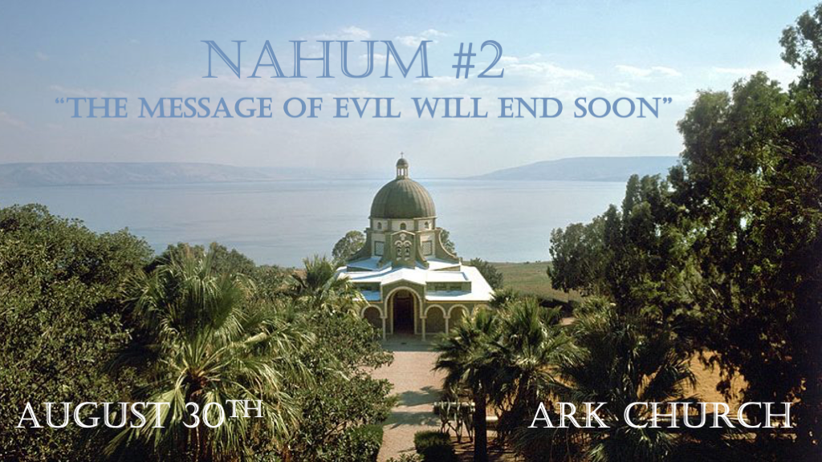
*Nahum name means comfort.
*Key Verses: Nahum 1:7 The LORD is good, a stronghold in the day of trouble; And He knows those who trust in Him.
Nahum 1:11 From you comes forth one who plots evil against the LORD, a wicked counselor.

*He who scatters is in the land right before a significant restoration.
*Nahum 2:1 He who scatters has come up before your face. Man the fort! Watch the road! Strengthen your flanks!
Fortify your power mightily.
2 For the LORD will restore the excellence of Jacob like the excellence of Israel, For the emptiers have emptied them out
and ruined their vine branches.

V:1 Nineveh represents a large Gentile pagan city that is at enmity with God and is destroyed by an invader.

Nineveh is destroyed by the hammer of the earth, Babylon. Jeremiah 50:23: How the hammer of the earth will be cut apart describing the destruction of Babylon.

Bible prophecy gives us four warnings.
Man the fort. In a day when masculinity is being destroyed, who will man up?

Watch the road. When many say the way is broad and love will win, all will go to heaven. Beware!

Strengthen your flanks. There is no spiritual armor that protects the back.

Fortify your power mightily. The source of our mighty power is always God.

V:2 The Assyrians destroyed the Northern kingdom of Israel and most of the ten tribes.
Now, the promise to the southern kingdom of restoration is Jacob and Israel.

The Emptiers: The plural use of the word empty reveals more than attackers destroyed the vine branches.

*Song of Solomon 2:15 Catch us the foxes, the little foxes that spoil the vines, for our vines have tender grapes.

Ezekiel 13:4 O Israel, thy prophets are like foxes in the desert.

*The Destruction of Nineveh and Much More.
*Nahum 2:3 The shields of his mighty men are made red, the valiant men are in scarlet. The chariots come with flaming torches
in the day of his preparation, and the spears are brandished. 4 The chariots rage in the streets, they jostle one another in the broad roads; They seem like torches, they run like lightning. 5 He remembers his nobles; They stumble in their walk; They make haste to her walls, and the defense is prepared. 6 The gates of the rivers are opened, and the palace is dissolved.
7 It is decreed: She shall be led away captive, she shall be brought up; And her maidservants shall lead her as with the voice of doves, beating their breasts.

V:3-4 Jewish tank named Merkava with the Hebrew meaning Chariot. (2022.)
Nahum sees all of this in a vision as a man who could only use his century language to describe what he saw.

Israel is not involved in the destruction of Nineveh. Babylon is the destroyer.

V:5-6 Nineveh and the Tigris River are being described. A future battle seems to be defined as well.

Nineveh's lack of noblemen brings an exciting twist to this destruction of its city.

Is this a prophecy for the future?

Prophecy can move immediately between are apart time periods.

V:7 Nineveh wasn't taken into captivity. Who could this be referring to?

Israel's captivity is apparent, but is there another captivity for a Gentile nation, city, or people group?

*The voice of your messengers shall be heard no more.
*Nahum 2:8 Though Nineveh of old was like a pool of water, now they flee away. "Halt! Halt!" they cry; But no one turns back.
9 Take spoil of silver! Take spoil of gold! There is no end of treasure, or wealth of every desirable prize. 10 She is empty, desolate, and waste! The heart melts, and the knees shake; Much pain is in every side, and all their faces are drained of color.
11 Where is the dwelling of the lions, and the feeding place of the young lions, Where the lion walked, the lioness and lion's cub, and no one made them afraid? 12 The lion tore in pieces enough for his cubs, killed for his lionesses, filled his caves with prey, and his dens with flesh.
13 "Behold, I am against you," says the LORD of hosts, "I will burn your chariots in smoke, and the sword shall devour your young lions; I will cut off your prey from the earth, and the voice of your messengers shall be heard no more."

V:8 The destruction of Nineveh was so complete no one could locate it for years.

Nineveh is wholly destroyed. They could not even be found until 1847 by British archeologists.

V:9-10 The Archaeologists who discovered Nineveh in the 19th century found no silver or gold.

Suppose gold or silver is your goal in life. When the wrath of God comes, it won't help.

V:11-13 The lion was the national emblem of the Assyrian empire. Even the young lion warriors don't survive.

The last key: The Lord of host is the one doing this, burning with fire.

The last message: The voice of evil and their messages will end!

