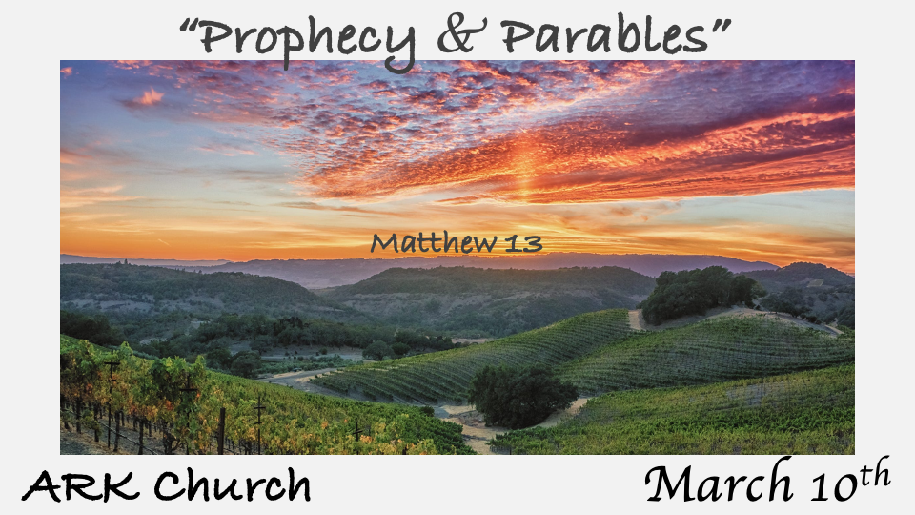

*Learning how to live a good, godly life in Christ Jesus.

*Matthew 13:3 Then He spoke many things to them in parables, saying: "Behold, a sower went out to sow.
V:8 But others fell on good ground and yielded a crop: some a hundredfold, some sixty, some thirty. 9 He who has ears to hear, let him hear!"
10 And the disciples came and said to Him, "Why do You speak to them in parables?"
11 He answered and said to them, "Because it has been given to you to know the mysteries of the kingdom of heaven, but to them it has not been given. 12 For whoever has, to him more will be given, and he will have abundance; but whoever does not have, even what he has will be taken away from him. 13 Therefore I speak to them in parables, because seeing they do not see, and hearing they do not hear, nor do they understand.

- *What makes the soil of your heart, good? The Word fertilizes it, has the correct supply of nutrients, and is protected by the Spirit of God. (Keeping us from the weeds).

The parable describes three other lifestyles that allow everything to enter or be entertained in their hearts, and nothing good can grow in those hearts.

- *Who receives the mysteries of the kingdom of heaven? The person who hears the Word of God understands it, accepts it, and keeps it. Matt. 13:23, Mark 4:20, and Luke 8:15.

Matthew 13:23 But he who received seed on the good ground hears the word and understands it, bears fruit and produces a crop some a hundredfold, some sixty, some thirty."
Mark 4:20 Adds: the one who hears the word and accepts it.
Luke 8:15 Adds: the one who hears the word and keeps it/retained it.

*Three Prophetic Parables about Wheat, Mustard Seeds, and Leaven

*Matthew 13:24 Another parable He put forth to them, saying: "The kingdom of heaven is like a man who sowed good seed in his field; 25 but while men slept, his enemy came and sowed tares among the wheat and went his way.

*Matthew 13:31 Another parable He put forth to them, saying: "The kingdom of heaven is like a mustard seed, which a man took and sowed in his field, 32 which indeed is the least of all the seeds; but when it is grown it is greater than the herbs and becomes a tree, so that the birds of the air come and nest in its branches."
33 Another parable He spoke to them: "The kingdom of heaven is like leaven, which a woman took and hid in three measures of meal till it was all leavened."
34 All these things Jesus spoke to the multitude in parables; and without a parable He did not speak to them, 35 that it might be fulfilled which was spoken by the prophet, saying: "I will open My mouth in parables; I will utter things kept secret from the foundation of the world."

- The 1st parable answers the most asked question. Why doesn't God do something about evil? The tares represent evil growing alongside the good (the wheat).

- *The best time to deal with evil (tares) is to wait till the end of the harvest process.

- *Evil will always be separated from the good, but it must come at the best time.

- The 2nd parable begins to answer mysteries of the Christian faith.

- *The Mustard seed of faith is the parable of the growth of the Church.

- *The birds in its branches are evil and are a warning to the Church.

- * It is also a warning to nations that reject God. A Trees does represent an empire in O.T. Daniel 4:10-27

All the previous parables warned against the corruption of God's Word and people.

The Mustard seed parable states that as the church starts small, it will grow large. The danger is in the teaching from the birds singing in the branches, signifying false teaching.

- The 3rd parable about leaven would be a deal breaker for listening Jews. Leaven is the symbol of sin.

G. Campbell Morgan 1863 – 1945 Evangelist from England said; This is the prophecy of the paganizing of Church with falsehoods.
V:34-35 All these things were hidden from the foundation of the world. Hidden from the O.T. is the Church and these prophecies about us.

*Hidden Treasure, a Pearl of Great Price, and the Dragnet Prophecies.

*Matthew 13:44 "Again, the kingdom of heaven is like treasure hidden in a field, which a man found and hid; and for joy over it he goes and sells all that he has and buys that field.
45 "Again, the kingdom of heaven is like a merchant seeking beautiful pearls, 46 who, when he had found one pearl of great price, went and sold all that he had and bought it.
47 "Again, the kingdom of heaven is like a dragnet that was cast into the sea and gathered some of every kind, 48 which, when it was full, they drew to shore; and they sat down and gathered the good into vessels, but threw the bad away. 49 So it will be at the end of the age. The angels will come forth, separate the wicked from among the just, 50 and cast them into the furnace of fire. There will be wailing and gnashing of teeth."
51 Jesus said to them, "Have you understood all these things?"
They said to Him, "Yes, Lord."
52 Then He said to them, "Therefore every scribe instructed concerning the kingdom of heaven is like a householder who brings out of his treasure things new and old."

- The previous three parables deal with corruption—the last three speak of a King who loves His kingdom and its people.

- The treasure and the pearl are insights into the kingdom of heaven.

The treasure in the field is the world, and the man is Jesus. We must see Jesus' view of this world as the potential of the treasure in our lives.

Jesus sold all that He had in heaven to purchase redemption for humanity.

The pearl is the great gift of Salvation, and again, Jesus gives up everything: His body, blood, and life to purchase it for all who would receive it.

- The 7th Parable is rightly the dragnet prophecy. At the end of time, a dragnet (rapture) will be cast, and only those who know and understand these seven parables and love and accept Jesus, the one who buys the land, purchased the great gift of salvation, will be taken with Him.

- The Last question Jesus asked them. Do you understand all these things? They answered, Yes! Go and tell the world what you know.

