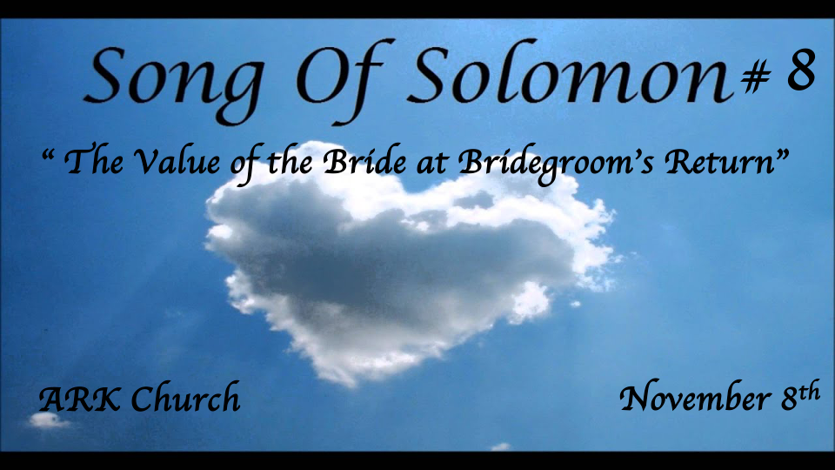
Reflections:
- Preparing for the Wedding feast
- At the Wedding banquet
- In the Bridal chambers (Shulamite)
- Courtship & the pain of separation
- The Wedding Procession (Shulamite)
- The Wedding Night (The Beloved)
- The Dream of Rejecting the Bridegroom
- The Return of the King
- The Dance of the Two Camps
- The Stability of the Beloved's Love
- Journey Out of the Wilderness
- The Family Gathering & the Vineyard

*The 10th Reflection Continues and a Third Warning in the Same Area.
*Song of Solomon 8:1-4

The Shulamite
1 Oh, that you were like my brother,
Who nursed at my mother’s breasts!
If I should find you outside,
I would kiss you;
I would not be despised.
2 I would lead you and bring you
Into the house of my mother,
She who used to instruct me.
I would cause you to drink of spiced wine,
Of the juice of my pomegranate.
To the Daughters of Jerusalem
3 His left hand is under my head,
And his right hand embraces me.
4 I charge you, O daughters of Jerusalem,
Do not stir up nor awaken love
Until it pleases.

Insights V:1-2 The Shulamite desired to show public affection.

Public affection wasn’t permissible except in certain family relations.

As a Bride, the desire is to grow in her ability to please her husband.

Insights V:2-3 The third time we see this embrace and the charge to the younger women.

- A hug is still a compelling part of intimacy.

- *V:4 Sexual passion should not be aroused where it cannot or should not be fulfilled.

- Song of Song 2:7 Is written In the context of marriage.

- Song of Song 3:5 Is written in the context of courtship.

- Song of Song 8:4 Until in its proper place and it pleases either or both husband and wife.

- The three above verses imply the profound truth about the differences between love and desire.

The deception that desire is love. “I love you but am not in love with you.” It is a statement communicating that I care about you, but I no longer desire you.

The daughters of Jerusalem were learning not to ignite desire because it doesn’t always lead to love.

The truth is love is more profound and longer-lasting than desire. Desire is something that must be controlled.

*The 11th Reflection: Out of the Wilderness & The 12th The Family Gathering
*Song of Solomon 8: 5-9

Unknown Voice
5 Who is this coming up from the wilderness,
Leaning upon her beloved?
I awakened you under the apple tree.
There your mother brought you forth;
There she who bore you brought you forth.
The Shulamite to Her Beloved
6 Set me as a seal upon your heart,
As a seal upon your arm;
For love is as strong as death,
Jealousy as cruel as the grave;
Its flames are flames of fire,
A most vehement flame.
7 Many waters cannot quench love,
Nor can the floods drown it.
If a man would give for love
All the wealth of his house,
It would be utterly despised.
The Shulamite’s Brothers
8 We have a little sister,
And she has no breasts.
What shall we do for our sister
In the day when she is spoken for?
9 If she is a wall,
We will build upon her
A battlement of silver;
And if she is a door,
We will enclose her
With boards of cedar.

Insight V:5 Who is this question? It comes up again as a person is coming up from the wilderness.
Song of song 3:6 Like a pillar of smoke that came out of the wilderness is pointing to God’s presence.

The wilderness is symbolic and literal—a place of provision and a time of testing. God is in both situations.

Insights V:6-7 The Value of Love from the Bridegroom for the Bride.
We are sealed with God’s love. We must learn not to let anything quench that love for God or our spouse.
Love (Salvation) cannot be purchased, and the attempts to buy it are met with scorn.

Insights V:8-9 Who will be the wall (protection) to this kind of love (Salvation)?
If the bride is like a door, she loses her value. She must always point to the Bridegroom.
If she takes on the role of a door, they will close it off with boards of cedar.

The 12th Reflection: The Gathering at the Vineyard
Song of Solomon 8:10-14

The Shulamite to her brothers
10 I am a wall,
And my breasts like towers;
Then I became in his eyes
As one who found peace.
11 Solomon had a vineyard at Baal Hamon;
He leased the vineyard to keepers;
Everyone was to bring for its fruit
A thousand silver coins.
To Solomon
12 My own vineyard is before me.
You, O Solomon, may have a thousand,
And those who tend its fruit two hundred.
The Beloved
13 You who dwell in the gardens,
The companions listen for your voice—
Let me hear it!
The Shulamite
14 Make haste, my beloved,
And be like a gazelle
Or a young stag
On the mountains of spices.

Insights to V:10 The bride declares her value as a protector because of the peace she found in the Bridegroom.
The Hebrew word for wall is a firm fortress standing against every assault.

Her breast-like towers are saying her honor is strong. The Bride realizes her value in the Savior’s eyes.

As the bride becomes like a tower/standard, she will find peace in her Savior’s eyes.

Insights to V:11-12 The King’s vineyards He leased some this may imply Israel. The Bride’s Vineyard could be a futuristic look at the Church. This is an Eschatological allegory.

Insights to V:13-14: For the married, whispering is the sign of tenderness and love.

Allegory: Are you ready to hear the bridegroom’s voice? The Bride is saying make haste, my beloved, and we are ready.

