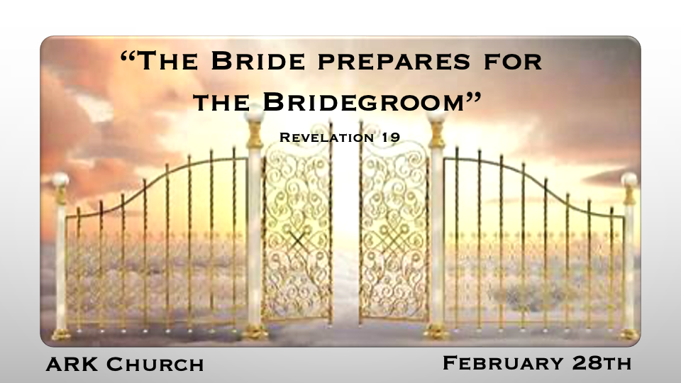
*Last week, Rev. 18:21 Then a mighty angel took up a stone like a great millstone and threw it into the sea, saying, “Thus with violence the great city Babylon shall be thrown down, and shall not be found anymore. 22 The sound of harpists, musicians, flutists, and trumpeters shall not be heard in you anymore. No craftsman of any craft shall be found in you anymore, and the sound of a millstone shall not be heard in you anymore. 23 The light of a lamp shall not shine in you anymore, and the voice of bridegroom and bride shall not be heard in you anymore.

Sun…Moon… and You
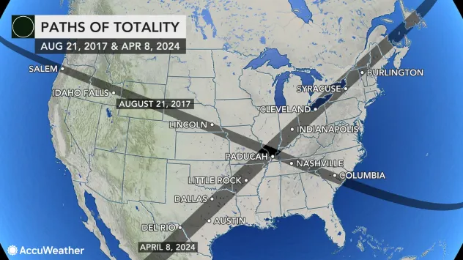
2017 width 70 miles (Psalm 90:10)
2024 width 120 miles (Genesis 6:3)
The X Centers over an area called Little Egypt (Ezekiel 37:15-23)

In 2017, it covered 12 cities named Salem
In 2024, it will cover 5 cities named Salem

In 2024, it covers 1 city named Nineveh

An Eclipse that crosses a Nation or Empire is a sign of judgment.
Examples: Assyria Empire, 710 B.C. Ottoman/Turk Empire Aug. 21, 1914

*Getting ready for the call to the marriage supper of the Lamb.
*Revelation 19:1 After these things I heard a loud voice of a great multitude in heaven, saying, “Alleluia! Salvation and glory and honor and power belong to the Lord our God! 2 For true and righteous are His judgments, because He has judged the great harlot who corrupted the earth with her fornication; and He has avenged on her the blood of His servants shed by her.” 3 Again they said, “Alleluia! Her smoke rises up forever and ever!” 4 And the twenty-four elders and the four living creatures fell down and worshiped God who sat on the throne, saying, “Amen! Alleluia!” 5 Then a voice came from the throne, saying, “Praise our God, all you His servants and those who fear Him, both small and great!”
6 And I heard, as it were, the voice of a great multitude, as the sound of many waters and as the sound of mighty thunderings, saying, “Alleluia! For the Lord God Omnipotent reigns! 7 Let us be glad and rejoice and give Him glory, for the marriage of the Lamb has come, and His wife has made herself ready.” 8 And to her it was granted to be arrayed in fine linen, clean and bright, for the fine linen is the righteous acts of the saints.
9 Then he said to me, “Write: Blessed are those who are called to the marriage supper of the Lamb!’ ” And he said to me, “These are the true sayings of God.” 10 And I fell at his feet to worship him. But he said to me, “See that you do not do that! I am your fellow servant, and of your brethren who have the testimony of Jesus. Worship God! For the testimony of Jesus is the spirit of prophecy.”

- *V:1-5 Babylon the Great Harlot is judged, and the response is “Amen! Alleluia!

Praise our God, all you, His servants, and those who fear Him, both small and great!”

- *V:6-8 The preparation for the Wedding Banquet has two important announcements.
- The Lord God Omnipotent reigns!
- The Bride made herself ready. How?
- The Bride gives God the glory for what His Son has done.
- She is granted fine linens, clean and bright. She has embraced righteousness.

- *V:9-10 The Bride was ready because she understood the testimony of Jesus is the spirit of prophecy.

*In righteousness, He judges and makes war.

*Revelation 19:11 Now I saw heaven opened, and behold, a white horse. And He who sat on him was called Faithful and True, and in righteousness He judges and makes war. 12 His eyes were like a flame of fire, and on His head were many crowns. He had a name written that no one knew except Himself. 13 He was clothed with a robe dipped in blood, and His name is called The Word of God. 14 And the armies in heaven, clothed in fine linen, white and clean, followed Him on white horses. 15 Now out of His mouth goes a sharp sword, that with it He should strike the nations. And He Himself will rule them with a rod of iron. He Himself treads the winepress of the fierceness and wrath of Almighty God.
16 And He has on His robe and on His thigh a name written: KING OF KINGS AND LORD OF LORDS.

V:11 Christians must not stay neutral in the righteousness of Christ; we, too, are in a war and judge sin but not the sinner.

V:12-13 Jesus has a name that we must identify with; it is the Word of God

V:14-16 The armies of heaven follow Jesus into the battle of evil. War and following Jesus are more than futuristic ideas; they are a here-and-now union.

*The Final war is not nations against nations and a different banquet.

*Revelation 19:17 Then I saw an angel standing in the sun; and he cried with a loud voice, saying to all the birds that fly in the midst of heaven, “Come and gather together for the supper of the great God, 18 that you may eat the flesh of kings, the flesh of captains, the flesh of mighty men, the flesh of horses and of those who sit on them, and the flesh of all people, free and slave, both small and great.”
19 And I saw the beast, the kings of the earth, and their armies, gathered together to make war against Him who sat on the horse and against His army. 20 Then the beast was captured, and with him the false prophet who worked signs in his presence, by which he deceived those who received the mark of the beast and those who worshiped his image. These two were cast alive into the lake of fire burning with brimstone. 21 And the rest were killed with the sword which proceeded from the mouth of Him who sat on the horse. And all the birds were filled with their flesh.

- *V:17-18 The loud warning or invitation? Both great and small will be offered up to the birds as a feast because of their evil.

- *V:19 The armies of the earth gather to make war against Him; Jesus is the subject of the final battle, not Israel.

*Psalm 2:1 Why do the nations rage,
And the people plot a vain thing?
2 The kings of the earth set themselves,
And the rulers take counsel together,
Against the LORD and against His Anointed, saying,
3 “Let us break Their bonds in pieces
And cast away Their cords from us.”

