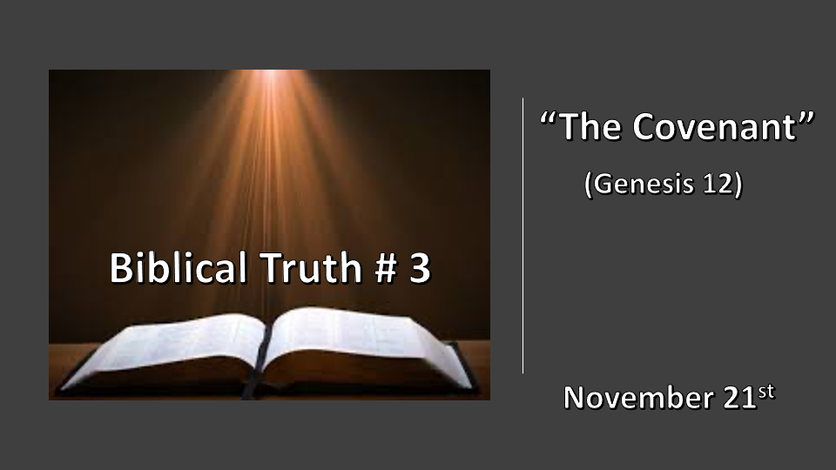

*Psalm 11: 3 When the foundations are being destroyed, what can the righteous do?"

Five Biblical truths that will determine how you view the Bible, God, and our choices.
- A place of refuge & the wrath of God. Genesis 6 & 7
- Making a name without God. (Defining deception) Genesis 10 & 11
- *The Covenants of Abraham and David. Genesis 12, 2 Samuel 7:16 & Luke 1:32
- The Nation of Israel. Genesis 32:28
- The remnant and its role. Genesis 45:7

*Genesis 12:1 The LORD had said to Abram, "Go from your country, your people and your father's household to the land I will show you.
2 "I will make you into a great nation, and I will bless you; I will make your name great, and you will be a blessing.
3 I will bless those who bless you, and whoever curses you I will curse; and all peoples on earth will be blessed through you."
*Genesis 3:3 NKJV I will bless those who bless you, And I will curse him who curses you; And in you all the families of the earth shall be blessed.”

*A Seven-fold Covenant

- Who makes a nation great? (God) Genesis 15:4-5

- What is a blessing from God? It’s something beyond favor or fortune, it has more to do with enlarging your territory and influence.

- A great name is for identification and is attached to spiritual paths.

- What then does it mean to be a blessing?

- Reciprocity is the mutual benefit for the people or country that blesses Israel. Two groups of people have experienced this promise. (The United States and The Church)

- The exchange God will curse those who curse the people or country of Israel.

- Israel will have a world influence. All the world has been and will be blessed through Israel. The key blessings are to families and beyond. Galatians 3:8-9 (The Original blessing)

*2 Samuel 7:8 "Now then, tell my servant David, 'This is what the LORD Almighty says: I took you from the pasture, from tending the flock, and appointed you ruler over my people Israel. 9 I have been with you wherever you have gone, and I have cut off all your enemies from before you. Now I will make your name great, like the names of the greatest men on earth. 10 And I will provide a place for my people Israel and will plant them so that they can have a home of their own and no longer be disturbed. Wicked people will not oppress them anymore, as they did at the beginning 11 and have done ever since the time I appointed leaders over my people Israel. I will also give you rest from all your enemies. " 'The LORD declares to you that the LORD himself will establish a house for you: 12 When your days are over and you rest with your ancestors, I will raise up your offspring to succeed you, your own flesh and blood, and I will establish his kingdom. 13 He is the one who will build a house for my Name, and I will establish the throne of his kingdom forever. 14 I will be his father, and he will be my son. When he does wrong, I will punish him with a rod wielded by men, with floggings inflicted by human hands. 15 But my love will never be taken away from him, as I took it away from Saul, whom I removed from before you. 16 Your house and your kingdom will endure forever before me; your throne will be established forever. ' "

17 Nathan reported to David all the words of this entire revelation.

*An eternal and unconditional covenant.

- 2 Samuel 7:9 When God makes a “Name” great it is because that name will bring eternal glory to God and His purposes.

- 2 Samuel 7:11 A promise of rest to David is pointing to a promising time in our future.

- V:12-16 Is about the answer to the prayer you prayed as a child. Matthew 6:9-15

*Luke 1:30 But the angel said to her, "Do not be afraid, Mary; you have found favor with God. 31 You will conceive and give birth to a son, and you are to call him Jesus. 32 He will be great and will be called the Son of the Most High. The Lord God will give him the throne of his father David, 33 and he will reign over Jacob's descendants forever; his kingdom will never end."

*Isaiah 9:6 For to us a child is born, to us a son is given, and the government will be on his shoulders. And he will be called Wonderful Counselor, Mighty God, Everlasting Father, Prince of Peace.

7 Of the greatness of his government and peace there will be no end. He will reign on David's throne and over his kingdom, establishing and upholding it with justice and righteousness from that time on and forever. The zeal of the LORD Almighty will accomplish this.

*The forever witness of God’s Word.

- The activator of Biblical truth is the witness of scripture where at least 2 verify the truth. Luke 24:4

- The connector of the unconditional Biblical covenant is not tied to human obedience but is held together by the promises of God. 2 Samuel 7:16, Isaiah 9:7, and Luke 1:30 and it is sealed through three witnesses.

