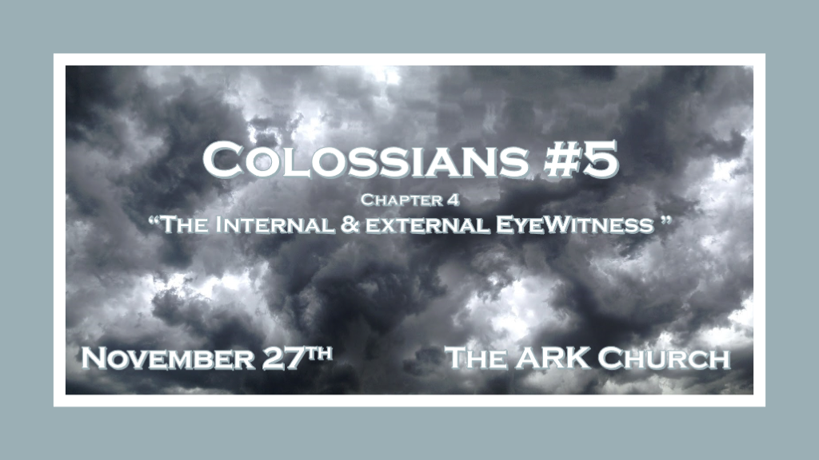

*How can we redeem the times we live in?

*Colossians 4:1 Masters, give your bondservants what is just and fair, knowing that you also have a Master in heaven.

*Colossians 3:1 If then you were raised with Christ, seek those things which are above, where Christ is, sitting at the right hand of God. 2 Set your mind on things above, not on things on the earth. 3 For you died, and your life is hidden with Christ in God. 4 When Christ who is our life appears, then you also will appear with Him in glory.

*Colossians 4:2 Continue earnestly in prayer, being vigilant in it with thanksgiving; 3 meanwhile praying also for us, that God would open to us a door for the word, to speak the mystery of Christ, for which I am also in chains, 4 that I may make it manifest, as I ought to speak.
5 Walk in wisdom toward those who are outside, redeeming the time. 6 Let your speech always be with grace, seasoned with salt, that you may know how you ought to answer each one.

- Colossians 4:1 We have job to do! We can never work for our (transformation) salvation, but we must give witness to the internal changes and become an external witnesses to others.
- Colossians 3:1 Reminds us that we should seek an added dimension to our focus on the things that are above.

- Colossians 3:2 & 4:2 The connection with the above is done through prayer.
- Earnest: Sincere and intense conviction, steadfast.
- Vigilant: Keeping careful watch for danger. Being on the outlook or a watchman.

- Colossians 4:3 Looking for opportunities to speak the mysteries of Christ and the Word of God.

The opportunities that are the most powerful happen from Monday through Saturday.

- V:4-5 Walking in wisdom is a key ingredient to redeeming the times.
The fear of the Lord is the beginning of wisdom.

- V:6 Our communication is transformed by grace & salt (Not antifungal) safeguarding the Word of God.
But seasoning the Word so we can taste and see that the Lord is good. This practice is real grace

- You will not know or understand these answers if you’re not a Biblical Worldview person.

A person whose focus is on the things above will be a Biblical Worldview person, have a Kingdom of God mindset, and understands the bottom line is a life transformed.

*The external or living eyewitnesses we all need.

*Colossians 4:7 Tychicus, a beloved brother, faithful minister, and fellow servant in the Lord, will tell you all the news about me. 8 I am sending him to you for this very purpose, that he may know your circumstances and comfort your hearts, 9 with Onesimus, a faithful and beloved brother, who is one of you. They will make known to you all things which are happening here.
10 Aristarchus my fellow prisoner greets you, with Mark the cousin of Barnabas (about whom you received instructions: if he comes to you, welcome him), 11 and Jesus who is called Justus. These are my only fellow workers for the kingdom of God who are of the circumcision; they have proved to be a comfort to me.
12 Epaphras, who is one of you, a bondservant of Christ, greets you, always laboring fervently for you in prayers, that you may stand perfect and complete in all the will of God. 13 For I bear him witness that he has a great zeal for you, and those who are in Laodicea, and those in Hierapolis. 14 Luke the beloved physician and Demas greet you. 15 Greet the brethren who are in Laodicea, and Nymphas and the church that is in his house.

- V:7-9 Tychicus & Onesimus: Faithful ministers and brothers that know how to comfort the hearts of people.
Tychicus was from Colosse and Onesimus had a rare gift he could comfort the laity and leaders.

- V:10-11 Aristarchus, Mark & Justus: Fellow workers in the kingdom that know how to comfort leaders.
Mark is the author of the Gospel that bears his name

- V:12-13 Epaphras: A person of prayer who is also a teacher willing to show us how to stand and be in the will of God.

We need those who have a zeal for those living in Laodicea.

- V:14-15 Luke, Demas, & Nymphas: Luke author of the Gospel of Luke and a faithful follower, Demas who in 2 Timothy loved the world. Nymphas was a pastor of a house church.

*Take heed this epistle that we may fulfill it.

*Colossians 4:16 Now when this epistle is read among you, see that it is read also in the church of the Laodiceans, and that you likewise read the epistle from Laodicea. 17 And say to Archippus, “Take heed to the ministry which you have received in the Lord, that you may fulfill it.”
- This salutation by my own hand—Paul. Remember my chains. Grace be with you. Amen.

- V:16 The public reading of the scriptures.

This and the Book of Revelations that tells us about the last age church of Laodicea speak of the public reading the scriptures. Parents/Grandparents take up the reading of the Word to your families.

- V:17-18 Take care of the ministry.

The ministry is the body of Christ. Most churches have taken up a social ministry to non-believers. We need wisdom in ministry today more than ever before.

