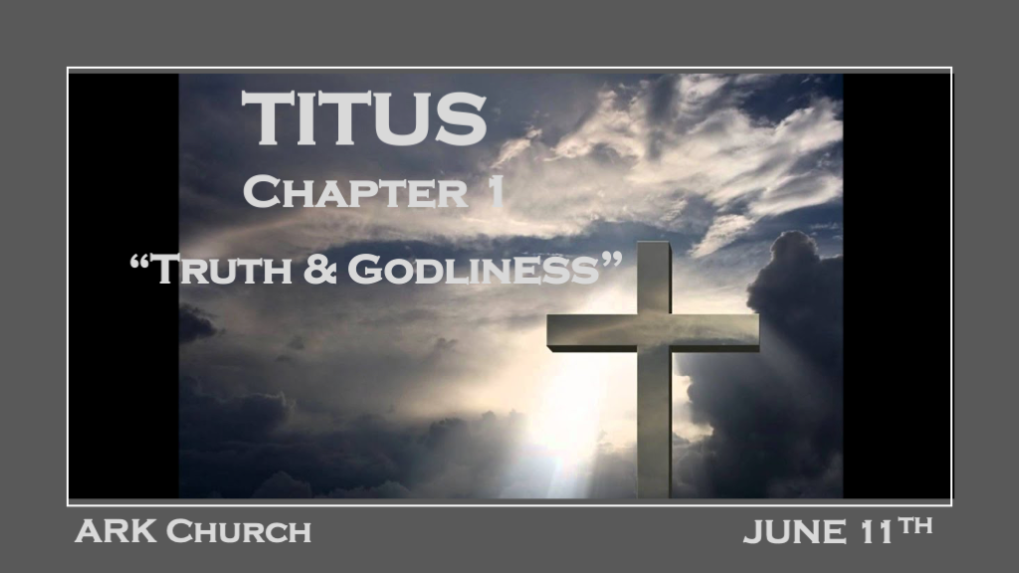
*If you are willing to fight for truth, how much more should you support godliness/sacredness?

*Step One: Acknowledge The Truth that Leads to Godliness.

*Titus 1:1 Paul, a bondservant of God and an apostle of Jesus Christ, according to the faith of God’s elect and the acknowledgment of the truth which accords with godliness, 2 in hope of eternal life which God, who cannot lie, promised before time began, 3 but has in due time manifested His word through preaching, which was committed to me according to the commandment of God our Savior;
4 To Titus, a true son in our common faith:
Grace, mercy, and peace from God the Father and the Lord Jesus Christ our Savior.

V:1 Paul was on the island of Crete with Titus. He left him there to be the Overseer of many churches.

All letters written by the Holy Spirit to the Churches were to be read in public.

In Paul’s opening, he attaches the bond between truth and godliness.

We are also dealing with a significant disconnect between truth and leading a godly lifestyle in this generation.
Science may show man’s intellectual advances, but nothing in science leads to eternal life.

V:2 The reinforcing of eternal truths. We must fortify the truth about the hope that it doesn’t disappoint. Romans 5:5

Eternal life is our Hope in God/Christ. This truth is anchored with God cannot lie.
A new insight, the Hope of eternal life, is a promise before time began.

V:3-4 The truths Paul has introduced were not always obvious.

The eternal truths manifested through God’s Word, preaching, and Paul’s Calling to the Kingdom of God.
Titus, a true son! God and our Church are looking for true sons and daughters of the faith.

*Step Two: Set things in order that are lacking in leadership.
*Titus 1:5 For this reason I left you in Crete, that you should set in order the things that are lacking, and appoint elders in every city as I commanded you— 6 if a man is blameless, the husband of one wife, having faithful children not accused of dissipation or insubordination. 7 For a bishop must be blameless, as a steward of God, not self-willed, not quick-tempered, not given to wine, not violent, not greedy for money, 8 but hospitable, a lover of what is good, sober-minded, just, holy, self-controlled, 9 holding fast the faithful word as he has been taught, that he may be able, by sound doctrine, both to exhort and convict those who contradict.

V:5 When things are lacking, raise up leaders.

The island of Crete was the Church. Now they are going to every city.

V:6-9 Where do we find these kinds of leaders? Elder is a leading forefather, and Bishop is an overseer of the Church or steward of God.

V:6 Nothing has taken hold of him that could hold on to him. (Blameless is not perfect)
V:6 Training up their Children in the way they should go.
V:7 Under God’s will, the Holy Spirit tempers their emotions and actions.
V:8-9 Holds faithful to the Word and has sound doctrine. Must be able to exhort and convict those who contradict God’s Word.

*Leaders that will deal with insubordinate and deceivers.

*Titus 1:10 For there are many insubordinate, both idle talkers and deceivers, especially those of the circumcision, 11 whose mouths must be stopped, who subvert whole households, teaching things which they ought not, for the sake of dishonest gain. 12 One of them, a prophet of their own, said, “Cretans are always liars, evil beasts, lazy gluttons.” 13 This testimony is true. Therefore rebuke them sharply, that they may be sound in the faith, 14 not giving heed to Jewish fables and commandments of men who turn from the truth. 15 To the pure all things are pure, but to those who are defiled and unbelieving nothing is pure; but even their mind and conscience are defiled. 16 They profess to know God, but in works they deny Him, being abominable, disobedient, and disqualified for every good work.

V:10-11 Those who reject God’s Word, love to talk and intellectually play mind-deceiving games about the Bible. (Greek Study insights)
They teach things that ought not to be taught.

They believe they are spiritual but are dishonest, and they prosper from teaching treacherous falsehoods.

V:12-14 Difficult problems and what to do about them.

*Paul didn’t say to Titus, “Cretans are liars and cheats and gluttons, with one of the worst reputations of any group in the Roman Empire. You should look for an easier group to work with.” Instead, he said, “I know how bad they are. Go out and change them with the power of Jesus and for His glory.”

Personal Testimony: We all deal with people who aren’t easy to work with. Hopefully, you will add this insight to your call from God to believe in the power of change.

The scripture says to rebuke them sharply. Sadly, in today’s world, people want to rebuke the Pastor sharply.

They tell all their friends when the Pastor, in a last-ditch effort, rebukes them sharply.

The most challenging problem is dealing with people who have turned from the truth and are believing deceptive lies.

Sometimes after sharing the truth with them, you must depart from fellowship with them.

V:15-16 Upside down people and their Character. (Beware, this is not the heathen but the spiritual person.)

To the defiled and unbelieving people, nothing is pure. Their minds and spirits have become contaminated.

V:16 Abominable/idolatry, disobedient by willfully refusing God, and disqualified are terrible words, but the worst was they deny God.

