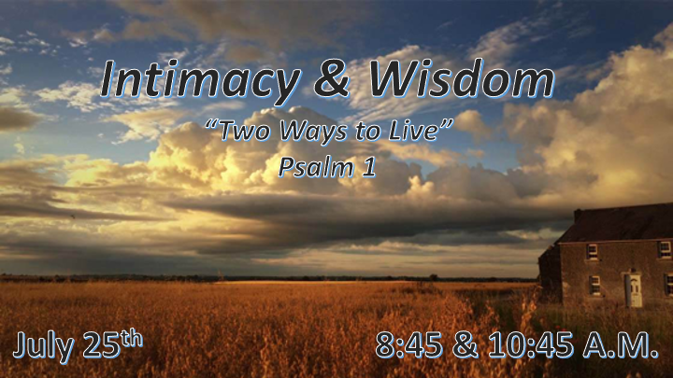

*Do you know how to connect your heart and mind with God?

Overview Psalm and Proverbs

- The goal of these books is to lead us to a focused, aggressive, and dynamic life.
- What’s beyond obedience to God? Answer: Intimacy and the Wisdom of God.
- We are to live as the clean people of this world. Illustration: The clean animals did what?
- Meditating on the Word of God.* “Meditation is to the soul what digestion is to the body” ~ Chuck Missler Jer. 15:16-17, Ezekiel 3:3, and Revelation 10:9
- Both books give us the practical instructions of Hebrew poetry. You will see God’s patterns.

*Psalm 1:1 Blessed is the one who does not walk in step with the wicked or stand in the way that sinners take or sit in the company of mockers,
2 but whose delight is in the law of the LORD, and who meditates on his law day and night.
3 That person is like a tree planted by streams of water, which yields its fruit in season and whose leaf does not wither—whatever they do prospers.
4 Not so the wicked! They are like chaff that the wind blows away.
5 Therefore the wicked will not stand in the judgment, nor sinners in the assembly of the righteous.
6 For the LORD watches over the way of the righteous, but the way of the wicked leads to destruction.

*Two Men, Two Ways to live, and Two Destinies.

- V:1 We can see the progression of the ungodly lifestyle.

- V:2-4 Those who love God’s Word and draw fruit from it, they will not be blown away by wickedness.

- V:5-6 One will have their ways watched over. The other will go to destruction.

*Luke 24:44-45 Will you allow Jesus to open your minds to the scriptures?

*Psalm 2:1 Why do the nations conspire and the peoples plot in vain?
2 The kings of the earth rise up and the rulers band together against the LORD and against his anointed, saying,
3 "Let us break their chains and throw off their shackles." (KJV) 3 Let us break their bands asunder, and cast away their cords from us.

The Coming War Between Humanity and God.

- Over 3,000 years ago a prophecy of Nations plotting an uprising against God. (Acts 4:24-31)

- Globalization will gain speed as the world leaders come together against God. (Gen. 2:15-25)

- They will communicate it (This breaking away) as true freedom for humanity.

*Psalm 2:4 The One enthroned in heaven laughs; the Lord scoffs at them.
5 He rebukes them in his anger and terrifies them in his wrath, saying,
6 "I have installed my king on Zion, my holy mountain."
7 I will proclaim the LORD's decree: He said to me, "You are my son; today I have become your father.
8 Ask me, and I will make the nations your inheritance, the ends of the earth your possession.
9 You will break them with a rod of iron; you will dash them to pieces like pottery."

*Nothing can stop the Kingdom of God.

- Jesus installed as King is a done deal!
- The Coming Kingdom Psalm 46 (God is our refuge in time of troubles.)
- The Range of Kingdom Psalm 47 (Shout to God with triumph for He is king over all the earth.)
- The Center of the Kingdom Psalm 48 (Great is the Lord, and greatly to be praised in the city of our God. Zion!)

- V:9 The Potter has authority over the clay.

*Psalm 2:10 Therefore, you kings, be wise; be warned, you rulers of the earth.
11 Serve the LORD with fear and celebrate his rule with trembling.
12 Kiss his son, or he will be angry and your way will lead to your destruction, for his wrath can flare up in a moment. Blessed are all who take refuge in him.

*The Wise and Warned hear the voice of the Holy Spirit

- Psalm 2 What voice are you listening to?
- V:1-3 The voice of the Nations.
- V:4-6 The voice of the Father.
- V:7-9 The voice of the Son (Jesus.)
- V:10-12 The voice of Holy Spirit.

- V:12 Learn the behavior of taking refuge in Jesus.

