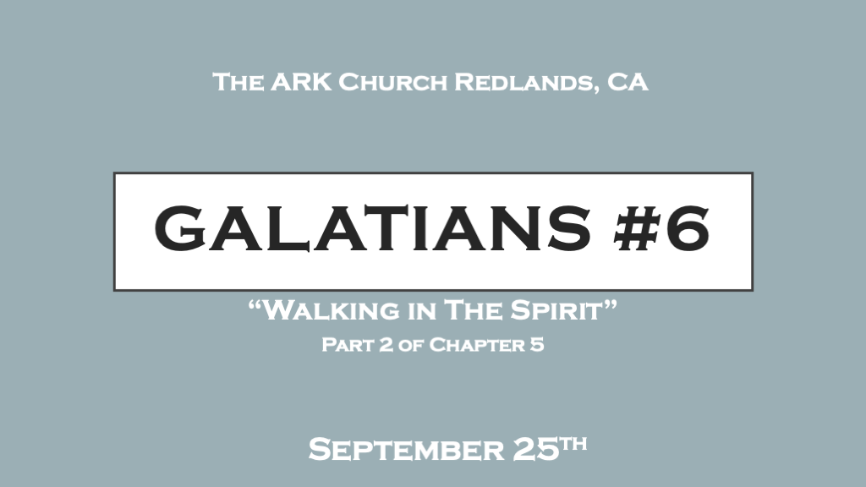

Learning the ways of the Holy Spirit starts with greater self-awareness.

*Growing in the Spirit starts with being sensitive to the Holy Spirit.
*Galatians 5:16 I say then: Walk in the Spirit, and you shall not fulfill the lust of the flesh. 17 For the flesh lusts against the Spirit, and the Spirit against the flesh; and these are contrary to one another, so that you do not do the things that you wish. 18 But if you are led by the Spirit, you are not under the law.
19 Now the works of the flesh are evident, which are: adultery, fornication, uncleanness, lewdness, 20 idolatry, sorcery, hatred, contentions, jealousies, outbursts of wrath, selfish ambitions, dissensions, heresies, 21 envy, murders, drunkenness, revelries (orgies), and the like; of which I tell you beforehand, just as I also told you in time past, that those who practice such things will not inherit the kingdom of God.

- V:16-17 Walking in the Spirit is a relational term. With a “New insight,” you are moving to the Spiritual side of life when you are more aware of your regret.
When you are aware that you’ve grieved the Holy Spirit it is a sign you’re in a relationship with God.

- V:19-21 The Mature Christian is Unadulterated, Pure, God-centered, Spirit-empowered, Life-focused, Sober, and enjoys Koinonia (Christian fellowship).
- The Sexual revolution is where the great apostasy possibly started. “Free love” cost us everything.

- What came out of the shadows as signs of enlightenment, freedom, and power of choice was actually bondage to evil spirits.

- The post-Christian era is worse off than the world of paganism.

*Matthew 12:43-45 "When an impure spirit comes out of a person, it goes through arid places seeking rest and does not find it. 44 Then it says, 'I will return to the house I left.' When it arrives, it finds the house unoccupied, swept clean, and put in order. 45 Then it goes and takes with it seven other spirits more wicked than itself, and they go in and live there. And the final condition of that person is worse than the first. That is how it will be with this wicked generation."
*2 Peter 2:20 If they have escaped the corruption of the world by knowing our Lord and Savior Jesus Christ and are again entangled in it and are overcome, they are worse off at the end than they were at the beginning.

The Christian life is not a flip-flop life; it’s a commitment to relational direction with God.

*Fruit is the result of being rooted and drawing life from the Holy Spirit.

*Galatians 5:22 But the fruit of the Spirit is love, joy, peace, longsuffering, kindness, goodness, faithfulness, 23 gentleness, self-control. Against such there is no law. 24 And those who are Christ’s have crucified the flesh with its passions and desires. 25 If we live in the Spirit, let us also walk in the Spirit. 26 Let us not become conceited, provoking one another, envying one another.

- V:22 Tips to producing healthy fruit trees.
- Don’t plant it in a place that has had a fungus problem. Planting in a new unused site is best.
Beware of what’s in the soil only a healthy sow is promised to give a return Matthew 13, Mark 4, & Luke 8.

- Keep it well water. This must be monitored.
Jesus is living water. If you drink from him you won’t be thirsty for the sinful side of life.

- Prune it immediately.
The pruning process produces faster and healthier fruit.

- V:22 The Fruit of Love.
*1 Corinthians 13:4 Love suffers long and is kind; love does not envy; love does not parade itself, is not puffed up; 5 does not behave rudely, does not seek its own, is not provoked, thinks no evil; 6 does not rejoice in iniquity, but rejoices in the truth; 7 bears all things, believes all things, hopes all things, endures all things.8 Love never fails.

The Holy Spirit’s 1st fruit helps us with the concept that the Spirit's life will help us get our eyes off ourselves.
This evidence of a Spirit-filled life grows us up rather quickly. In marriages, Churches (The bride), Christian businesses, and Christian relationships the concept of love is selfless love are present.

- V:22 The fruit of joy.
John 16:19 Now Jesus knew that they desired to ask Him, and He said to them, “Are you inquiring among yourselves about what I said, ‘A little while, and you will not see Me; and again a little while, and you will see Me’? 20 Most assuredly, I say to you that you will weep and lament, but the world will rejoice; and you will be sorrowful, but your sorrow will be turned into joy. 21 A woman, when she is in labor, has sorrow because her hour has come; but as soon as she has given birth to the child, she no longer remembers the anguish, for joy that a human being has been born into the world. 22 Therefore you now have sorrow; but I will see you again and your heart will rejoice, and your joy no one will take from you.
23 “And in that day you will ask Me nothing. Most assuredly, I say to you, whatever you ask the Father in My name He will give you. 24 Until now you have asked nothing in My name. Ask, and you will receive, that your joy may be full.

Joy is being with Jesus; it’s looking for Jesus’ involvement in your life. Realizing that Jesus wants to fill your joy tank.

*Psalm 16:11You will show me the path of life;
In Your presence is fullness of joy;
At Your right hand are pleasures forevermore.

- V:22 The fruit of peace.

*John 14:25 “These things I have spoken to you while being present with you. 26 But the Helper, the Holy Spirit, whom the Father will send in My name, He will teach you all things, and bring to your remembrance all things that I said to you. 27 Peace I leave with you, My peace I give to you; not as the world gives do I give to you. Let not your heart be troubled, neither let it be afraid.

How Jesus gives you peace is in an opposite way the world gives it.
*Philippians 4:6-7 His peace guards your heart and mind.
The world gives peace along with the promise of safety.

Jesus gives a peace that is supernatural not dependent on circumstances or safety.
Jesus' in John 14 goes on to say our peace is based on His promise of coming & taking us where He is.

