A Disturbing Warning (Daniel 8:25) He will cause deceit to prosper, and he will consider himself superior. When they feel secure, he will destroy many and take his stand against the Prince of princes. Yet he will be destroyed, but not by human power.

*Daniel11:1 And in the first year of Darius the Mede, I took my stand to support and protect him.)
2 "Now then, I tell you the truth: Three more kings will arise in Persia, and then a fourth, who will be far richer than all the others. When he has gained power by his wealth, he will stir up everyone against the kingdom of Greece. 3 Then a mighty king will arise, who will rule with great power and do as he pleases. 4 After he has arisen, his empire will be broken up and parceled out toward the four winds of heaven. It will not go to his descendants, nor will it have the power he exercised, because his empire will be uprooted and given to others.
5 "The king of the South will become strong, but one of his commanders will become even stronger than he and will rule his own kingdom with great power. 6 After some years, they will become allies. The daughter of the king of the South will go to the king of the North to make an alliance, but she will not retain her power, and he and his power will not last. In those days she will be betrayed, together with her royal escort and her father and the one who supported her. 7 "One from her family line will arise to take her place. He will attack the forces of the king of the North and enter his fortress; he will fight against them and be victorious. 8 He will also seize their gods, their metal images and their valuable articles of silver and gold and carry them off to Egypt. For some years he will leave the king of the North alone. 9 Then the king of the North will invade the realm of the king of the South but will retreat to his own country. 10 His sons will prepare for war and assemble a great army, which will sweep on like an irresistible flood and carry the battle as far as his fortress.

The Silent Years of the Bible

- V:1The angel came to also protect a world leader.

- V:2-35 Three more Persian kings will come. Alexander the Great will appear on the scene and the Greek empire will split into 4 empires. We learn who the kings of the south and north.

The Blue Letter Commentary: Study Guide for Daniel 11
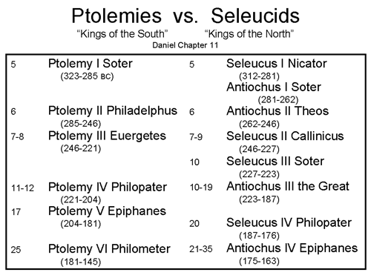
*Daniel 11:21 "He will be succeeded by a contemptible person who has not been given the honor of royalty. He will invade the kingdom when its people feel secure, and he will seize it through intrigue.

*Daniel 11:36 "The king will do as he pleases. He will exalt and magnify himself above every god and will say unheard-of things against the God of gods. He will be successful until the time of wrath is completed, for what has been determined must take place. 37 He will show no regard for the gods of his ancestors or for the one desired by women, nor will he regard any god, but will exalt himself above them all. 38 Instead of them, he will honor a god of fortresses; a god unknown to his ancestors he will honor with gold and silver, with precious stones and costly gifts. 39 He will attack the mightiest fortresses with the help of a foreign god and will greatly honor those who acknowledge him. He will make them rulers over many people and will distribute the land at a price.

The King who is against God

- V:21 The pattern revealed how the evil rulers came when the people felt secure. *1st Thess. 5:1-3 Now, brothers and sisters, about times and dates we do not need to write to you, 2 for you know very well that the day of the Lord will come like a thief in the night. 3 While people are saying, "Peace and safety," destruction will come on them suddenly, as labor pains on a pregnant woman, and they will not escape. (Daniel 8:25)

- V:36 A successful evil ruler that will speak against every god & say unheard-of things against our God.

- V:37-39 The Anti-Christ establishes a new religion? What nationality is he? How will Israel accept him? Two things to remember.

*Daniel 11: 40 "At the time of the end the king of the South will engage him in battle, and the king of the North will storm out against him with chariots and cavalry and a great fleet of ships. He will invade many countries and sweep through them like a flood. 41 He will also invade the Beautiful Land. Many countries will fall, but Edom, Moab and the leaders of Ammon will be delivered from his hand. 42 He will extend his power over many countries; Egypt will not escape. 43 He will gain control of the treasures of gold and silver and all the riches of Egypt, with the Libyans and Cushites in submission. 44 But reports from the east and the north will alarm him, and he will set out in a great rage to destroy and annihilate many. 45 He will pitch his royal tents between the seas at the beautiful holy mountain. Yet he will come to his end, and no one will help him.

Wars and a place of refuge

- V:40-41 Two nations will come against the anti-Christ but they will be defeated. God designed an escape for Israel’s remnant. *Matthew 24:15 "So when you see standing in the holy place 'the abomination that causes desolation,' spoken of through the prophet Daniel—let the reader understand— 16 then let those who are in Judea flee to the mountains.

- V:42-45 The Beast: Cruel ___________ like a beast. ___________ roar like a lion. Strong as a ___________. Fast as a Leopard. This is the Bible repeating itself.

