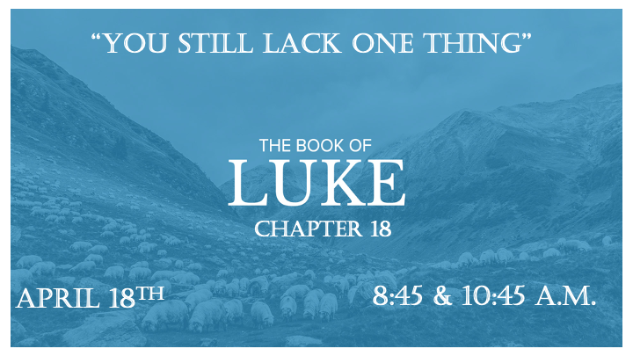

*Can you determine what one thing you need?

*Luke 18:1 1 Then Jesus told his disciples a parable to show them that they should always pray and not give up. 2 He said: “In a certain town there was a judge who neither feared God nor cared what people thought. 3 And there was a widow in that town who kept coming to him with the plea, 'Grant me justice against my adversary.'
4 "For some time he refused. But finally, he said to himself, 'Even though I don't fear God or care what people think, 5 yet because this widow keeps bothering me, I will see that she gets justice so that she won't eventually come and attack me!' "
6 And the Lord said, "Listen to what the unjust judge says. 7 And will not God bring about justice for his chosen ones, who cry out to him day and night? Will he keep putting them off? 8 I tell you, he will see that they get justice, and quickly. However, when the Son of Man comes, will he find faith on the earth?"

Who removes the obstacles to your need?

- V:1-2 Luke talks more about widows than any other gospel. She had three obstacles, her adversary, lack of access to a judge, and she had no advocate.

- V:4-7 The parable is a contrast not a comparison to God. If an unjust judge will give justice to a persistent woman, then how much more will God answer our prayers.

- V:8 Misplaced or a lack of faith is a reality in every generation. The sign of the end is the shortage of belief within the faith community.

*Luke 18:9 To some who were confident of their own righteousness and looked down on everyone else, Jesus told this parable: 10 "Two men went up to the temple to pray, one a Pharisee and the other a tax collector. 11 The Pharisee stood by himself and prayed: 'God, I thank you that I am not like other people—robbers, evildoers, adulterers—or even like this tax collector. 12 I fast twice a week and give a tenth of all I get.' 13 "But the tax collector stood at a distance. He would not even look up to heaven, but beat his breast and said, 'God, have mercy on me, a sinner.' 14 "I tell you that this man, rather than the other, went home justified before God. For all those who exalt themselves will be humbled, and those who humble themselves will be exalted."

*Lacking righteousness is more dangerous than having no confidence.

*Luke 18:15-17 The childlike spirit is a vital need to Christianity.

*Luke 18:18 A certain ruler asked him, "Good teacher, what must I do to inherit eternal life?"
19 "Why do you call me good?" Jesus answered. "No one is good—except God alone. 20 You know the commandments: 'You shall not commit adultery, you shall not murder, you shall not steal, you shall not give false testimony, honor your father and mother.'" 21 "All these I have kept since I was a boy," he said.
22 When Jesus heard this, he said to him, "You still lack one thing. Sell everything you have and give to the poor, and you will have treasure in heaven. Then come, follow me."
23 When he heard this, he became very sad, because he was very wealthy. 24 Jesus looked at him and said, "How hard it is for the rich to enter the kingdom of God! 25 Indeed, it is easier for a camel to go through the eye of a needle than for someone who is rich to enter the kingdom of God."
26 Those who heard this asked, "Who then can be saved?"
27 Jesus replied, "What is impossible with man is possible with God."
28 Peter said to him, "We have left all we had to follow you!"
29 "Truly I tell you," Jesus said to them, "no one who has left home or wife or brothers or sisters or parents or children for the sake of the kingdom of God 30 will fail to receive many times as much in this age, and in the age to come eternal life."

*The Key is not what you’ve been able to keep, but what have you been able to give away.

- V:18-21 Why did Jesus pick the 5th through 8th commandments to test the young ruler?

- V:22-26 It's impossible to serve God without surrendering completely to God.

- V:27-30 God keeps a record. You won’t be disappointed.

*Luke 18:35 As Jesus approached Jericho, a blind man was sitting by the roadside begging. 36 When he heard the crowd going by, he asked what was happening. 37 They told him, "Jesus of Nazareth is passing by."
38 He called out, "Jesus, Son of David, have mercy on me!"
39 Those who led the way rebuked him and told him to be quiet, but he shouted all the more, "Son of David, have mercy on me!"
40 Jesus stopped and ordered the man to be brought to him. When he came near, Jesus asked him, 41 "What do you want me to do for you?" "Lord, I want to see," he replied.
42 Jesus said to him, "Receive your sight; your faith has healed you." 43 Immediately he received his sight and followed Jesus, praising God. When all the people saw it, they also praised God.

*All in faith

- V:35-38 Wants to see, and know the mercy of Jesus. They will call on Jesus!

- V:39-43 When rebuked for their faith they will shout louder to Jesus, even when everyone else insists they be quiet.

