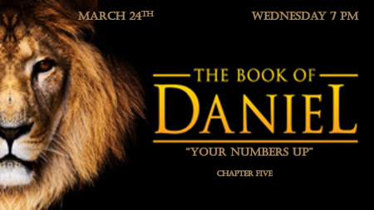

*Is the Handwriting on the Wall? (The cup of Iniquity.)

*Daniel 5:1 King Belshazzar gave a great banquet for a thousand of his nobles and drank wine with them. 2 While Belshazzar was drinking his wine, he gave orders to bring in the gold and silver goblets that Nebuchadnezzar his father had taken from the temple in Jerusalem, so that the king and his nobles, his wives and his concubines might drink from them. 3 So they brought in the gold goblets that had been taken from the temple of God in Jerusalem, and the king and his nobles, his wives and his concubines drank from them. 4 As they drank the wine, they praised the gods of gold and silver, of bronze, iron, wood and stone.
5 Suddenly the fingers of a human hand appeared and wrote on the plaster of the wall, near the lampstand in the royal palace. The king watched the hand as it wrote. 6 His face turned pale, and he was so frightened that his legs became weak, and his knees were knocking.

The Beginning of Wisdom

- V:1The Grandson of Nebuchadnezzar is wicked. While he should have been preparing for war, he was holding a huge party.

- V:2 He used what was sacred to praise the false gods of this world.

- V:5-6 He sees the hand of God and the fear began to set in but, it was too late. V:6 KJV Then the king's countenance was changed, and his thoughts troubled him so that the joints of his loins were loosed, and his knees smote one against another. (This was a fulfillment of prophecy)

*Isaiah 45:1 Thus saith the LORD to his anointed, to Cyrus, whose right hand I have holden, to subdue nations before him; and I will loose the loins of kings, to open before him the two leaved gates; and the gates shall not be shut;

*Daniel 5:13 So Daniel was brought before the king, and the king said to him, "Are you Daniel, one of the exiles my father the king brought from Judah? 14 I have heard that the spirit of the gods is in you and that you have insight, intelligence and outstanding wisdom. 15 The wise men and enchanters were brought before me to read this writing and tell me what it means, but they could not explain it.
Daniel 5:17 Then Daniel answered the king, "You may keep your gifts for yourself and give your rewards to someone else. Nevertheless, I will read the writing for the king and tell him what it means.
Daniel 5:22 "But you, Belshazzar, his son, have not humbled yourself, though you knew all this. 23 Instead, you have set yourself up against the Lord of heaven.

When you Knew Better but…

- V:7-11 Grandma is brought to the Palace, and she reminds Belshazzar of Daniel.

- V:12-15 Grandma gives testimony about Daniel. The grandson dismissed the source of Daniel’s giftedness as from the “Most High God.”

- V:17-21 Daniel gives the King a history lesson about God’s power. Each generation is responsible for their choices.

- V:22-23 Pride goes before destruction. Proverbs 16:18 KJV

*Daniel 5:26 "Here is what these words mean: Mene: God has numbered the days of your reign and brought it to an end.
27 Tekel: You have been weighed on the scales and found wanting.
28 Peres: Your kingdom is divided and given to the Medes and Persians."
30 That very night Belshazzar, king of the Babylonians, was slain.

What is God writing to our world leaders?

- V:26 “Your numbers up.” A phrase used around the world. God sent a message last week to our world, the warning came from the discovery of the book of Nahum where a gentile nation is destroyed by the hand of God. So, whose number is up?

- V:27 “You have been weighed, measured and found wanting.” A popular movie line, means there is something vital missing in a person’s character.

- V:28 “Broken and Divided” The Babylonian empire was broken then conquered.

Why did the Jews Connect Cyrus and Trump?

