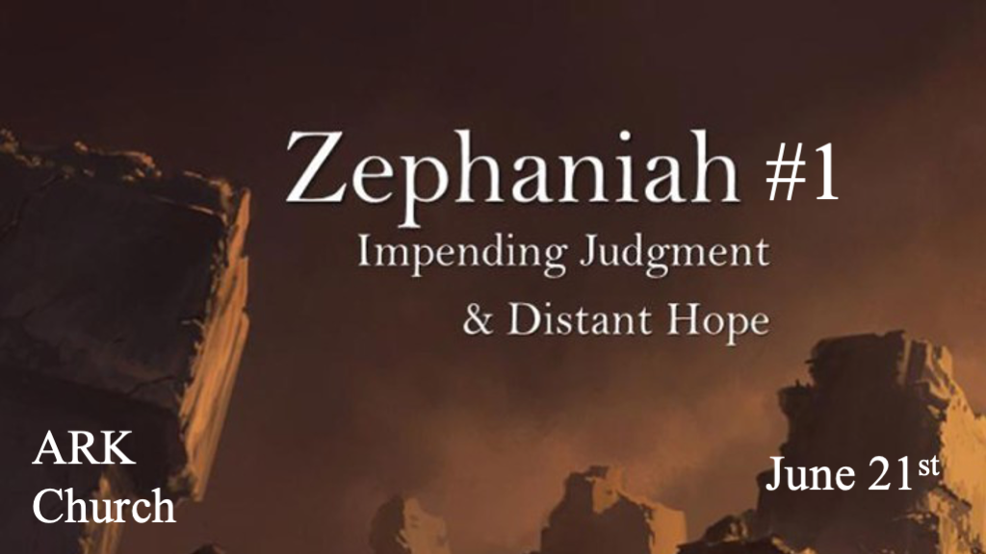
*Zephaniah means Yahweh has hidden.

*Coming judgment and the reason for it.
*Zephaniah 1:1 The word of the LORD which came to Zephaniah the son of Cushi, the son of Gedaliah, the son of Amariah, the son of Hezekiah, in the days of Josiah the son of Amon, king of Judah.
2 “I will utterly consume everything from the face of the land, ”Says the LORD; 3 “I will consume man and beast; I will consume the birds of the heavens, the fish of the sea, and the stumbling blocks along with the wicked. I will cut off man from the face of the land,” says the LORD.

V:1-2 How does the Word of the Lord come to you?

- V:1 In the time of Zephaniah, the scriptures were banned from Israel for almost six decades.
Our world is closely paralleling this time. Israel is about three years away from the Wrath of God and being taken into captivity by the Babylonians.

- V:2 Utterly consuming everything from the face of the land. The wrath does include Israel, but most scholars agree this has a broader application.
The birds of the heavens and the fish of the sea are part of the judgment during the great tribulation.

- V:3 Two groups of people, the stumbling blocks and the wicked, will be cut off.
Over a hundred scriptures deal with stumbling blocks. Malachi 2:8 says instructing people with wrong advice, you are guilty of corruption.

Some stumbling blocks are cultural, like eating certain foods.

Stumbling blocks that are intentional fall into the category of the wicked. Ezekiel 14:3 They set their stumbling blocks of iniquities right before their eyes.

*Specific judgment for Idolatry, Royalty, and Merchants that are evil.
*Zephaniah 1:4 “I will stretch out My hand against Judah, and against all the inhabitants of Jerusalem. I will cut off every trace of Baal from this place, the names of the idolatrous priests with the pagan priests—5 Those who worship the host of heaven on the housetops; Those who worship and swear oaths by the LORD, but who also swear by Milcom; 6 Those who have turned back from following the LORD, and have not sought the LORD, nor inquired of Him.” 7 Be silent in the presence of the Lord GOD;
For the day of the LORD is at hand, for the LORD has prepared a sacrifice; He has invited His guests. 8 “And it shall be, in the day of the LORD’s sacrifice, that I will punish the princes and the king’s children, and all such as are clothed with foreign apparel.
9 In the same day I will punish all those who leap over the threshold, who fill their masters’ houses with violence and deceit.
10 “And there shall be on that day,” says the LORD, “The sound of a mournful cry from the Fish Gate, a wailing from the Second Quarter, and a loud crashing from the hills. 11 Wail, you inhabitants of Maktesh! For all the merchant people are cut down; All those who handle money are cut off.

- V:4-6 Idolatrous and pagan leaders are under the same judgment.
They’ve turned their backs on oaths sworn to the Lord.

Leaders from the House of Judah would include Josiah’s Dad and Grandpa, who destroyed the country through their evil practices.

Milcom is the Babylonian god called Moloch. They sacrifice their children to him. Our country has over five decades of this practice, but in our society is called Abortion.

- V:7-9 The judgment on Royalty.
The warning comes during godly reform and king.

God reveals His omniscient by saying that future generations will return to stumbling/wicked practices. They will be destroyed, and the wrath of God comes on the nation because of it.

- V:10-11 The judgment on Merchants.
All the merchants are cut down. I believe this two-fold; they lost their prosperity and their lives.

*Colossians 3:5-7 Therefore put to death your members which are on the earth: fornication, uncleanness, passion, evil desire, and covetousness, which is idolatry. 6 Because of these things the wrath of God is coming upon the sons of disobedience, 7 in which you yourselves once walked when you lived in them.

*The complacent receive a description of the intensity and certainty of destruction.
*Zephaniah 1:12 “And it shall come to pass at that time that I will search Jerusalem with lamps, and punish the men who are settled in complacency, who say in their heart, ‘The LORD will not do good, nor will He do evil.’ 13 Therefore their goods shall become booty, and their houses a desolation; They shall build houses, but not inhabit them; They shall plant vineyards, but not drink their wine.” 14 The great day of the LORD is near; It is near and hastens quickly. The noise of the day of the LORD is bitter; There the mighty men shall cry out. 15 That day is a day of wrath, a day of trouble and distress, a day of devastation and desolation, a day of darkness and gloominess, a day of clouds and thick darkness, 16 a day of trumpet and alarm against the fortified cities and against the high towers. 17 “I will bring distress upon men, and they shall walk like blind men, because they have sinned against the LORD; Their blood shall be poured out like dust, and their flesh like refuse.” 18 Neither their silver nor their gold shall be able to deliver them In the day of the LORD’s wrath; But the whole land shall be devoured by the fire of His jealousy, for He will make speedy riddance of all those who dwell in the land.

- V:12-13 The lukewarm believer is also deceived about what The Lord will or will not do.
This is a mirror of the warning to the Church of Laodicea.

Sadly, it is also the falsehood preached in today’s Churches. Their message is God is only love, and we should just mind our own business.

- V:14-16 The Great Day of the Lord is near.
A day of tribulation, a day of destruction and bleakness with no hope, is the same description in Revelation.

A day of darkness and gloominess, a day of no sun and thick darkness, it too is described in Revelation.

A day of trumpet alarm against those who thought they were safe and fortified.

- V:17-18 The certainty of judgment and the reason behind it.
Listen, this is NOT the Babylonian captivity.

I will bring distress on men. This is God actively engaged in the punishment of humanity.

The key is they are all devoured by fire. This is foretold in one hundred scriptures and again in Zephaniah 3:8.

